there's a... / there are some... Activity 1
Read Grammar bank 10A. Complete the sentences with the correct form of there’s / there are, Is there / Are there, or there isn’t / there aren’t. Listen and check.
Grammar Bank
10A there's a... / there are some...
Singular
[+] There’s a TV in the room. There’s a shower. (there’s = there is)
[–] There isn’t a phone. There isn’t a bathtub.
[?] Is there a TV? [✓] Yes, there is.
[?] Is there a bathtub? [✗] No, there isn’t.
Plural
[+] There are two beds in the room. There are some pictures.
[–] There aren’t any towels. There aren’t any books.
[?] Are there any pictures? [✓] Yes, there are.
[?] Are there any towels? [✗] No, there aren’t.
- We use there is/there are to say that something or somebody is in a place. There’s a TV in my hotel room. = The room has a TV.
Word order
There’s a swimming pool. → Is there a swimming pool?
some and any
There are some towels in the bathroom.
There aren’t any towels in the bathroom.
Are there any towels in the bathroom?
• Use some with plural nouns in [+] sentences. some = you don’t say exactly how many.
• Use any with plural nouns in [–] sentences and [?].

1 __________ any free tables in the restaurant?
2 __________ any elevators. Would you like rooms on the ground floor?
3 __________ a bathtub in the bathroom. It’s very big.
4 __________ a gym? I want to exercise.
5 __________ a remote control for the TV. Can you ask for one?
6 __________ some very ugly pictures in this room.
7 __________ a spa in the hotel?
8 __________ some tables in the yard if you want to eat outside.
9 __________ a parking lot, but we can help you park your car.
10 __________ any clean towels?

there's a... / there are some... Activity 2
Read Grammar bank 10A. Complete the sentences with a, some, or any. Listen and check.

Grammar Bank
10A there's a... / there are some...
Singular
[+] There’s a TV in the room. There’s a shower. (there’s = there is)
[–] There isn’t a phone. There isn’t a bathtub.
[?] Is there a TV? [✓] Yes, there is.
[?] Is there a bathtub? [✗] No, there isn’t.
Plural
[+] There are two beds in the room. There are some pictures.
[–] There aren’t any towels. There aren’t any books.
[?] Are there any pictures? [✓] Yes, there are.
[?] Are there any towels? [✗] No, there aren’t.
- We use there is/there are to say that something or somebody is in a place. There’s a TV in my hotel room. = The room has a TV.
Word order
There’s a swimming pool. → Is there a swimming pool?
some and any
There are some towels in the bathroom.
There aren’t any towels in the bathroom.
Are there any towels in the bathroom?
• Use some with plural nouns in [+] sentences. some = you don’t say exactly how many.
• Use any with plural nouns in [–] sentences and [?].

1 There aren’t ___________ cars in the parking lot.
2 There are ___________ pillows in the closet.
3 There’s ___________ sauna in the spa.
4 Are there ___________ chairs in the yard?
5 Is there ___________ TV in the café?
6 There isn’t ___________ table in the bedroom.
7 There aren’t ___________ windows in my room.
8 There are ___________ stores in the hotel.
9 There are ___________ nice T-shirts in the gift shop.
10 Are there ___________ restaurants in the town?

Hotels: Activity 1
Match the words to the highlighted objects in the hotel room.
a table a light a bed a pillow the bathroom a lamp
a remote control the floor
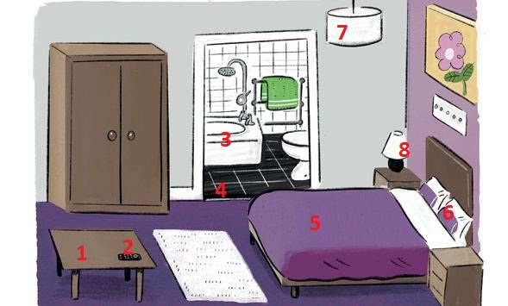
1. |  | 5.
2. |  | 6.
3. |  | 7.
4. |  | 8.

Hotels: Activity 2
Match the words to the highlighted places in the hotel
a gym a swimming pool a spa a gift shop restrooms
an elevator a restaurant a kitchen

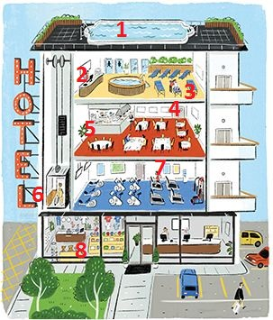

1. |  | 5.
2. |  | 6.
3. |  | 7.
4. |  | 8.

in, on, under
Choose in, on or under to complete the sentence.
1. The remote control is in / on / under the table. | 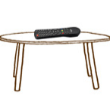
2. The remote control is in / on / under the bed. | 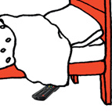
3. The remote control is in / on / under the cup. | 
4. The remote control is in / on / under the blanket. | 
5. The remote control is in / on / under the bed. | 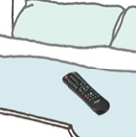
6. The remote control is in / on / under the suitcase. | 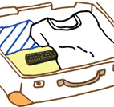
/ɪr/ and /ɛr/
Match the sound pictures to the correct words. Then listen and repeat.

 | 

Oceanside Hotel: Activity 1
Listen to the conversation at the hotel reception. Choose True or False.
- There are elevators.
  - True
  - False
- There's an ocean view.
  - True
  - False
- There’s a TV in the room.
  - True
  - False
- There are books.
  - True
  - False
- There’s a restaurant.
  - True
  - False
- There's a gym.
  - True
  - False
- There are drinks in the room.
  - True
  - False
- There's a gift shop.
  - True
  - False

Oceanside Hotel: Activity 2
Listen again and complete the conversation. Use contractions when needed.
isn't aren't there last room gym small
floor there's elevator drinks books shop
ocean
A Good afternoon. Welcome to Oceanside Hotel. Do you have a reservation?
B Yes, we do. Our ___________ name is Green.
A Welcome, Mr. and Mrs. Green. You’re in ___________ 304. That’s on the third ___________ .
B Great. Where are the ___________ ?
A Uh, actually we’re a ___________ hotel. There aren’t any elevators.
B That’s OK. Can we see the ___________ from our room?
A Yes, there’s a beautiful view from your room.
B Perfect! Is ___________ a TV in our room?
A No, there ___________ , but there are some ___________ and magazines in the room, and you can also use the Internet. Also, ___________ a TV in the restaurant.
B OK. Oh, and is there a ___________ ?
A There isn’t a gym. I’m sorry. But you can swim in the ocean. That’s good exercise.
B That’s true. Oh, and are there any ___________ in the room like juice or soda?
A No, there ___________ . But there’s a gift ___________ on the first floor. You can buy drinks there.
B OK. Thanks!

