Singular and plural nouns: Activity 1
Read Grammar bank 3A. Then complete the sentences. Listen and check.
Grammar Bank
3A Singular nouns; a / an
What is it?
It's a book.
It's a key.
It's an umbrella.
It's an ID card.
What is it? NOT What's it?
We use a / an + singular noun
We use a + word beginning with a consonant, e.g., a bag, a phone
We use an + word beginning with a vowel, e.g., an umbrella
Plural nouns
What is it? It's a book.
What are they? They're books.
What is it? It's a key.
What are they? They're keys.
What is it? It's a watch.
What are they? They're watches.
What is it? It's a dictionary.
What are they? They're dictionaries.
Spelling rules
1 +s a bag/bags, a vacation/vacations
2 +es (words ending in ch, sh, s, ss, x) a class/classes /ɪz/
3 +ies (words ending in consonant +y) a country/countries
the
Look at the board. Open the door. Close the windows.
We use the + singular or plural nouns, e.g., the door, the windows

1. A What is it / are they ? B It's / They're a laptop.
2. A What is it / are they? B It's / They're books.
3. A What is it / are they ? B It's / They're a bag.
4. A What is it / are they ? B It's / They're glasses.
5. A What is it / are they ? B It's / They're a camera.
6. A What is it / are they ? B It's / They're an ID card.

Singular and plural nouns: Activity 2
Read Grammar bank 3A. Complete the pairs of singular and plural sentences.
For example, It's a pen. They're pens. Listen and check.
Grammar Bank
3A Singular nouns; a / an
What is it?
It's a book.
It's a key.
It's an umbrella.
It's an ID card.
What is it? NOT What's it?
We use a / an + singular noun
We use a + word beginning with a consonant, e.g., a bag, a phone
We use an + word beginning with a vowel, e.g., an umbrella
Plural nouns
What is it? It's a book.
What are they? They're books.
What is it? It's a key.
What are they? They're keys.
What is it? It's a watch.
What are they? They're watches.
What is it? It's a dictionary.
What are they? They're dictionaries.
Spelling rules
1 +s a bag/bags, a vacation/vacations
2 +es (words ending in ch, sh, s, ss, x) a class/classes /ɪz/
3 +ies (words ending in consonant +y) a country/countries
the
Look at the board. Open the door. Close the windows.
We use the + singular or plural nouns, e.g., the door, the windows

1. It's _________ pen. They're _________ .
2. It's _________ phone. They're _________ .
3. It's _________ watch. They're _________ .
4. It's _________ umbrella. They're _________ .
5. It's _________ dictionary. They're _________ .
6. It's _________ email. They're _________ .
7. It's _________ key. They're _________ .
8. It's _________ laptop. They're _________ .

Small things: Activity 1
Match the words to the highlighted objects in the picture.
an umbrella a credit card and a debit card a watch a phone
a newspaper a photo glasses a key
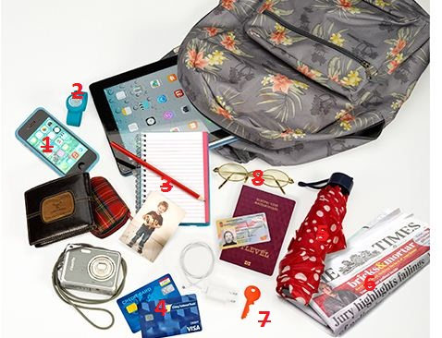
1.
2.
3.
4.
5.
6.
7.
8.

/z/ and /s/
Listen and read. Match the sound pictures to the correct words. Then listen and repeat.
 | 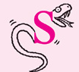

Plural endings
Listen and write. Then listen and repeat.
- _________ |  | 6. _________
- _________ |  | 7. _________
- _________ |  | 8. _________
- _________ |  | 9. _________
- _________ |  | 10. _________

Where are my keys? Activity 1
Listen to the conversations. Choose the correct answer.
1.
  - The keys are in his pocket.
  - The keys are in his bag.
2.
  - It's a book.
  - It's a tablet.
3.
  - She has a phone in her bag.
  - She has a book in her bag.
4.
  - His wallet is in his bag.
  - His wallet is on the table.
5.
  - Her phone is in her pocket.
  - Her phone is in her coat.

Where are my keys? Activity 2
Listen and read. Then say and record.
1.Where are my keys?
2.Are they in your bag?
3.No, they aren't.
4.Well, I don't know.
5.Here they are. They're in my pocket.

