Possessive adjectives
Read Grammar bank 4A. Then complete the sentences. Listen and check.
Grammar Bank
4A Possessive adjectives; possessive 's
Possessive adjectives
I'm from the US. My name is Sara.
You're Canadian. Your name is Kim.
He's from China. His name is Ming.
She's Japanese. Her name is Satoko.
It's a Turkish restaurant. Its name is Kebob Kitchen.
We're from Brazil. Our names are Sema and Luis.
You're Chilean. Your names are Matias and Pia.
They're from Mexico. Their names are Pedro and Maria.
- your names, our books, their coats NOT yours names, ours books, theirs coats
- its = for things and animals, e.g.,
Pizzeria Marco is a good restaurant. Its phone number is 212-555-3387.
Senegal is in Africa. Its flag is red, yellow, and green.
Look at that fish! Its eyes are yellow.

It's or its?
It's = it is It's a Turkish restaurant.
Its = possessive Its name is Kebob Kitchen.
Possessive 's
This is Jack's car.
Ella is Ben's wife.
Maria is Carlos's sister.
My sister's name is Molly.
This is my parents' house.
We use 's after a person to talk about family and things, e.g., Ann's brother, Jim's car.
We use ' after plural people, e.g., my brothers' room (= two brothers).
's
She's American. Her name's Emma. ('s = is)
Emma is Maria's daughter. ('s = possessive s)
pronunciation of 's
's usually = /s/, e.g., Jack's or /z/, e.g., Maria's.
's after a name that ends in s = /ɪz/, e.g., Carlos's = /ˈkɑrlousɪz/

Her Our Their their its our Its my
your His your Their
1. They're from Turkey. _________ names are Ayla and Sabriye.
2. A What's _________ name?
B I'm Julia. Nice to meet you.
3. He's Peruvian. _________ name is Roberto.
4. It's a good hotel, and _________ restaurant is fantastic.
5. They're Mexican. _________ last name is Romero.
6. I know a very good restaurant in Madrid. _________ name is Café Castillo.
7. _________ name is Tina. She's Brazilian.
8. Lisa and Amy are American, but _________ husbands are British.
9. A We're Jane and Mark Kelley. We have a reservation.
B You're in room 22. This is _________ room key.
10. Here are _________ coffees. The cappuccino is for you, the latte is for Tom, and the Americano is for me.
11. I'm Sally, and this is _________ husband, Tom.
12. A Are those your children?
B No, they aren't. _________ children are over there.

Possessive 's
Read Grammar bank 4A. Complete the sentences. For example, Diego is Carmen's brother. Then listen and check.

Grammar Bank
4A Possessive adjectives; possessive 's
Possessive adjectives
I'm from the US. My name is Sarah.
You're Canadian. Your name is Kim.
He's from China. His name is Ming.
She's Japanese. Her name is Satoko.
It's a Turkish restaurant. Its name is Kebob Kitchen.
We're from Brazil. Our names are Sema and Luis.
You're Chilean. Your names are Matias and Pia.
They're from Mexico. Their names are Pedro and Maria.
- your names, our books, their coats NOT yours names, ours books, theirs coats
- its = for things and animals, e.g.,
Pizzeria Marco is a good restaurant. Its phone number is 212-555-3387.
Senegal is in Africa. Its flag is red, yellow, and green.
Look at that fish! Its eyes are yellow.
It's or its?
It's = it is It's a Turkish restaurant.
Its = possessive Its name is Kebob Kitchen.
Possessive 's
This is Jack's car.
Ella is Ben's wife.
Maria is Carlos's sister.
My sister's name is Molly.
This is my parents' house.
We use 's after a person to talk about family and things, e.g., Ann's brother, Jim's car.
We use ' after plural people, e.g., my brothers' room (= two brothers).
's
She's American. Her name's Emma. ('s = is)
Emma is Maria's daughter. ('s = possessive s)
pronunciation of 's
's usually = /s/, e.g., Jack's or /z/, e.g., Maria's.
's after a name that ends in s = /Iz/, e.g., Carlos's = /ˈkɑrlousɪz/

1. Carmen is Diego's sister.
Diego is _________ _________ .
2. Charlotte is Peter's wife.
Peter is _________ _________ .
3. Mark is Angelina's brother.
Angelina is _________ _________ .
4. Richard is Maria's father.
Maria is _________ _________ .
5. Ana is Paulo's mother.
Paulo is _________ _________ .
6. William is Megan's husband.
Megan is _________ _________ .
7. Sarah is Michael's daughter.
Michael is _________ _________ .
8. Roberto is Luisa's son.
Luisa is _________ _________ .

People and family: Activity 1
Listen and read. Match the pictures to the words. Then listen and repeat.
 |  | 
 |  | 

People and family: Activity 2
Listen and read. Match the sound pictures to the correct words. Then listen and repeat.
brother son daughter husband wife father
sister mother
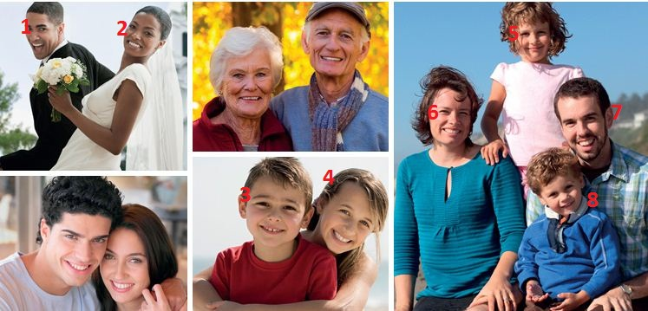

1.
2.
3.
4.
5.
6.
7.
8.

People and family: Activity 3
Complete the conversation. Then listen and check.
Maria Hi, Sarah! Come in.
Sarah Thanks.
Maria This is my husband / wife , Pablo.
Pablo Hello.
Sarah Hi.
Maria And these are our child / children .
Children Hello!
Sarah Who / What are their names?
Maria Her name’s Emma, and his name’s Francisco.
Emma And this is our cat.
Sarah Ah! What’s it's / its name?
Emma Her name is Princess. She’s a boy / girl .
Sarah Oh, sorry.

/ʌ/, /æ/, and /ə/
Listen to the conversations. Choose the correct answer.
 | 


Family photo: Activity 1
Listen to the conversation. Choose True or False.
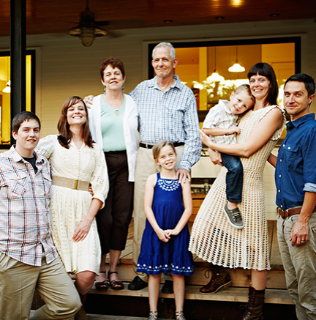
- Emily is Tom's mother.
  - True
  - False
- Matthew is five.
  - True
  - False
- Laura is Tom's daughter.
  - False
  - True
- Tom's parents aren't in the photo.
  - True
  - False
- David is Tom's brother.
  - False
  - True
- Alison is David's wife.
  - False
  - True
- It's Tom's birthday party.
  - False
  - True

Family photo: Activity 2
Listen and complete the conversation. You can read the audio script to help you.
A Is that a photo of your family, Tom?
B Yes, it is.
A Can I see it?
B Yes, of course. Well, that’s me. And that’s my wife, Emily, with my son, Matthew.
A How old is he?
B He’s four. And that’s my daughter, Laura. She’s eight.
A They’re beautiful!
B Thank you. And then those are my parents.
A Ah yes. I can see. You and your father are very similar. So who are these people?
B That’s my little brother, David.
A And is that his wife?
B No, that’s my brother’s girlfriend, Alison.
A Ah, what a beautiful photo!
B Yes, it’s from my father’s birthday party.

parents birthday father daughter wife son
brother girlfriend photo
A Is that a _________ of your family, Tom?
B Yes, it is.
A Can I see it?
B Yes, of course. Well, that’s me. And that’s my _________ , Emily, with my _________ , Matthew.
A How old is he?
B He’s four. And that’s my _________ , Laura. She’s eight.
A They’re beautiful!
B Thank you. And then those are my _________ .
A Ah yes. I can see. You and your _________ are very similar. So who are these people?
B That’s my little _________ , David.
A And is that his wife?
B No, that’s my brother’s _________ , Alison.
A Ah, what a beautiful photo!
B Yes, it’s from my father’s _________ party.

Writing 2
Write about your family.
My name ...  My father's name ...  My mother's name ...  I have a ...  His / Her name is  We have a ...  Her name ... | Write here ..

