Verb be (singular): I and you: Activity 1
1 Hello. I'm Maria. What's your name?
2 Hi. I'm Tony.
3 Hello. I'm your teacher. You're in my class. You're in room 4.
4 Hello. I'm your student. I'm in room 4.
5 I'm not Tom. I'm Tony.
6 You aren't in room 5. You're in room 4.
7 I'm not in room 6. I'm in room 7.
8 A Are you Sam?
B Yes, I am.
Verb be (singular): I and you: Activity 2
1A Am I in room 8?
1B No, you aren't . You're in room 6.
2A Are you in room 4?
2B No, I 'm not . I'm in room 5.
3A Are you Henry?
3B Yes, I am . Nice to meet you!
4A Am I in your class?
4B Yes, you are . I 'm your teacher.

Numbers 0-10
- 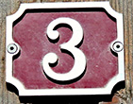
- 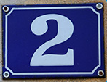
- 
- 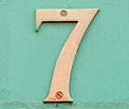
- 
- 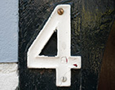
- 
- 
- 
- 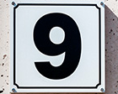
Days of the week
- Monday
- Tuesday
- Wednesday
- Thursday
- Friday
- Saturday
- Sunday

Saying goodbye
1 A Goodbye.
B Bye, Alicia. See you on Friday.
2 A Bye , Pedro.
B Bye, Hayeun. See you tomorrow.
3 A Bye, Ahmed. See you on Saturday .
B Bye, Helen .
/h/, /aɪ/, and /i/
 |  |  | 
 |  |  | 
 |  |  | 

At a party: Activity 1




At a party: Activity 2

- 917-555-6542
- room five.
- five dollars and twenty cents.
- 23 Canal Street

