Verb be (singular): he, she, it: Activity 1
- It's
- She's
- It's
- He's
- It's
- He's
- She's
- It's
- He's

Verb be (singular): he, she, it: Activity 2
1. A Where 's Osaka? is it in Japan?
B Yes, it is .
2. A is Mark from the US?
B No, he 's from England.
3. A Where 's she from?
B She 's from Rio.
4. A Is Ivan from Russia?
B No, he isn't . He 's from Turkey.
5. A is Bogota in Chile?
B No, it isn't . It 's in Colombia.
6. A is Ana from Mexico?
B No, she isn't . She's from Peru.

Countries: Activity 1
 |  |  | 
 | 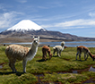 |  | 
 |  |  | 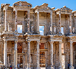

Countries: Activity 2
- 
- 
- 
- 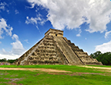
- 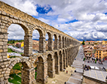
- 
- 
- 

/ɪ/, /oʊ/, /s/, and /ʃ/
 | 
 |  |  | 
 | 
Countries: Activity 2
- Mexico
- Brazil
- Peru
- Korea
- good
- Vietnam
- London
- Spain

Countries: Activity 1
- Canada
- Saudi Arabia
- Atlanta
- Argentina
- Japan
- Spain

