Simple present [+] and [-]: I, you, we, they: Activity 1
- have
- don't drink
- like
- eat
- eat
- don't have
- don't like
- eat
Simple present [+] and [-]: I, you, we, they: Activity 2
1. have
People in the US don't have a big lunch – they usually have a sandwich.
We always have lunch with my family on Sundays.
2. eat
I don't eat meat. I’m a vegetarian.
People eat a lot of fish and rice in Japan.
3. drink
You drink a lot of coffee! It isn’t good for you.
They don't drink coffee. They only drink tea.
4. go
We don't go to restaurants. They’re very expensive.
I don’t have breakfast at home. I go to a café.

Food and drink: Activity 1
- 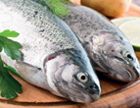
- 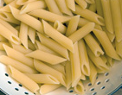
- 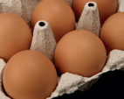
- 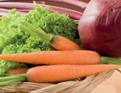
- 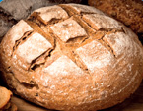
- 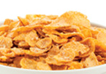
- 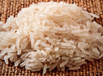
- 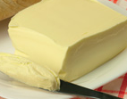
- 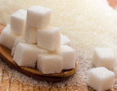
- 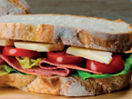
- 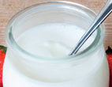
- 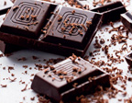
Food and drink: Activity 2
- It's coffee.
- It's milk.
- It's orange juice.
- It's water.
- It's tea.
Food and drink: Activity 3
 | 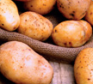 |  | 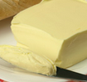
 | 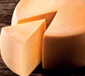 |  | 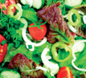
 | 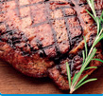 |  | 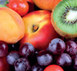

/dʒ/ and /g/

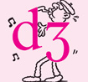
What's your favorite meal? Activity 1
- b
- e
- d
- c
- f
- a

What's your favorite meal? Activity 2
1. A What’s your favorite meal of the day, Anna?
B Um, I prefer breakfast .
A Really? What do you have for breakfast?
B I have yogurt and some fruit, and I drink green tea .
2. A Which meal do you prefer, Luca?
B I like dinner , because I have it at home with my family.
A What do you have?
B We have meat or fish with potatoes, pasta or rice, and some vegetables . We eat a lot!
3. A Isabelle, what do you have for lunch ?
B I usually go to a restaurant with my friends from work. We don’t have much. Just soup or maybe a salad .
4. A Do you go out for lunch , Keiko?
B No. I don’t have a lot of time for lunch. I just have a sandwich and a coffee at my computer.
5. A What’s your favorite meal of the week?
B Dinner on Friday night. Our children go to my mother’s house. Then my husband and I go out to a restaurant , maybe Japanese, Italian, Mexican – we always have something different.
6. A Sarah, what do you have for breakfast ?
B During the week, I have coffee and cereal .
A And on the weekend?
B On Sundays, I have a typical American breakfast with my family: eggs , meat, pancakes, and coffee. It’s great!

