Vocabulary: the alphabet
Listen and read. Then say and record.
1.a, b, c, d, e
2.f, g, h, i, j
3.k, l, m, n, o
4.p, q, r, s, t
5.u, v, w
6.x, y, z

Vocabulary: things in the classroom
Listen to the words in the box. Match the words to the highlighted objects in the classroom.
Then listen and repeat.
a dictionary a window the board a chair a laptop
the door a coat a table
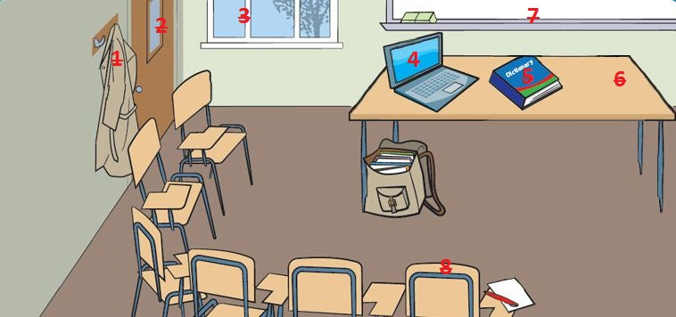

1.
2.
3.
4.
5.
6.
7.
8.

Vocabulary: classroom language
Listen and complete the sentences. Then listen and repeat.
1. Look at the _________ , please.
2. _________ your books.
3. _________ to page 10.
4. _________ your books.
5. _________ up, please.
6. _________ down.
7. How do you _________ it?
8. Can you _________ that, please?
9. Excuse me. _________ gracias in English?
10. I don't _________ .
11. I _________ know.
12. Sorry I'm _________ .

Interactive video: Checking into a hotel
Watch the video of Rob checking in to a hotel. Then record Rob's part of the conversation.
Rob: Hello.
Receptionist: Good afternoon.
Rob: My name’s Rob Walker. I have a reservation.
Receptionist: Sorry, what’s your surname?
Rob: Walker.
Receptionist: How do you spell it?
Rob: W-A-L-K-E-R.
Receptionist: Sorry?
Rob: W-A-L-K-E-R.
Receptionist: Thank you. OK, Mr Walker. You’re in room 321.
Rob: Thanks.

Interactive video: Useful phrases
Watch the Useful phrases. Then record yourself saying them.
Rob: I have a reservation.
Receptionist: How do you spell it?
Receptionist: Sorry?
Receptionist: Thank you.
Waiter: Good morning.
Waiter: How can I help you?
Jenny: A table for tomorrow, please.
Jenny: That’s right.

