***there's a... / there are some...* Activity 1**

Read Grammar bank 10A. Complete the sentences with the correct form of *there’s* / *there are*, *Is there* / *Are there*, or *there isn’t* / *there aren’t*. Listen and check.

|  |
| --- |
| **Grammar Bank**  **10A*there's a*... / *there are some*...**  **Singular**  [+] **There’s** a TV in the room.  **There’s** a shower. (there’s = there is) [–] **There isn’t** a phone.  **There isn’t** a bathtub. [?] **Is there** a TV?  [✓] Yes, **there is**. [?] **Is there** a bathtub?  [✗] No, **there isn’t**.  **Plural**  [+] **There are** two beds in the room. **There are *some*** pictures. [–] **There aren’t** any towels.**There aren’t *any*** books. [?] **Are there *any*** pictures?  [✓] Yes, **there are**. [?] **Are there *any***towels? [✗] No, **there aren’t**.   * We use *there is*/*there are* to say that something or somebody is in a place. *There’s a TV in my hotel room*.  =  *The room has a TV*.   **Word order**  ***There’s*** *a swimming pool.* → ***Is there*** *a swimming pool?*  ***some* and *any*** *There are* ***some*** *towels in the bathroom.  There aren’t* ***any*** *towels in the bathroom.  Are there* ***any*** *towels in the bathroom?* • Use *some* with plural nouns in [+] sentences. *some* = you don’t say exactly how many.  • Use *any* with plural nouns in [–] sentences and [?]. |

|  |  |
| --- | --- |
| 1 __________ any free tables in the restaurant? 2 __________ any elevators. Would you like rooms on the ground floor?  3 __________ a bathtub in the bathroom. It’s very big. 4 __________ a gym? I want to exercise. 5 __________ a remote control for the TV. Can you ask for one? 6 __________ some very ugly pictures in this room. 7 __________ a spa in the hotel? 8 __________ some tables in the yard if you want to eat outside. 9 __________  a parking lot, but we can help you park your car. 10 __________ any clean towels? |  |

***there's a... / there are some...* Activity 2**

Read Grammar bank 10A. Complete the sentences with *a*, *some*, or *any*. Listen and check.

|  |
| --- |
| **Grammar Bank**  **10A*there's a*... / *there are some*...**  **Singular**  [+] **There’s** a TV in the room.  **There’s** a shower. (there’s = there is) [–] **There isn’t** a phone.  **There isn’t** a bathtub. [?] **Is there** a TV?  [✓] Yes,**there is**. [?] **Is there** a bathtub?  [✗] No, **there isn’t**.  **Plural**  [+] **There are** two beds in the room. **There are *some*** pictures. [–] **There aren’t** any towels.**There aren’t *any*** books. [?] **Are there *any*** pictures?  [✓] Yes,**there are**. [?] **Are there *any***towels? [✗] No, **there aren’t**.   * We use *there is*/*there are* to say that something or somebody is in a place. *There’s a TV in my hotel room*.  =  *The room has a TV*.   **Word order**  ***There’s****a swimming pool.* →***Is there****a swimming pool?*  ***some* and *any*** *There are****some****towels in the bathroom.  There aren’t****any****towels in the bathroom.  Are there****any****towels in the bathroom?* • Use *some* with plural nouns in [+] sentences. *some* = you don’t say exactly how many.  • Use *any* with plural nouns in [–] sentences and [?]. |

|  |  |
| --- | --- |
| 1 There aren’t ___________ cars in the parking lot. 2 There are ___________ pillows in the closet. 3 There’s ___________ sauna in the spa. 4 Are there ___________ chairs in the yard? 5 Is there ___________ TV in the café? 6 There isn’t ___________ table in the bedroom. 7 There aren’t ___________ windows in my room. 8 There are ___________ stores in the hotel. 9 There are ___________ nice T-shirts in the gift shop. 10 Are there ___________ restaurants in the town? |  |

**Hotels: Activity 1**

Match the words to the highlighted objects in the hotel room.

|  |
| --- |
| a table a light a bed a pillow the bathroom a lamp  a remote control the floor |

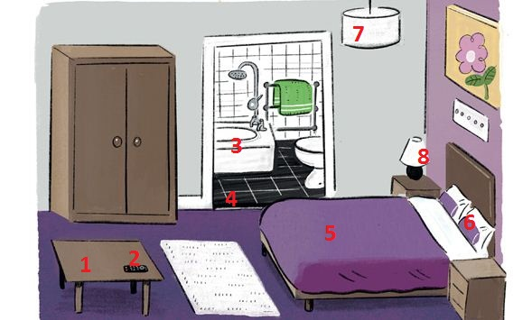

|  |  |  |  |
| --- | --- | --- | --- |
| 1. |  | 5. |  |
| 2. |  | 6. |  |
| 3. |  | 7. |  |
| 4. |  | 8. |  |

**Hotels: Activity 2**

Match the words to the highlighted places in the hotel

|  |
| --- |
| a gym a swimming pool a spa a gift shop  restrooms  an elevator a restaurant a kitchen |

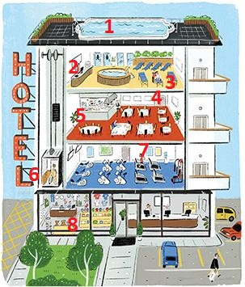

|  |  |  |  |
| --- | --- | --- | --- |
| 1. |  | 5. |  |
| 2. |  | 6. |  |
| 3. |  | 7. |  |
| 4. |  | 8. |  |

**in, on, under**

Choose *in*, *on* or *under* to complete the sentence.

|  |  |
| --- | --- |
| 1. The remote control is in / on / under the table. |  |
| 2. The remote control is in / on / under the bed. |  |
| 3. The remote control is in / on / under the cup. |  |
| 4. The remote control is in / on / under the blanket. |  |
| 5. The remote control is in / on / under the bed. |  |
| 6. The remote control is in / on / under the suitcase. |  |

**/ɪr/ and /ɛr/**

Match the sound pictures to the correct words. Then listen and repeat.

|  |  |  |
| --- | --- | --- |
|  |  |  |
|  |  |  |

|  |  |  |  |
| --- | --- | --- | --- |
|  |  |  |  |
|  |  |  |  |
|  |  |  |  |

**Oceanside Hotel: Activity 1**

Listen to the conversation at the hotel reception. Choose *True* or *False*.

|  |  |
| --- | --- |
| 1. There are elevators.    * True    * False 2. There's an ocean view.    * True    * False 3. There’s a TV in the room.    * True    * False 4. There are books.    * True    * False 5. There’s a restaurant.    * True    * False 6. There's a gym.    * True    * False 7. There are drinks in the room.    * True    * False 8. There's a gift shop.    * True    * False |  |

**Oceanside Hotel: Activity 2**

Listen again and complete the conversation. Use contractions when needed.

|  |  |
| --- | --- |
| isn't aren't there last room gym small  floor there's elevator drinks books shop  ocean |  |

**A** Good afternoon. Welcome to Oceanside Hotel. Do you have a reservation?  
**B** Yes, we do. Our ___________ name is Green.  
**A** Welcome, Mr. and Mrs. Green. You’re in ___________ 304. That’s on the third ___________ .  
**B** Great. Where are the ___________ ?  
**A** Uh, actually we’re a ___________ hotel. There aren’t any elevators.  
**B** That’s OK. Can we see the ___________ from our room?  
**A** Yes, there’s a beautiful view from your room.  
**B** Perfect! Is ___________ a TV in our room?  
**A** No, there ___________ , but there are some ___________ and magazines in the room, and you can also use the Internet. Also, ___________ a TV in the restaurant.  
**B** OK. Oh, and is there a ___________ ?  
**A** There isn’t a gym. I’m sorry. But you can swim in the ocean. That’s good exercise.  
**B** That’s true. Oh, and are there any ___________  in the room like juice or soda?  
**A** No, there ___________ . But there’s a gift ___________ on the first floor. You can buy drinks there.  
**B** OK. Thanks!