**Singular and plural nouns: Activity 1**

Read Grammar bank 3A. Then complete the sentences. Listen and check.

|  |
| --- |
| **Grammar Bank**  **3A Singular nouns; a / an** What is it? It's a book. It's a key. It's an umbrella. It's an ID card.  *What is it?* **NOT***What's it?* We use *a* / *an* + singular noun We use *a* + word beginning with a consonant, e.g., *a bag*, *a phone* We use *an* + word beginning with a vowel, e.g., *an umbrella* **Plural nouns**  What is it? It's a book.           What are they? They're books.  What is it? It's a key.              What are they? They're keys.  What is it? It's a watch.         What are they? They're watches.  What is it? It's a dictionary.   What are they? They're dictionaries.  **Spelling rules** 1 +*s* a bag/bag**s,**a vacation/vacation**s** 2 +*es* (words ending in *ch, sh, s, ss, x*) a class/class**es** /ɪz/ 3 +*ies* (words ending in consonant +*y*) a country/countr**ies  *the*** *Look at****the****board.   Open****the****door.  Close****the****windows.* We use *the* + singular or plural nouns, e.g., *the door, the windows* |

|  |  |
| --- | --- |
| **1. A** What is it / are they ?**B**  It's / They're a laptop. **2. A** What is it / are they?**B**  It's / They're books. **3. A** What is it / are they ?**B**  It's / They're a bag. **4. A** What is it / are they ?**B**  It's / They're glasses. **5. A** What is it / are they ? **B** It's / They're a camera. **6. A** What is it / are they ? **B** It's / They're an ID card. |  |

**Singular and plural nouns: Activity 2**

Read Grammar bank 3A. Complete the pairs of singular and plural sentences.   
For example, *It's a pen*. *They're pens*. Listen and check.

|  |
| --- |
| **Grammar Bank**  **3A Singular nouns; a / an** What is it? It's a book. It's a key. It's an umbrella. It's an ID card.  *What is it?* **NOT***What's it?* We use *a* / *an* + singular noun We use *a* + word beginning with a consonant, e.g., *a bag*, *a phone* We use *an* + word beginning with a vowel, e.g., *an umbrella* **Plural nouns**  What is it? It's a book.           What are they? They're books.  What is it? It's a key.              What are they? They're keys.  What is it? It's a watch.         What are they? They're watches.  What is it? It's a dictionary.   What are they? They're dictionaries.  **Spelling rules** 1 +*s* a bag/bag**s,**a vacation/vacation**s** 2 +*es* (words ending in *ch, sh, s, ss, x*) a class/class**es** /ɪz/ 3 +*ies* (words ending in consonant +*y*) a country/countr**ies  *the*** *Look at****the****board.   Open****the****door.  Close****the****windows.* We use *the* + singular or plural nouns, e.g., *the door, the windows* |

|  |  |
| --- | --- |
| 1.  It's _________ pen. They're _________ .  2.  It's _________ phone. They're _________ .  3.  It's _________ watch. They're _________ .  4.  It's _________ umbrella. They're _________ .  5.  It's _________ dictionary. They're _________ .  6.  It's _________ email. They're _________ .  7.  It's _________ key. They're _________ .  8.  It's _________ laptop. They're _________ . |  |

**Small things: Activity 1**

Match the words to the highlighted objects in the picture.

|  |
| --- |
| an umbrella a credit card and a debit card a watch a phone  a newspaper a photo glasses a key |

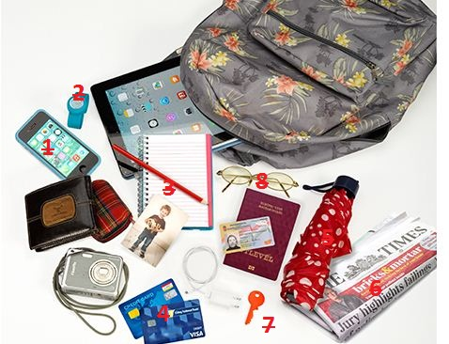

|  |  |
| --- | --- |
| 1. |  |
| 2. |  |
| 3. |  |
| 4. |  |
| 5. |  |
| 6. |  |
| 7. |  |
| 8. |  |

**/z/ and /s/**

Listen and read. Match the sound pictures to the correct words. Then listen and repeat.

|  |  |  |
| --- | --- | --- |
|  |  |  |
|  |  |  |

|  |  |  |  |
| --- | --- | --- | --- |
|  |  |  |  |
|  |  |  |  |
|  |  |  |  |

**Plural endings**

Listen and write. Then listen and repeat.

|  |  |  |  |
| --- | --- | --- | --- |
| 1. _________ |  | 6. _________ |  |
| 1. _________ |  | 7. _________ |  |
| 1. _________ |  | 8. _________ |  |
| 1. _________ |  | 9. _________ |  |
| 1. _________ |  | 10. _________ |  |

**Where are my keys? Activity 1**

Listen to the conversations. Choose the correct answer.

|  |  |
| --- | --- |
| 1.   * + The keys are in his pocket.   + The keys are in his bag.   2.   * + It's a book.   + It's a tablet.   3.   * + She has a phone in her bag.   + She has a book in her bag.   4.   * + His wallet is in his bag.   + His wallet is on the table.   5.   * + Her phone is in her pocket.   + Her phone is in her coat. |  |

**Where are my keys? Activity 2**

Listen and read. Then say and record.

|  |  |
| --- | --- |
| 1.Where are my keys? |  |
| 2.Are they in your bag? |  |
| 3.No, they aren't. |  |
| 4.Well, I don't know. |  |
| 5.Here they are. They're in my pocket. |  |