***this / that / these / those*: Activity 1**

Read Grammar bank 3B. Listen and complete the conversation.

|  |
| --- |
| **Grammar Bank**  **3B  *this*/ *that* / *these* / *those***  What’s **this**? It’s a key.                  What are **these**? They’re keys.  What’s **that**? It’s a cat.                   What are **those**? They’re cats.   * We use *this* / *these* for things near you (things here). * We use *that* / *those* for things that aren’t near you (things there or over there). * *this* / *that* = singular, *these* / *those* = plural * We also use *this / that / these / those* for people, e.g., *This is my brother. Who are those girls over there?*   ***this*, *that*, *these*, *those*** *This*, *that*, *these*, and *those* are pronouns or adjectives. ***This****is my book*. (= pronoun) ***This****book is very nice*. (= adjective) |

|  |  |
| --- | --- |
| these that this those |  |

**Woman**  Excuse me. What are _________ ?   
**Man**       They’re T-shirts.  
**Woman**  How much are they?  
**Man**       They’re $15.  
**Woman**  And how much are _________ key rings?  
**Man**       They’re $5.  
**Woman**  And _________ mug?  
**Man**       $14  
**Woman**  Is _________ a New York Yankees shirt?  
**Man**       No, it’s Boston Red Sox.  
**Woman**  How much is it?  
**Man**       $25.  
**Woman**  Oh…no. Thank you. Bye.

***this / that / these / those*: Activity 2**

Complete the sentences.

|  |  |
| --- | --- |
| 1. Those / That is a beautiful picture. |  |
| 2. **A**Is this / that a good hat? **B** No, it isn't. |  |
| 3.Those / These are $10. |  |
| 4. **A** Are this / these your keys? **B** Yes, they are. Thank you. |  |
| 5. Look! This / That 's Martin from our English class. |  |
| 6. Wow! These / Those are good glasses. |  |

**Souvenirs**

Listen to the words in the box. Match the words to the highlighted objects. Then listen and repeat.

|  |
| --- |
| a postcard a T-shirt sunglasses a cap a toy a mug  a map a key chain |

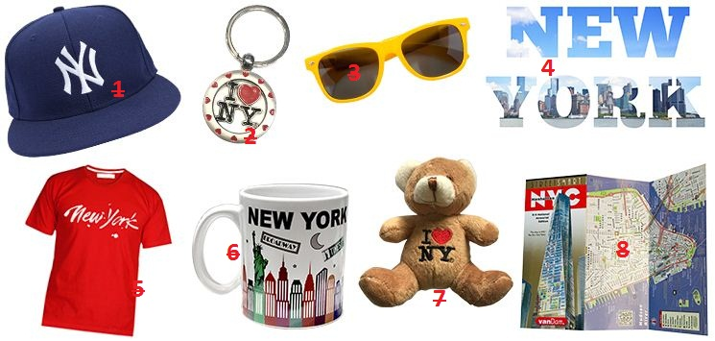

|  |  |  |  |
| --- | --- | --- | --- |
| 1. |  | 5. |  |
| 2. |  | 6. |  |
| 3. |  | 7. |  |
| 4. |  | 8. |  |

**/ð/**

﻿Listen and read. Then say and record.

|  |  |
| --- | --- |
| 1.mother |  |
| 2.this |  |
| 3.that |  |
| 4.these |  |
| 5.those |  |
| 6.the |  |
| 7.they |  |

**Sentence rhythm**

Listen and read. Then say and record. Copy the rhythm.

|  |  |
| --- | --- |
| 1.**A** How much is this mug? **B** It's $9. |  |
| 2.**A** How much is that cap? **B** It's $12. |  |
| 3.**A** How much are these plates? **B** They're $15. |  |
| 4.**A** How much are those T-shirts? **B** They're $20. |  |
| 5.**A** Two caps, please. **B** That's $24 |  |

**How much is it? Activity 1**

Listen to the conversations. Complete the sentences.

|  |  |
| --- | --- |
| keychain sunglasses hat maps |  |

**1** It’s a _________ .  
**2** It’s a Mexican _________ .  
**3** They’re _________ .  
**4** They’re _________ .

**How much is it? Activity 2**

Listen again and complete the conversations. Use contractions. You can read the audio script to help you.

|  |  |
| --- | --- |
| 1  **A** Excuse me. What is this? Is it a toy? **B** No, it isn't. It's a keychain. **A** Oh, OK. It's cute!  2 **A** Is that for sale? **B** The hat? Yes, that's twenty dollars. **A** Is it from Mexico? **B** Yes, it's a Mexican hat.  3 **A** Are those sunglasses? **B** Those? Yes, they're sunglasses. They're two dollars. **A** Two dollars? Are they good? **B** They aren't good, but they're OK.  4 **A** Are these maps of the city? **B** Yes. They're ten dollars. **A** Ten dollars! That's a lot! **B** They're great maps. |  |

**1. A** Excuse me. What is this? Is it a toy?  
    **B** No, it isn't. _________ a keychain.  
    **A** Oh, OK. It's cute!  
  
**2.** **A** Is _________ for sale?  
    **B** The hat? Yes, _________ twenty dollars.  
    **A** Is it from Mexico?  
    **B** Yes, it's a Mexican hat.  
  
**3. A** Are _________ sunglasses?  
    **B** Those? Yes, _________ sunglasses. They're two dollars.  
**A** Two dollars? Are they good?  
**B** They aren't good, but they're OK.  
  
**4. A** Are _________ maps of the city?  
    **B** Yes. _________ ten dollars.  
    **A** Ten dollars! That's a lot!  
    **B** They're great maps.