Adjectives: Activity 1
Read Grammar bank 4B. Complete the sentences with It’s a / an or They’re. Listen and check.
Grammar Bank
4B adjectives
1 An Audi is expensive. It’s fast.
2 An Audi is an expensive car. It’s a fast car.
3 They’re old houses. My glasses are new.
4 He’s tall. She’s tall, too.
1 We use adjectives after the verb be, e.g., An Audi is expensive. NOT An Audi expensive is.
2 We use adjectives before a noun, e.g., It’s a fast car. NOT It’s
a car fast.
3 Adjectives are the same for singular and plural: It’s an old
house. They’re old houses. NOT They’re olds houses.
4 Adjectives are the same for and men and women.

1. _________ old car.
2. _________ black coats.
3. _________ new phone.
4. _________ big houses.
5. _________ expensive sunglasses.
6. _________ good book.

Adjectives: Activity 2
Read Grammar bank 4B. Order the words to make sentences. For example, "blue is bag my," My bag is blue. Listen and check.
4B adjectives
1 An Audi is expensive. It’s fast.
2 An Audi is an expensive car. It’s a fast car.
3 They’re old houses. My glasses are new.
4 He’s tall. She’s tall, too.
1 We use adjectives after the verb be, e.g., An Audi is expensive. NOT An Audi expensive is.
2 We use adjectives before a noun, e.g., It’s a fast car. NOT It’s
a car fast.
3 Adjectives are the same for singular and plural: It’s an old
house. They’re old houses. NOT They’re olds houses.
4 Adjectives are the same for and men and women.

1. beautiful a day it’s ___________________________ .
2. is husband nice very Amy’s ___________________________ .
3. questions difficult they're very ___________________________ .
4. phone cheap is this ___________________________ .
5. photo it’s terrible a ___________________________ .
6. Maggie teacher is fantastic a ___________________________ .
7. very is cat old our ___________________________ .
8. restaurant this good a very isn’t ___________________________ .
9. long it’s a exercise very ___________________________ .
10. is ugly very dog their ___________________________ .
11. expensive Italian bags are very ___________________________ .
12. very this is small room a ___________________________ .

Colors
Listen to the words in the box. Match the words to the highlighted objects. Then listen and repeat.
 | 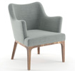 | 
 | 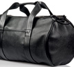 | 

Common adjectives: Activity 1
Look, read and choose. Listen and check.
1. It's a ______ house.  - small  - big | 
2. It's a / an ______ jacket.  - new  - old | 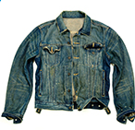
3. It's a ______ car.  - fast  - slow | 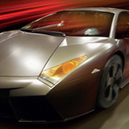
4. It's a / an ______ cat.  - ugly  - beautiful | 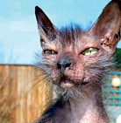
5. It's a / an ______ watch  - expensive  - cheap | 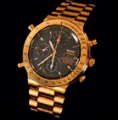
6. It's a ______ name.  - short  - long | 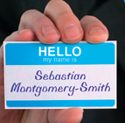
7. They're ______ boots.  - clean  - dirty | 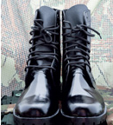
8. It's a / an ______ book.  - difficult  - easy | 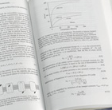

Common adjectives: Activity 2
Listen and read. Then say and record.
1.small
2.new
3.slow
4.beautiful
5.cheap
6.short
7.dirty
8.easy

/ɑr/ and /ɔr/
Listen and read. Match the sound pictures to the words. Then listen and repeat.
 |  | 

Linking
Listen and read. Then say and record.

1.a big umbrella
2.a short email
3.brown eggs
4.an old man
5.an orange coat
6.an expensive watch

A new car: Activity 1
Listen to the conversation. Choose the correct answers.
1.
  - The car is for the woman.
  - The car is for the family.
2.
  - The Toyota Camry is very old.
  - The Toyota Camry isn't very old.
3.
  - The woman doesn't like the Toyota Camry.
  - The woman likes the Toyota Camry.
4.
  - The woman doesn't want a Ford Focus.
  - The woman wants a Ford Focus.
5.
  - The Audi TT is a beautiful car.
  - The Audi TT isn't a beautiful car.
6.
  - The Audi TT is a fast car.
  - The Audi TT is a slow car.

A new car: Activity 2
Listen again and complete the conversation.
Salesman Is the car for you or for the family?
Woman It’s for me.
Salesman For you. Well, the Toyota Camry is a __________ car. It isn’t very old and it isn’t __________ . Only sixteen thousand dollars.
Woman But it isn’t very __________ .
Salesman OK. What about the __________ Subaru Outback? Or the Ford Focus? They’re __________ cars.
Woman No, thanks. I prefer that __________ car over there.
Salesman The Audi TT?
Woman Yes, it’s beautiful!
Salesman It’s a very fast car…
Woman __________ ! How much is it?

