Simple present [+] and [-]: I, you, we, they: Activity 1
Read Grammar bank 5A. Write [+] or [-] sentences. Listen and check.
Grammar Bank
5A present simple [+] and [-]: I, you, we, they
[+]
I have cereal for breakfast.
You have rice for lunch.
We have coffee for breakfast.
They have fish for dinner.
[-]
I don’t have eggs for breakfast.
(don’t = do not)
You don’t have pasta for lunch.
We don’t have tea for breakfast.
They don’t have meat for dinner.
• We use the simple present to talk about present habits (= things we usually do), e.g., I have coffee for breakfast and things that are always true, e.g., In my country we eat a lot of rice.
• Simple present [+] and [–] is the same for I, you (singular and plural), we, and they.
• We make [–] sentences with don’t, e.g., We don’t have coffee. NOT We not have coffee.

1. +
I _________ eggs for breakfast. (have)
2. -
We _________ coffee in the evening. (drink)
3. +
They _________ chocolate. (like)
4. +
You _________ steak. (eat)
5. +
We _________ rice in the evening. (eat)
6. -
I _________ sugar in my coffee. (have)
7. -
You _________ cheese. (like)
8. +
The children _________ vegetables. (eat)

Simple present [+] and [-]: I, you, we, they: Activity 2
Read Grammar bank 5A. Complete the sentences with the bold verb. Write one [+] sentence and one [-] sentence. Listen and check.
Grammar Bank
5A present simple [+] and [-]: I, you, we, they
[+]
I have cereal for breakfast.
You have rice for lunch.
We have coffee for breakfast.
They have fish for dinner.
[-]
I don’t have eggs for breakfast.
(don’t = do not)
You don’t have pasta for lunch.
We don’t have tea for breakfast.
They don’t have meat for dinner.
• We use the simple present to talk about present habits (= things we usually do), e.g., I have coffee for breakfast and things that are always true, e.g., In my country we eat a lot of rice.
• Simple present [+] and [–] is the same for I, you (singular and plural), we, and they.
• We make [–] sentences with don’t, e.g., We don’t have coffee. NOT We not have coffee.

1. have
People in the US _________ a big lunch – they usually have a sandwich.
We always _________ lunch with my family on Sundays.
2. eat
I _________ meat. I’m a vegetarian.
People _________ a lot of fish and rice in Japan.
3. drink
You _________ a lot of coffee! It isn’t good for you.
They _________ coffee. They only drink tea.
4. go
We _________ to restaurants. They’re very expensive.
I don’t have breakfast at home. I _________ to a café.

Food and drink: Activity 1
Listen and read. Match the food to the correct picture. Listen and repeat.
1. fish
- 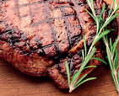
- 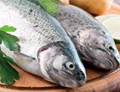
2. pasta
- 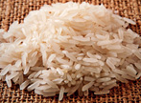
- 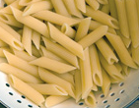
3. eggs
- 
- 
4. vegetables
- 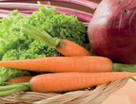
5. bread
- 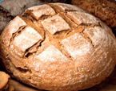
6. cereal
- 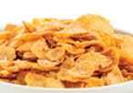
7. rice
8. butter
- 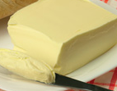
- 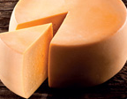
9. sugar
- 
- 
10. a sandwich
- 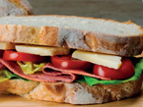
11. yogurt
12. chocolate

Food and drink: Activity 2
Look, read and choose. Listen and check.
1. What's this?  - It's tea.  - It's coffee. | 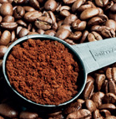
2. What's this?  - It's milk.  - It's yogurt. | 
3. What's this?  - It's tea.  - It's orange juice. | 
4. What's this?  - It's milk.  - It's water. | 
5. What's this?  - It's orange juice.  - It's tea. | 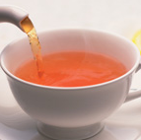

Food and drink: Activity 3
Listen and read. Match the pictures to the correct food.
 |  | 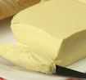
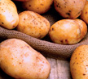 | 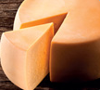 | 

/dʒ/ and /g/
Listen to the conversations. Choose the correct answer.
 | 

What's your favorite meal? Activity 1
Listen to six speakers talking about food. Match the speakers with the meals.

1 ___
2 ___
3 ___
4 ___
5 ___
6 ___
a a traditional breakfast
b a healthy breakfast
c lunch at work
d lunch in a restaurant
e a big dinner
f food from other countries

What's your favorite meal? Activity 2
Listen again and complete the conversations.
1. A What’s your favorite meal of the day, Anna?
B Um, I prefer _________ .
A Really? What do you have for breakfast?
B I have _________ and some fruit, and I drink green _________ .
2. A Which meal do you prefer, Luca?
B I like _________ , because I have it at home with my family.
A What do you have?
B We have meat or _________ with potatoes, pasta or rice, and some _________ . We eat a lot!
3. A Isabelle, what do you have for _________ ?
B I usually go to a restaurant with my friends from work. We don’t have much. Just soup or maybe a _________ .
4. A Do you go out for _________ , Keiko?
B No. I don’t have a lot of time for lunch. I just have a _________ and a coffee at my computer.
5. A What’s your favorite _________ of the week?
B Dinner on Friday night. Our children go to my mother’s house. Then my husband and I go out to a _________ , maybe Japanese, Italian, Mexican – we always have something different.
6. A Sarah, what do you have for _________ ?
B During the week, I have coffee and _________ .
A And on the weekend?
B On Sundays, I have a typical American breakfast with my family: _________ ,meat, pancakes, and coffee. It’s great!

Writing 3
Write an online comment about your dinner.
Make notes to answer the questions below. Add more information to make your comment interesting.  - Is dinner important for you?  - What do you have?  - Where do you have it?  - Who do you have it with?  - Is it healthy?  Write about 50 words. | Writing here …

