Present continuous or simple present? Activity 1
Read Grammar bank 9B. Choose the correct form. Listen and check.
Grammar bank
9B present continuous or simple present?
1 I work in an office. I usually wear a suit.
2 Today I’m working at home. I’m wearing jeans.
1 We use the simple present for things we usually do.
We often use the simple present with always, usually, sometimes, never, e.g., I sometimes have lunch in my office. I never get up early on Saturday.
2 We use the present continuous for things happening now / at the moment / today.
Jane’s in the kitchen. She’s cooking.
A What are you doing here? B I’m waiting for a friend

1. A Hi, Sue. Where are you? In the office?
B No, I work / I'm working at home today.
2. A Do you do / Are you doing your homework?
B I don't have any homework today. I play / I'm playing a video game.
3. My wife is a nurse. She works / She’s working in a children's hospital.
4. We're on vacation in Hawaii. We're staying / We stay in a nice little hotel.
5. A Hi. Can you talk or do you drive / are you driving?
B I don't drive / I'm not driving, but I can't talk now. I have / I'm having lunch with my boss.
6. It always rains / is raining a lot here in the winter.
7. I usually have / am having toast for breakfast, but today I'm having / I have cereal.

Present continuous or simple present? Activity 2
Read Grammar bank 9B. Complete the sentences with the verb in (parentheses). Use the simple present or present continuous. Use contractions. Listen and check.

1 Oh no. It__________ and I don't have my umbrella. (rain)
2 My father and I __________ dinner together every week. (have)
3 Louisa and Carlos are on vacation this week. They__________ in Yellowstone Park. (camp)
4 A Hi, Sam. __________ you __________ the soccer game on TV? (watch)
B No, I__________ my French homework. (do)
5 I always __________ late, and I never __________ time for breakfast. (get up, have)
6 My sister __________ in Thailand at the moment. (travel)
7 A What time __________ you usually __________ to bed? (go)
B At about 11:30.
8 Look! That's my brother over there. Can you see him? He__________ a blue hat. (wear)
9 A Hello, Nick. Where __________ you __________ ? (go)
B To the gym. I always __________ on Tuesdays. (go)

Clothes: Activity 1
Listen, read and choose.
1. sweater
- 
- 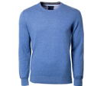
2. T-shirt
- 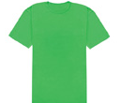
3. shirt
- 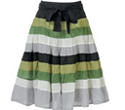
4. pants
- 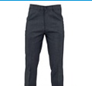
- 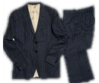
5. jeans
- 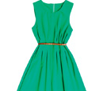
- 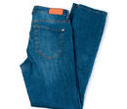
6. suit
- 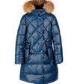
7. dress
8. skirt
9. coat
10. shorts
- 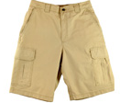

Clothes: Activity 2
Listen and read. Match the photos to the correct words.

 | 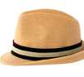 | 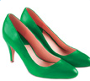
 | 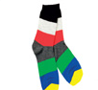 | 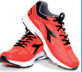

/ər/
Listen and read. Then say and record.
1.bird
2.shirt
3.skirt
4.T-shirt
5.serve
6.work

Where were you?: Activity 1
Listen to the conversations. Choose the correct answer.
- A famous person was at the ______ .
  - supermarket
  - gym
- The woman was on vacation ______ .
  - in the mountains
  - at the beach
- James was ______ yesterday.
  - at school
  - at the movie theater
- The man was in Paris ______.
  - for work

Where were you?: Activity 2
Listen again and complete the text.
1
A Tracy, ________ ________ this picture on my phone.
B Wow, that’s a ________ ________ star, right?
A Yeah. He was at the supermarket this ________ .
B Too bad. I was ________ the ________ this afternoon.
A I guess I’m lucky! He ________ very nice and friendly.
2
A How was your ________ ?
B Terrible! First, we were ________ the ________ for twelve hours!
A Oh, no.
B Our ________ was terrible too, and the beach wasn’t ________ .The restaurant ________ bad, too.
A I’m sorry to ________ that.
B Yeah. And the weather was ________ and windy every day.
3
A Was James at school today?
B No, he wasn’t. And he wasn’t in school yesterday.
A Oh. Maybe he’s sick.
B But he was at the ________ ________ yesterday evening.
A Hmm. That’s strange…
4
A You weren’t at home last week. Where ________ you?
B I ________ in Paris.
A Paris! Wow. How was it?
B It was great. The food was good, and the views were beautiful.
A How long was your vacation?
B Oh, actually, I wasn’t there on vacation. I was there ________ ________ .
Writing 4
Write an email to invite a friend to do something.
Think about what you want to do e.g., have lunch, come to a party, see a movie, go to a concert. Remember to say:  - what you want to do  - why you want your friend to come  - the time  - the place | Writing here …

