**Verb *be* (singular): *I* and *you*: Activity 1**

**1** Hello. I'm Maria. What's your name?  
**2** Hi. I'm Tony.  
**3** Hello. I'm your teacher. You're in my class. You're in room 4.  
**4** Hello. I'm your student. I'm in room 4.  
**5** I'm not Tom. I'm Tony.  
**6** You aren't in room 5. You're in room 4.  
**7** I'm not in room 6. I'm in room 7.  
**8** **A** Are you Sam?  
**B** Yes, I am.

**Verb *be* (singular): *I* and *you*: Activity 2**

1A  Am I in room 8?

1B  No, you aren't . You're in room 6.

2A  Are you in room 4?

2B  No, I 'm not . I'm in room 5.

3A  Are you Henry?

3B  Yes, I am . Nice to meet you!

4A  Am I in your class?

4B  Yes, you are . I 'm your teacher.

**Numbers 0-10**

1. 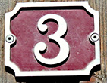
2. 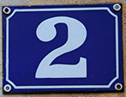
3. 
4. 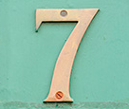
5. 
6. 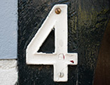
7. 
8. 
9. 
10. 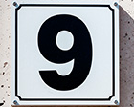

**Days of the week**

1. Monday
2. Tuesday
3. Wednesday
4. Thursday
5. Friday
6. Saturday
7. Sunday

**Saying goodbye**

**1 A** Goodbye.  
   **B** Bye, Alicia. See you on Friday.  
  
**2 A** Bye , Pedro.   
   **B**  Bye, Hayeun. See you tomorrow.  
  
**3 A**  Bye, Ahmed. See you on  Saturday .   
   **B**   Bye, Helen .

**/h/, /aɪ/, and /i/**

|  |  |  |  |
| --- | --- | --- | --- |
|  |  |  |  |
|  |  |  |  |
|  |  |  |  |

**At a party: Activity 1**

|  |  |
| --- | --- |
|  |  |
|  |  |
|  |  |

**At a party: Activity 2**

1. 917-555-6542
2. room five.
3. five dollars and twenty cents.
4. 23 Canal Street