**Verb *be* (singular): *he, she, it*: Activity 1**

1. It's
2. She's
3. It's
4. He's
5. It's
6. He's
7. She's
8. It's
9. He's

**Verb *be* (singular): *he, she, it*: Activity 2**

1.  **A** Where 's Osaka? is it in Japan?  
**B** Yes, it is .

2.  **A** is Mark from the US?  
**B** No, he 's from England.

3.  **A** Where 's she from?  
**B** She 's from Rio.

4.  **A** Is Ivan from Russia?  
**B** No, he isn't . He 's from Turkey.

5.  **A** is Bogota in Chile?  
**B** No, it isn't . It 's in Colombia.

6.  **A** is Ana from Mexico?  
**B** No, she isn't . She's from Peru.

**Countries: Activity 1**

|  |  |  |  |
| --- | --- | --- | --- |
|  |  |  |  |
|  |  |  |  |
|  |  |  |  |

**Countries: Activity 2**

1. 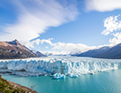
2. 
3. 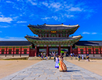
4. 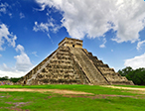
5. 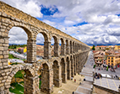
6. 
7. 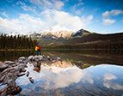
8. 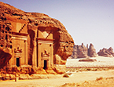

**/ɪ/, /oʊ/, /s/, and /ʃ/**

|  |  |  |  |
| --- | --- | --- | --- |
|  |  |  |  |
|  |  |  |  |
|  |  |  |  |

**Countries: Activity 2**

1. Mexico
2. Brazil
3. Peru
4. Korea
5. good
6. Vietnam
7. London
8. Spain

**Countries: Activity 1**

* Canada
* Saudi Arabia
* Atlanta
* Argentina
* Japan
* Spain