**Simple present [+] and [-]: *I, you, we, they*: Activity 1**

1. have
2. don't drink
3. like
4. eat
5. eat
6. don't have
7. don't like
8. eat

**Simple present [+] and [-]: *I, you, we, they*: Activity 2**

1.  **have**   
People in the US don't have a big lunch – they usually have a sandwich.  
We always have lunch with my family on Sundays.

2.  **eat**  
I don't eat meat. I’m a vegetarian.  
People eat a lot of fish and rice in Japan.

3.  **drink**  
You drink a lot of coffee! It isn’t good for you.  
They don't drink coffee. They only drink tea.

4.  **go**   
We don't go to restaurants. They’re very expensive.  
I don’t have breakfast at home. I go to a café.

**Food and drink: Activity 1**

1. 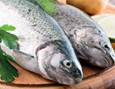
2. 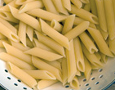
3. 
4. 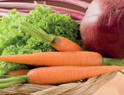
5. 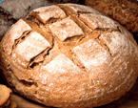
6. 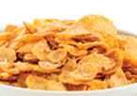
7. 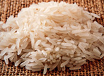
8. 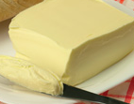
9. 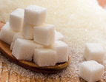
10. 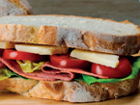
11. 
12. 

**Food and drink: Activity 2**

1. It's coffee.
2. It's milk.
3. It's orange juice.
4. It's water.
5. It's tea.

**Food and drink: Activity 3**

|  |  |  |  |
| --- | --- | --- | --- |
|  |  |  |  |
|  |  |  |  |
|  |  |  |  |

**/dʒ/ and /g/**

|  |  |  |  |
| --- | --- | --- | --- |
|  |  |  |  |
|  |  |  |  |
|  |  |  |  |

**What's your favorite meal? Activity 1**

1. b
2. e
3. d
4. c
5. f
6. a

**What's your favorite meal? Activity 2**

1.  **A**What’s your favorite meal of the day, Anna?  
**B**Um, I prefer breakfast .  
**A**Really? What do you have for breakfast?  
**B**I have yogurt and some fruit, and I drink green tea .

2.  **A**Which meal do you prefer, Luca?  
**B**I like dinner , because I have it at home with my family.  
**A**What do you have?  
**B**We have meat or fish with potatoes, pasta or rice, and some vegetables . We eat a lot!

3.  **A**Isabelle, what do you have for lunch ?  
**B**I usually go to a restaurant with my friends from work. We don’t have much. Just soup or maybe a salad .

4.  **A**Do you go out for lunch , Keiko?  
**B**No. I don’t have a lot of time for lunch. I just have a sandwich and a coffee at my computer.

5.  **A**What’s your favorite meal of the week?  
**B**Dinner on Friday night. Our children go to my mother’s house. Then my husband and I go out to a restaurant , maybe Japanese, Italian, Mexican – we always have something different.

6.  **A**Sarah, what do you have for breakfast ?  
**B**During the week, I have coffee and cereal .  
**A**And on the weekend?  
**B**On Sundays, I have a typical American breakfast with my family: eggs , meat, pancakes, and coffee. It’s great!