**Word order in questions: *be* and simple present: Activity 1**

1. What
2. How
3. What
4. Who
5. When
6. How
7. Where
8. Where

**Word order in questions: *be* and simple present: Activity 2**

1. Is
2. do
3. are
4. Are
5. do
6. Does
7. is
8. does
9. Do

**Common verb phrases 2: free time: Activity 1**

1. 
2. 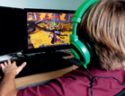
3. 
4. 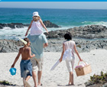
5. 
6. 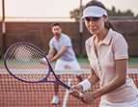

**Common verb phrases 2: free time: Activity 2**

1. hike
2. play
3. swim
4. meet
5. relax
6. travel

**/w/, /h/, /ɛr/, and /aʊ/**

|  |  |  |  |
| --- | --- | --- | --- |
|  |  |  |  |
|  |  |  |  |
|  |  |  |  |

**Tony's weekend: Activity 1**

* goes to a party
* takes a shower
* reads the newspaper
* dances

**Tony's weekend: Activity 2**

**A** Tony, what time do you get up on weekends?  
**B** I usually get up late – about ten o’clock or ten-thirty. I never get up early. After that, I always take a shower and have a big breakfast.  
**A** Do you have coffee or tea with breakfast?  
**B** Well, actually, I never drink coffee or tea. I usually have orange juice.  
**A** What do you do after breakfast?  
**B** I usually read the newspaper and listen to music.  
**A** Do you do housework?  
**B** Sometimes . But not usually.  
**A** What do you do in the afternoon?  
**B** Nothing special. I sometimes go to the gym.  
**A** What do you do in the evening?  
**B** I always go out with my friends. We usually go to a party and dance!