**Present continuous or simple present? Activity 1**

1.  **A** Hi, Sue. Where are you? In the office?  
**B** No, I'm working at home today.

2.  **A** Are you doing your homework?  
**B** I don't have any homework today. I'm playing a video game.

3.  My wife is a nurse. She works in a children's hospital.

4.  We're on vacation in Hawaii. We're staying in a nice little hotel.

5.  **A** Hi. Can you talk or are you driving?  
**B** I'm not driving, but I can't talk now. I'm having lunch with my boss.

6.  It always rains a lot here in the winter.

7.  I usually have toast for breakfast, but today I'm having cereal.

**Present continuous or simple present? Activity 2**

1. 's raining
2. have
3. 're camping
4. Are – watching- 'm doing
5. get up - have
6. is traveling
7. do – go
8. 's wearing
9. are – going- go

**Clothes: Activity 1**

1. 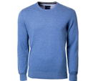
2. 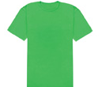
3. 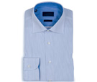
4. 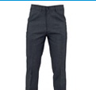
5. 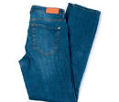
6. 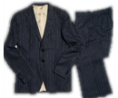
7. 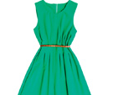
8. 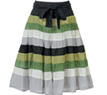
9. 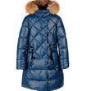
10. 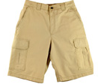

**Clothes: Activity 2**

|  |  |  |  |
| --- | --- | --- | --- |
|  |  |  |  |
|  |  |  |  |
|  |  |  |  |

**Where were you?: Activity 1**

1. gym
2. at the beach
3. at the movie theater
4. for work

**Where were you?: Activity 2**

1  
**A** Tracy, look at this picture on my phone.  
**B**Wow, that’s a famous movie star, right?  
**A** Yeah. He was at the supermarket this afternoon .  
**B**Too bad. I was at the gym this afternoon.  
**A** I guess I’m lucky! He was very nice and friendly.  
   
2  
**A** How was your vacation ?  
**B** Terrible! First, we were at the airport for twelve hours!  
**A** Oh, no.  
**B** Our hotel was terrible too, and the beach wasn’t clean . The restaurant was bad, too.  
**A** I’m sorry to hear that.  
**B** Yeah. And the weather was cold and windy every day.  
   
3  
**A** Was James at school today?  
**B** No, he wasn’t. And he wasn’t in school yesterday.  
**A** Oh. Maybe he’s sick.  
**B** But he was at the movie theater yesterday evening.  
**A** Hmm. That’s strange…  
   
4  
**A** You weren’t at home last week. Where were you?  
**B** I was in Paris.  
**A** Paris! Wow. How was it?  
**B** It was great. The food was good, and the views were beautiful.  
**A** How long was your vacation?  
**B** Oh, actually, I wasn’t there on vacation. I was there for work .