**Vocabulary: the alphabet**

Listen and read. Then say and record.

|  |  |
| --- | --- |
| 1.a, b, c, d, e |  |
| 2.f, g, h, i, j |  |
| 3.k, l, m, n, o |  |
| 4.p, q, r, s, t |  |
| 5.u, v, w |  |
| 6.x, y, z |  |

**Vocabulary: things in the classroom**

**Listen to the words in the box. Match the words to the highlighted objects in the classroom.   
Then listen and repeat.**

|  |
| --- |
| a dictionary a window the board a chair a laptop  the door a coat a table |

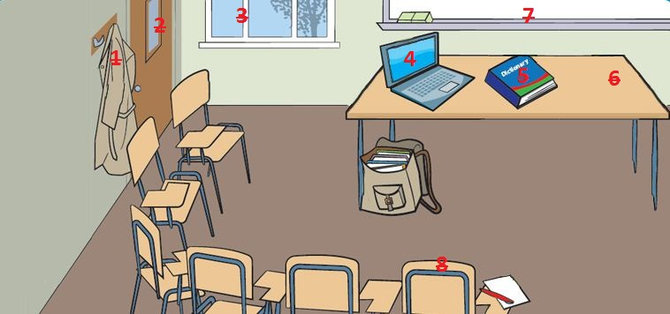

|  |  |
| --- | --- |
| 1. |  |
| 2. |  |
| 3. |  |
| 4. |  |
| 5. |  |
| 6. |  |
| 7. |  |
| 8. |  |

**Vocabulary: classroom language**

Listen and complete the sentences. Then listen and repeat.

|  |  |
| --- | --- |
| 1.  Look at the _________ , please. |  |
| 2.  _________ your books. |  |
| 3.  _________ to page 10. |  |
| 4.  _________ your books. |  |
| 5.  _________ up, please. |  |
| 6.  _________ down. |  |
| 7.  How do you _________ it? |  |
| 8.  Can you _________ that, please? |  |
| 9.  Excuse me. _________ *gracias* in English? |  |
| 10.  I don't _________ . |  |
| 11.  I _________ know. |  |
| 12.  Sorry I'm _________ . |  |

**Interactive video: Checking into a hotel**

Watch the video of Rob checking in to a hotel. Then record Rob's part of the conversation.

|  |  |
| --- | --- |
| **Rob:** Hello.  **Receptionist:** Good afternoon.  **Rob:** My name’s Rob Walker. I have a reservation.  **Receptionist:** Sorry, what’s your surname?  **Rob:** Walker.  **Receptionist:** How do you spell it?  **Rob:** W-A-L-K-E-R.  **Receptionist:** Sorry?  **Rob:** W-A-L-K-E-R.  **Receptionist:** Thank you. OK, Mr Walker. You’re in room 321.  **Rob:** Thanks. |  |

**Interactive video: Useful phrases**

Watch the Useful phrases. Then record yourself saying them.

|  |  |
| --- | --- |
| **Rob:** I have a reservation.  **Receptionist:** How do you spell it?  **Receptionist:** Sorry?  **Receptionist:** Thank you.  **Waiter:** Good morning.  **Waiter:** How can I help you?  **Jenny:** A table for tomorrow, please.  **Jenny:** That’s right. |  |