Superlative adjectives: Activity 1
Read Grammar Bank 10A. Then complete the sentences with superlatives of the adjectives in parentheses. Listen and check.
Grammar Bank
10A superlative adjectives
EXAMPLES
It's the oldest bridge in the world.
It's the most popular shopping mall in the US.
She's the best student in the class.
Monday is the worst day of the week.
FORM
- We use the + superlative adjective to say which is the (biggest, etc.) in a group.
- After superlatives we use in (not of) + places, e.g., the longest road in the world, the tallest building in New York.
SPELLING RULES
- one syllable adjectives: + -est or -st, e.g., old → the oldest, nice → the nicest.
- adjectives ending in one vowel + one consonant: double consonant + -est, e.g., big → the biggest, hot → the hottest.
- one- or two-syllable adjectives ending in consonant + y: change y to i + -est, e.g., dry → the driest, healthy → the healthiest.
- one-syllable adjectives ending in -ed: the most + adjective, e.g., bored → the most bored, stressed → the most stressed.
- two- or more-syllable adjectives: the most + adjective, e.g., famous → the most famous, expensive → the most expensive.
- irregular: good → the best; bad → the worst; far → the furthest/ the farthest.

1. Our house is _________ in the town. (big)
2. For me, Saturday is _________ day of the week. (good)
3. Tigers are _________ animals in the zoo. (dangerous)
4. July is _________ month in my country. (hot)
5. Ajda is _________ student in the class. (young)
6. _________ building in my city is the library. (beautiful)
7. My dad is _________ driver in my family. (bad)
8. Those are _________ flowers in the garden. (pretty)

Superlative adjectives: Activity 2
Read Grammar Bank 10A. Then use the words to write sentences. Listen and check.
Grammar Bank
10A superlative adjectives
EXAMPLES
It's the oldest bridge in the world.
It's the most popular shopping mall in the US.
She's the best student in the class.
Monday is the worst day of the week.
FORM
- We use the + superlative adjective to say which is the (biggest, etc.) in a group.
- After superlatives we use in (not of) + places, e.g., the longest road in the world, the tallest building in New York.
SPELLING RULES
- one syllable adjectives: + -est or -st, e.g., old → the oldest, nice → the nicest.
- adjectives ending in one vowel + one consonant: double consonant + -est, e.g., big → the biggest, hot → the hottest.
- one- or two-syllable adjectives ending in consonant + y: change y to i + -est, e.g., dry → the driest, healthy → the healthiest.
- one-syllable adjectives ending in -ed: the most + adjective, e.g., bored → the most bored, stressed → the most stressed.
- two- or more-syllable adjectives: the most + adjective, e.g., famous → the most famous, expensive → the most expensive.
- irregular: good → the best; bad → the worst; far → the furthest/ the farthest.

1. Everest / high mountain / world
__________________________________ .
2. The Mona Lisa / famous painting / world
__________________________________ .
3. The Amazon / long river / South America
__________________________________ .
4. The Louvre / popular museum / Europe
__________________________________ .
5. Shanghai / big city / China
__________________________________ .
6. Switzerland / expensive country / Europe
__________________________________ .
7. Antarctica / dry place / world
__________________________________ .
8. Lake Victoria / large lake / Africa
__________________________________ .

Places and buildings: Activity 1
Listen and read. Match the word to the correct picture.
1. a department store
- 
- 
- 
2. a police station
- 
- 
- 
3. a post office
- 
- 
4. a shopping mall
- 
- 
5. a town hall
6. a supermarket
7. an art gallery
8. a bus station
9. a parking lot
10. a train station

Places and buildings: Activity 2
Listen and read. Match the pictures to the correct places.
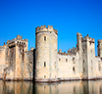 |  | 
 | 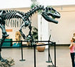 | 

Food and drink: Activity 3
Match the words to the correct pictures.
a street a river a bridge a zoo a park a square a church a road

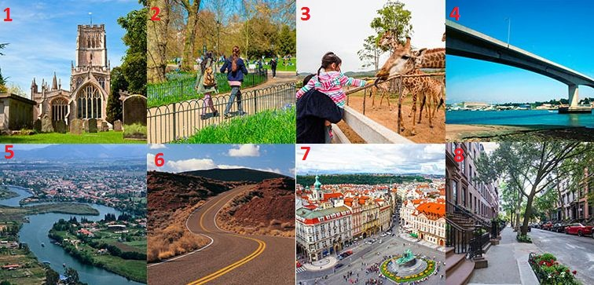
1. |  | 5.
2. |  | 6.
3. |  | 7.
4. |  | 8.

Consonant groups
Listen and write the words you hear. Then listen and repeat.
  - The _________ _________
  - The _________
  - The _________ _________
  - The _________
  - The _________ _________
  - The _________

Interview with a travel writer: Activity 1
Listen to a radio interview with a travel writer. Put the places in the order you hear them.
 | 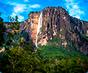 | 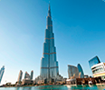
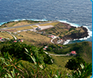 | 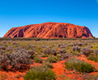 | 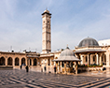

1.
2.
3.
4.
5.
6.

Interview with a travel writer: Activity 2
Listen again and complete the sentences. Write the numbers as numbers, not words.

1. Uluru is the __________ rock in the world.
2. The world's __________ waterfall is in Venezuela.
3. The tallest building in the world is __________ feet high.
4. The world's oldest city began in __________ BC.
5. The world's __________ train trip goes from Moscow to Vladivostock.
6. The shortest runway in the world is __________ feet long.

