Present perfect: Activity 1
﻿Read Grammar Bank 12A. Complete the sentences with the correct form of the present perfect. Listen and check.
Grammar Bank
12A present perfect
EXAMPLES
1 A Have you seen the new Matt Damon film?
B Yes, I have.
She hasn't read any books in English.
2 Have you ever read a Russian novel?
I've never worked in an office,
3 Have you finished the exercise?
Your parents have arrived. They're in the living room.
FORM
1 We use the present perfect when we talk or ask about events in the past, but when we don't say or ask when.
2 We often use the present perfect with ever (= at any time in your life) and never (= at no time in your life).
3 We also use the present perfect to talk about recent events, e.g., I've finished my homework.
- To make the present perfect we use have / has and the past participle of the verb.
- 's = has in present perfect.
- Past participles of regular verbs are the same as the simple past.
- Past participles of irregular verbs are sometimes the same as the simple past, e.g., read /red/ but sometimes different, e.g., seen.
Look at the list of irregular past participles on page 165 of the Student Book.

1. I 's seen / 've seen / hasn't seen this movie.
2. She hasn't read / haven't read / 've read the book.
3. You hasn't washed / 's washed / haven't washed the dishes.
4. We hasn't done / 's done / 've done the housework.
5. Have they gone / They've gone / Have gone they to the beach?
6. He haven't been / 's been / 've been sick.
7. They hasn't eaten / haven't eaten / 's eaten Egyptian food before.
8. She's broken / Has she broken / Has broken she her leg?

Present perfect: Activity 2
Read Grammar Bank 12A. Then complete the sentences with the present perfect form of the verbs. Use contractions. Listen and check.
Grammar Bank
12A present perfect
EXAMPLES
1 A Have you seen the new Matt Damon film?
B Yes, I have.
She hasn't read any books in English.
2 Have you ever read a Russian novel?
I've never worked in an office,
3 Have you finished the exercise?
Your parents have arrived. They're in the living room.
FORM
1 We use the present perfect when we talk or ask about events in the past, but when we don't say or ask when.
2 We often use the present perfect with ever (= at any time in your life) and never (= at no time in your life).
3 We also use the present perfect to talk about recent events, e.g., I've finished my homework.
- To make the present perfect we use have / has and the past participle of the verb.
- 's = has in present perfect.
- Past participles of regular verbs are the same as the simple past.
- Past participles of irregular verbs are sometimes the same as the simple past, e.g., read /red/ but sometimes different, e.g., seen.
Look at the list of irregular past participles on page 165 of the Student Book.

1. Yes, __________ a famous actor. (I / meet)
2. __________ his new shirt. (he / not wear)
3. __________ to your boss? (you / speak)
4. __________ their homework. (they / not do)
5. __________ in New York? (your sister / work)
6. __________ her book at home. ( she / leave)
7. __________ any photos. (we / not take)
8. __________ all the chocolate? (they / eat)

Irregular past participles
Complete the sentences with the past participle of the verbs in the list. Then listen and check.
buy fall give hear leave read see tell
1. I've never __________ Titanic.
2. Has Holly __________ you her news?
3. Eddie has __________ a new car.
4. Have you ever __________ in love?
5. My parents have __________ us their old sofa.
6. I'm surprised that you've never __________ of Thelonius Monk.
7. The train has __________ the station.
8. Don't give Beth that book – she's __________ it before.
Sentence stress
Read and listen. Then say and record.
1.Have you seen To Kill a Mockingbird?
2.No, I haven't.
3.Have you read the book?
4.Yes, I have.
5.I've read it three times.

From book to film: Activity 1
Listen to a radio interview about movie adaptations of books. Choose the correct answers.
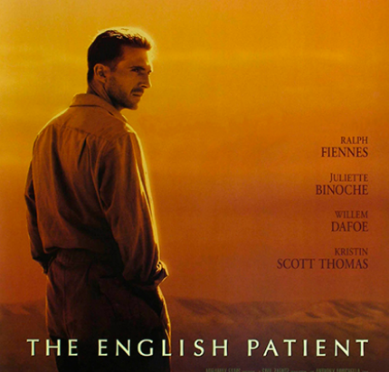
- The interview is about two ______ movie adaptations.
  - bad
  - new
  - good
- The first movie is ______ adaptation of Great Expectations.
  - a terrible
  - an early
  - a recent
- The second movie is ______ adaptation of The English Patient.
  - a more recent
  - an earlier
  - a really bad

From book to film: Activity 2
Listen to the interview again. Read the sentences and write T (true) or F (false).
1. The adaptation of Great Expectations is from 1956. ___
2. This adaptation is a black-and-white movie. ___
3. The main character in Great Expectations is a girl. ___
4. The movie is more frightening than the book. ___
5. The author of The English Patient isn't British. ___
6. The main character of The English Patient had a car crash. ___
7. The critic says the best thing about the movie is the love story. ___
8. Both the book and the movie won important prizes. ___

