Possessive adjectives: Activity 1
Read Grammar Bank 1C. Then complete the sentences with a possessive adjective or subject pronoun. Listen and check.

Grammar Bank
1C possessive adjectives

EXAMPLES
I’m Peruvian. My family is from Cusco.
You’re in Class 1. This is your classroom.
He’s the director. His name is Michael.
She’s your teacher. Her name is Tina.
It’s a language school. Its name is English House.
We’re an international Our students are from South
school. America and Asia.
They’re French students. Their names are Luc and Marie.
FORM
- We use possessive adjectives for people and things.
My family is from Peru. My car is Japanese.
- his = of a man, her = of a woman, its = of a thing.
- their = of people or things.
- Possessive adjectives don't change with plural nouns.
our students NOT ours students

Quick tips
it's or its?
Be careful with it's and its.
it's = it is It's a school. It's Spanish.
its = possessive Its name is English House. Its sign is red and yellow.

1. My name's Soraya. I'm in your / you class.
2. We’re Chinese. We / Our names are Zhang and Chen.
3. Peter is a teacher. He's / His from Canada.
4. I’m Maria. My / I last name is Gonzalez.
5. Is her / she Chinese?
6. How do you spell you / your last name, Keiko?
7. We're / Our in class 2.
8. That's my cat. Its / It's name is Daly.

Possessive adjectives: Activity 2
Read Grammar Bank 1C. Then complete the sentences with a possessive adjective. Listen and check.
Grammar Bank
1C possessive adjectives
EXAMPLES
I’m Peruvian. My family is from Cusco.
You’re in Class 1. This is your classroom.
He’s the director. His name is Michael.
She’s your teacher. Her name is Tina.
It’s a language school. Its name is English House.
We’re an international Our students are from South
school. America and Asia.
They’re French students. Their names are Luc and Marie.
FORM
- We use possessive adjectives for people and things.
My family is from Peru. My car is Japanese.
- his = of a man, her = of a woman, its = of a thing.
- their = of people or things.
- Possessive adjectives don't change with plural nouns.
our students NOT ours students

1. She's in my class. _____ name is Nook
2. We're from Japan. _____last name is Takano.
3. New York is famous for _____buildings.
4. I’m from Toronto. _____address is 31 Quincy Road.
5. Those students are from Brazil. _____names are Michael and Juliana.
6. Sit down and open _____books, please.
7. He's our teacher. _____name is Brad.
8. Hello. I'm Eunjoo. What's _____name?

Classroom language: Activity 1
Listen and read. Match the classroom language to the correct picture.
Quick Tips
Please
Use please at the beginning or end of a phrase to be polite.
Please come here. OR Come here, please.

- Read the text. |  | -   -   - 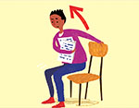
- Look at the board. |  | - 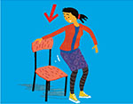  -   - 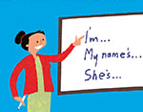
- Close the door. |  | -   -   - 
- Work in pairs. |  | - 
- Answer the questions. |  | - 
- Listen and repeat. |  | - 
- Stand up.
- Sit down.
- Turn off your phone.
- Open your books, please.
- Go to page 84.
- Do exercise a.

Classroom language: Activity 2

Match the pictures to the correct student phrases. Then listen and check.
1.  - How do you say gato in English?  - Can I have a copy, please?  - What page is it? | 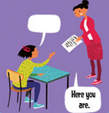
2.  - Sorry, can you repeat that, please?  - Can you help me, please?  - How do you spell it? | 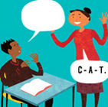
3.  - I don't know.  - Sorry I'm late.  - What page is it? | 
4.  - How do you say gato in English?  - Sorry, can you repeat that please?  - I don't understand. | 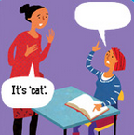
5.  - Can I have a copy, please?  - Can you help me, please?  - Sorry I'm late. | 
6.  - I don't understand.  - How do you spell it?  - What page is it? | 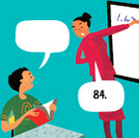
7.  - Can I have a copy, please?  - I don't know.  - Sorry, can you repeat that, please? | 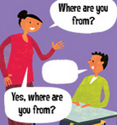
8.  - How do you spell it?  - How do you say gato in English?  - Sorry I'm late. | 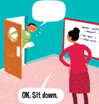

The alphabet
﻿Listen. Choose the letter that you hear. Then listen again and repeat.
1.
  - E
  - L

2.
  - J
  - G

3.
  - Q
  - K

4.
  - S
  - C

5.
  - V
  - B

6.
  - M
  - N

7.
  - V
  - W

8.
  - U
  - Y

/oʊ/, /u/, /ɑr/
Listen and read. Match the word to the correct sound. Then listen and repeat.
1. do
  - /oʊ/
  - /u/
  - /ɑr/
2. ar﻿e
  - /oʊ/
  - /u/
  - /ɑr/
3. go
  - /oʊ/
  - /u/
  - /ɑr/
4. two
  - /oʊ/
  - /u/
/ɑr/
5. close
  - /oʊ/
  - /u/
  - /ɑr/
6. Ar﻿gentina
  - /oʊ/
  - /u/
  - /ɑr/
7. Mexico
  - /oʊ/
  - /u/
  - /ɑr/
8. school
  - /oʊ/
  - /u/
  - /ɑr/
9. p﻿ar﻿tner
  - /oʊ/
  - /u/
  - /ɑr/

Can I help you? Activity 1
Listen and choose the correct answers.

  - They are in ______.
  - a language school
  - a hotel
  - The man is from ______.
  - Argentina
  - the US
  - His room number is ______.
  - 203
  - 503

Can I help you? Activity 2
Listen again and complete the form.
First name __________
Last name __________
Country __________
City Miami
Address __________ Atkinson Road
Zip code __________
Email address eriktaylor__________
Phone number 305-555-__________ .
Cell phone number 305-555-__________

Writing 1 - Completing a form
Read the online form. Correct the problems with capital letters.
About you
First name john
Last name (Family name) evans
Mr / Mrs / Ms mr
Date of birth 12 03 1987
Nationality american
Place of birth:
country usa
town / city new york
Address
48 main street
los angeles
california
Email address john.evans@mail.com

