Singular and plural nouns: Activity 1
Read Grammar Bank 2A. Then make the sentences plural. Use contractions. Listen and check.
Grammar Bank
2A singular and plural nouns
a/an, plurals
EXAMPLES
singular nouns plural nouns
It's a book. They're books.
It's a watch. They're watches.
It's a dictionary. They're dictionaries.
It's an umbrella. They're umbrellas.
It's an ID card. They're ID cards.
FORM
• We use a / an with singular nouns.
• We use an with a noun beginning with a vowel (a, e, i, o, u).
• We use a with nouns beginning with u or eu when the sound = /yu/, e.g. a university, a euro.
• We don't use a / an with plural nouns.
They're books. NOT They're a books.
regular plurals
Singular Plural Spelling
a book books add -s
a key keys
a watch watches add -es after ch, sh, s, x
a box boxes
a country countries consonant + y > ies
a dictionary dictionaries
• We add -s (or -es or -ies) to make plural nouns.
It’s a pen. They’re pens.
• With two-word nouns, we add -s (or -es or -ies) to the second noun.
credit card, credit cards NOT credits cards

1. It's a photo. __________________ .
2. It's a watch. __________________ .
3. It's a city. __________________ .
4. It's an address. __________________ .
5. She's a teacher. __________________ .
6. It's a university. __________________ .
7. It's a change purse. __________________ .
8. He's a student. __________________ .

Singular and plural nouns: Activity 2
Read Grammar Bank 2A. Then choose the correct noun forms. Listen and check.
Grammar Bank
2A irregular plurals
singular plural
a man /mæn/ men /mɛn/
a woman /ˈwʊmən/ women /ˈwɪmən/
a child /tʃaɪld/ children /ˈtʃɪldrən/
a person /ˈpərsn/ people /ˈpipl/

1. The child / children are at school.
2. One man / men is in a taxi.
3. The person / people are at the airport.
4. Two women / woman are at the restaurant.
5. A person / people is in my hotel room.
6. Three man / men are in the museum.
7. A children / child is under the desk.
8. The woman / women is from Turkey.

Things: Activity 1
Listen and read. Match the word to the correct picture.
1. a lamp
- 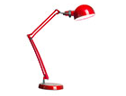
- 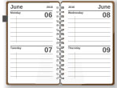
- 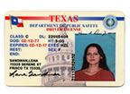
2. a coin
- 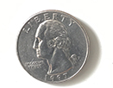
- 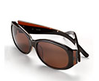
- 
3. an umbrella
- 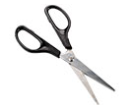
- 
- 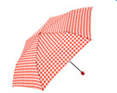
4. an ID card
- 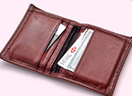
5. a pencil
- 
6. scissors
- 
7. a cal﻿endar
8. sunglasses
9. a laptop
10. a wallet
11. a piece of paper
12. a newspaper

Things: Activity 2
Listen to the words in the box. Match the words to the picture.
a tablet a notebook a pen a change purse a key a charger a credit card a ticket
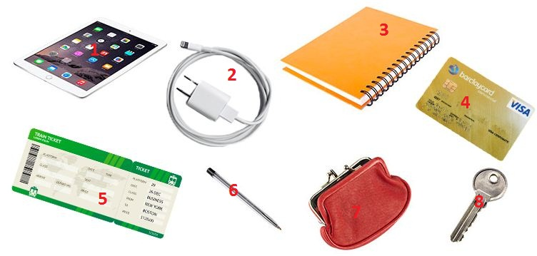
1. |  | 5.
2. |  | 6.
3. |  | 7.
4. |  | 8.
Things: Activity 3
﻿Look at the picture and complete the sentences with in, on, or under. Then listen and check.


- The headphones are ... the bag.
  - in
  - on
  - under
- The file is ... the desk.
  - in
  - on
  - under
- The phone is ... the chair.
  - in
  - on
  - under
- The tissues are ... the bag.
  - in
  - on
  - under
- The watch is ... the book.
  - in
  - on
  - under
- The photo is ... the desk.
  - in
  - on
  - under
- The magazine is ... the bag.
  - in
  - on
  - under

Final -s and -es
Read and listen. Then say and record.
1.bags |  | 6.laptops
2.watches |  | 7.boxes
3.chargers |  | 8.tickets
4.tablets |  | 9.sunglasses
5.pages |  | 10.umbrellas

What's in your bag? Activity 1
Listen to four speakers talking about the things in their bags. Check the speakers with books in their bags.
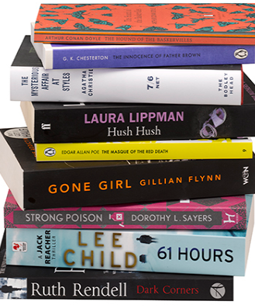
- Speaker 1
- Speaker 2
- Speaker 3
- Speaker 4

What's in your bag? Activity 2
Listen again. Match the sentences to the speakers. Write A-D.

Speaker 1 ___
Speaker2 ___
Speaker 3 ___
Speaker 4 ___
A has a book in his / her bag that helps him / her speak to people
B has something to listen to music
C changes bags every day
D has a computer in his / her bag

