Simple present (+/-)
﻿Read Grammar Bank 3A. Then make [+] or [–] simple present sentences with the verbs in parentheses. Use contractions. Listen and check.
Grammar Bank
3A ﻿simple present [+] and [–]
﻿EXAMPLES
I speak English.
Americans like fast food.
My mother cooks fantastic food.
I don't drink tea.
We don't live in a big city.
He doesn't play the guitar.
FORM
[+]
I / you / we / you / they work
he / she / it works
[–]
I / you / we / you / they don't work
he / she / it doesn't work
- We use the simple present for things that are generally true or are habits.
- Contractions: don't = do not, doesn't = does not.
- To make negatives we use don't / doesn't + verb (base form). He doesn't work. NOT He doesn't works.

1. (+) You __________ Arabic very well. (speak)
2. (-) I __________ games on my phone. (play)
3. (+) Julia __________ a new laptop. (need)
4. (-) We __________ to music in the car. (listen)
5. (-) My friend __________ fast food. (eat)
6. (+) Oliver __________ in an apartment. (live)
7. (+) They __________ housework on the weekend. (do)
8. (-) She __________ on Saturdays. (work)

Simple present - spelling
Read Grammar Bank 3A. Then complete the sentences with the correct form of the verbs in parentheses. Listen and check.
Grammar Bank
3A simple present spelling rules for he / she / it
I work / play / live. He works / plays / lives. add -s
I watch / finish. She watches / finishes. add -es after ch, sh, s, x
I study. She studies. consonant + y → ies
Be careful with some he / she / it forms.
I have he has /hæz/ NOT he haves
I go he goes /ɡoʊz/
I do he does /dʌz/

1. The class _________ at 7:30 p.m. (finish)
2. The store _________ very late. (close)
3. Marius _________ his room on Sunday mornings. (clean)
4. Leo _________ housework on the weekend. (do)
5. My teacher _________ tennis on Saturdays. (play)
6. Amy _________ to the movies on Wednesday evenings. (go)
7. Max _________ soccer on TV. (watch)
8. My friend _________ a big yard. (have)

Verb phrases: Activity 1
Listen to the verb phrases in the box. Match the verb phrases to the correct pictures.
live in an apartment take an umbrella like animals go to the movies
drink water wear glasses study history speak German
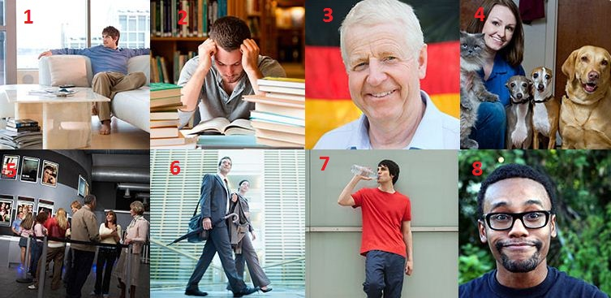
1. |  | 5.
2. |  | 6.
3. |  | 7.
4. |  | 8.

Verb phrases: Activity 2
Listen to the words in the box. Match the words to the picture.
 |  | 
 |  | 

Verb phrases: Activity 3
﻿Listen and read. Match the verb phrase to the correct picture.

1. listen to music
- 
- 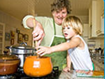
- 
2. play tennis
- 
- 
- 
3. do homework
- 
4. play the guitar
- 
- 
5. say sorry
- 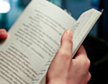
6. cook dinner
7. do yoga
8. drive a car
9. have a garden
10. read a book

Third person -s
Listen and read. Match the word to the correct sound. Then listen and repeat.
1.cooks  - /s/  - /z/  - /ɪz/ |  | 6. speaks  - /s/  - /z/  - /ɪz/
2.does  - /s/  - /z/  - /ɪz/ |  | 7. rains  - /s/  - /z/  - /ɪz/
3. closes  - /s/  - /z/  - /ɪz/ |  | 8. drinks  - /s/  - /z/  - /ɪz/
4. goes  - /s/  - /z/  - /ɪz/ |  | 9. watches  - /s/  - /z/  - /ɪz/
5. finishes  - /s/  - /z/  - /ɪz/ |  | 10. has  - /s/  - /z/  - /ɪz/

Things I love about South Korea: Activity 1
Read and listen. Choose the best heading for each paragraph 1-4.
Things I love about South Korea
Carly Hamilton is American, but she lives in Seoul, South Korea. Here are some things she loves about living there.
1 _________________________
In South Korea, the customer is really important. When you walk into a store, the salespeople greet you with a smile and say, “Hello.” As you shop, they ask you if you need help. If you can’t find something you want, the salespeople try to find it for you. They want you to be happy.
2 _________________________
I love restaurants that serve South Korean meat. It’s so delicious. The servers grill the meat, and then they cut it for you! They also serve banchan—little side dishes of vegetables. The servers are very busy in South Korean restaurants. They don’t talk as much as servers in the US, but they make sure that you have a great meal!
3 _________________________
There are so many places to shop in South Korea! People sell things like clothes and jewelry on the street. There are shopping booths in the subway stations, too! When I take the subway to work, I often buy a pretty bracelet or necklace because they’re so cheap. It’s really nice!
4 _________________________
The transportation system is great here! It’s easy to get around because there are signs, and a lot of them are in English! You can use your cell phone on the subway here, too. You can’t do that in the US!

- Paragraph 1
  - Shopping on the street.
  - We can find that for you.
  - Traveling is so easy!
  - Enjoy your dinner.
- Paragraph 2
  - Traveling is so easy!
  - Enjoy your dinner.
  - Shopping on the street.
  - We can find that for you.
- Paragraph 3
  - Traveling is so easy!
  - Enjoy your dinner.
  - Shopping on the street.
  - We can find that for you.
- Paragraph 4
  - We can find that for you.
  - Enjoy your dinner.
  - Traveling is so easy!
  - Shopping on the street.

Things I love about South Korea: Activity 2
Read the text again and choose true or false.

Things I love about South Korea
Carly Hamilton is American, but she lives in Seoul, South Korea. Here are some things she loves about living there.
1 We can find that for you
In South Korea, the customer is really important. When you walk into a store, the salespeople greet you with a smile and say, “Hello.” As you shop, they ask you if you need help. If you can’t find something you want, the salespeople try to find it for you. They want you to be happy.
2 Enjoy your dinner
I love restaurants that serve South Korean meat. It’s so delicious. The servers grill the meat, and then they cut it for you! They also serve banchan—little side dishes of vegetables. The servers are very busy in South Korean restaurants. They don’t talk as much as servers in the US, but they make sure that you have a great meal!
3 Shopping on the street
There are so many places to shop in South Korea! People sell things like clothes and jewelry on the street. There are shopping booths in the subway stations, too! When I take the subway to work, I often buy a pretty bracelet or necklace because they’re so cheap. It’s really nice!
4 Traveling is so easy!
The transportation system is great here! It’s easy to get around because there are signs, and a lot of them are in English! You can use your cell phone on the subway here, too. You can’t do that in the US!

- In South Korea, salespeople want the customer to be happy.
  - True
  - False
- Restaurants in South Korea are not busy.
  - True
  - False
- You can buy a shirt and earrings on the street in South Korea.
  - True
  - False
- Transportation in Seoul is very good.
  - True
  - False

