Possessive 's, Whose...? Activity 1
﻿Read Grammar Bank 4A. Then complete the sentences with the correct possessive phrases.Listen and check.
Grammar Bank
4A possessive 's, Whose ...?
﻿EXAMPLES
1 He's Brad Pitt's brother. It's James's laptop.
2 It's my parents' car.
3 "Whose is this bag?" "It's Maria's."
4 The end of the movie is fantastic. I live near the city park.
FORM
1 We use a person + 's to talk about family and possessions.
He's Brad Pitt's brother. NOT He's the brother of Brad Pitt.
2 With regular plural nouns we put the ' after the s.
It's my parents' car. NOT It's my parent's car.
- With irregular plural nouns, e.g. children, men, we use 's, e.g., the children's room, men's clothes.
3 We use Whose ...? to ask about possession.
We can ask Whose is this bag? OR Whose bag is this?
We can answer It's Maria's bag. OR It's Maria's.
4 We don't usually use a thing + 's, e.g., the end of the class NOT the class's end, the city park NOT the city's park.

1. It's my mother's birthday / mothers' birthday .
2. That's her parent's house / parents' house .
3. These are childrens' books / children's books .
4. Whose / Who's phone is this?
5. Those are the student's desks / the students' desks .
6. That's Annes' bag / Anne's bag .
7. Who's / Whose Kevin's girlfriend?
8. Those are women's sunglasses / womens' sunglasses .

Possessive 's, Whose...? Activity 2
Read Grammar Bank 4A. Complete the sentences. Use 's or s' with the person / people in parentheses, and the bold word. Listen and check.
Grammar Bank
4A possessive 's, Whose ...?
﻿EXAMPLES
1 He's Brad Pitt's brother. It's James's laptop.
2 It's my parents' car.
3 "Whose is this bag?" "It's Maria's".
4 The end of the movie is fantastic. I live near the city park.
FORM
1 We use a person + 's to talk about family and possessions.
He's Brad Pitt's brother. NOT He's the brother of Brad Pitt.
2 With regular plural nouns we put the ' after the s.
It's my parents' car. NOT It's my parent's car.
- With irregular plural nouns, e.g., children, men, we use 's, e.g., the children's room, men's clothes.
3 We use Whose ...? to ask about possession.
We can ask Whose is this bag? OR Whose bag is this?
We can answer It's Maria's bag. OR It's Maria's.
4 We don't usually use a thing + 's, e.g., the end of the class NOT the class's end, the city park NOT the city's park.

1. "Whose wallet is that?" "It's _______________ ." (my brother)
2. "Whose keys are those?" "They're _______________ ." (Tina)
3. "Which room is this?" "It's the _______________ ." (teachers)
4. "Whose headphones are those?" "They're _______________ ." (my girlfriend)
5. "What kind of book is this?" "It's a _______________ ." (children)
6. "Whose bags are those?" "They're _______________ ." (my friends)
7. "Which jackets are those?" "They're the _______________ ." (children)
8. "Whose car is that?" "It's _______________ ." (my grandparents)

Family: Activity 1
Look at the family tree and choose the correct answers. Listen and check.
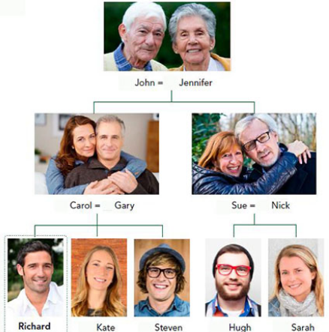

- Kate is Richard's ______ .
  - aunt
  - sister
  - mother
- Nick is Richard's ______ .
  - uncle
  - father
  - brother
- Jennifer is Richard's ______ .
  - aunt
  - grandmother
  - mother
- Hugh is Richard's ______ .
  - brother
  - uncle
  - cousin
- Carol is Richard's ______ .
  - mother
  - sister
  - aunt
- John is Richard's ______ .
  - uncle
  - grandfather
  - father
- Steven is Richard's ______ .
  - brother
  - uncle
  - father
- Sue is Richard's ______ .
  - aunt
  - mother
  - sister
- Gary is Richard's ______ .
  - uncle
  - father
  - brother

Family: Activity 2
Look at the family trees for Richard and his sister Kate. Choose the correct answers. Listen and check.

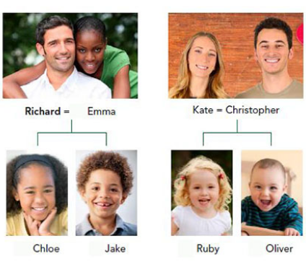
- Emma is Richard's ______ .
  - daughter
  - wife
  - niece
- Oliver is Richard's ______ .
  - niece
  - nephew
  - son
- Chloe is Richard's ______ .
  - wife
  - niece
  - daughter
- Christopher is Richard's ______ .
  - stepbrother
  - husband
  - brother-in-law
- Ruby is Richard's ______ .
  - daughter
  - cousin
  - niece
- Jake is Richard's ______ .
  - nephew
  - son
  - husband

Family: Activity 3
﻿ Complete the sentences with the correct family words. Listen and check.
mother-in-law parents-in-law children partner
grandparents parents stepfather stepmother
sister-in-law couple

1. My father and my mother are my __________________ .
2. My wife's mother and father are my __________________ .
3. My grandfather and my grandmother are my __________________ .
4. My son and my daughter are my __________________ .
5. A husband and wife are a __________________ .
6. My wife's mother is my __________________ .
7. My husband's sister is my __________________ .
8. My mother's new husband is my __________________ .
9. My father's new wife is my __________________ .
10. The person I'm in a relationship with is my __________________ .

/ʌ/, the letter o
Listen and read. Then match the word to the correct sound. Listen and repeat.

1. come
  - /ɑ/
  - /oʊ/
  - /ʌ/
  - /u/
2. do
  - /ɑ/
  - /oʊ/
  - /ʌ/
  - /u/
3. doctor
  - /ɑ/
  - /oʊ/
  - /ʌ/
  - /u/
4. don't
  - /ɑ/
  - /oʊ/
  - /ʌ/
  - /u/
5. go
  - /ɑ/
  - /oʊ/
  - /ʌ/
  - /u/
6. job
  - /ɑ/
  - /oʊ/
  - /ʌ/
  - /u/
7. money
  - /ɑ/
  - /oʊ/
  - /ʌ/
  - /u/
8. who
  - /ɑ/
  - /oʊ/
  - /ʌ/
  - /u/
9. model
  - /ɑ/
  - /oʊ/
  - /ʌ/
  - /u/
10. home
  - /ɑ/
  - /oʊ/
  - /ʌ/
  - /u/
11. one
  - /ɑ/
  - /oʊ/
  - /ʌ/
  - /u/
12. boot
  - /ɑ/
  - /oʊ/
  - /ʌ/
  - /u/

Who's that? Activity 1
Listen to Jessie showing photos to her friend.

- How many photos does she show her friend?
  - 6
  - 3
  - 2
  - 4

Who's that? Activity 2
Listen again and choose True or False.

- Jessie's sister has a son.
  - True
  - False
- Jessie's sister is short.
  - True
  - False
- Jessie's sister plays basketball.
  - True
  - False
- The beach in the photo is in Canada.
  - True
  - False
- Jessie went to a music festival with her sister.
  - True
  - False
- Rosie has blond hair.
  - True
  - False
- Rosie sees her boyfriend all the time.
  - True
  - False
- Pete is Jessie's boss.
  - True
  - False

