Prepositions - time
﻿Read Grammar Bank 4B. Then complete the sentences with the correct prepositions of time. Listen and check.
Grammar Bank
4B prepositions of time (at, in, on)
EXAMPLES
in on at
the morning Monday (morning) three o'clock
the afternoon January 1 noon / midnight
the evening the weekend lunchtime
the summer night
December
2018
FORM
- We use in for parts of the day, seasons, months, and years.
- We use on for days, dates, and the weekend.
- We use at for times of the day and night.

1. My father works on / in / at the weekend.
2. Bye! See you on / in / at Monday.
3. It's cold on / in / at night.
4. My birthday is on / in / at September.
5. He starts his new job on / in / at March 1st.
6. We have English classes on / in / at Tuesday mornings.
7. They watch TV on / in / at the evening.
8. The museum closes on / in / at 5:30.

Prepositions - place
﻿ ﻿Read Grammar Bank 4B. Then complete the sentences with at, in or to. Listen and check.
Grammar Bank
4B prepositions of place and movement
EXAMPLES
1 He has lunch at work.
He works in an office.
2 He goes to work at 8:00.
FORM
1 We use at and in for place.
- We use at + work, home, school.
- We use in + other places, e.g., a house, an office, a room, etc.
- We can use in or at with some public places, e.g., a restaurant, the movies, etc.
On Saturdays he usually has lunch in / at a restaurant.
2 We use to for movement or direction.
She goes to the gym. NOT She goes at the gym.
We don't use to before home.
go home NOT go to home

1. They live ____ an old house.
2. It's a beautiful day. Let's go ____ the beach.
3. Sorry, John isn't here. He's ____ work.
4. Beth isn't ____ home. She's on vacation.
5. The children go ____ school by bus.
6. She works ____ an office.
7. We go ____ the movies on the weekend.
8. Do you drive ____ work or do you take the bus?

Daily routine: Activity 1
Match the pictures to the correct verb phrases. Then listen and check.
1.  - take a shower  - get dressed  - put on make-up | 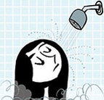
2.  - wake up at 7:00  - go to work by bus  - have a coffee | 
3.  - put on make-up  - get to work  - start work at 8:30 | 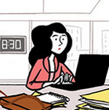
4.  - go to work by bus  - take a shower  - get dressed | 
5.  - get to work  - have a coffee  - wake up at 7:00 | 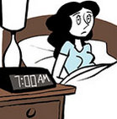
6.  - start work at 8:30  - take a shower  - put on make-up | 
7.  - have a coffee  - get dressed  - go to work by bus | 
8.  - start work at 8:30  - wake up at 7:00  - get to work | 

Daily routine: Activity 2
﻿ Listen to the verb phrases in the box. Match the phrases to the correct pictures.
have lunch at work have pizza for dinner check emails do housework
go shopping finish work at 6.30 go to bed get home late
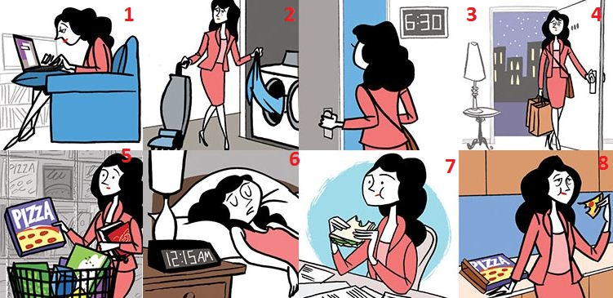

1. |  | 5.
2. |  | 6.
3. |  | 7.
4. |  | 8.
Daily routine: Activity 3

Listen and read. Match the verb phrase to the correct picture.

1. go to Spanish classes
- 
- 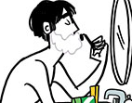
- 
2. get up at 8:00
- 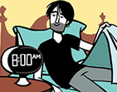
- 
- 
3. have breakfast
- 
- 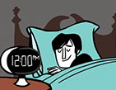
4. go home early
- 
- 
5. walk to work
- 
- 
6. relax
7. take the dog for a walk
8. sleep for eight hours
9. make dinner
10. take a bath
11. shave
12. see friends

Linking
Read and listen.Then say and record. Try to link the connected words.
1.I get_up_at seven.
2.I take_a shower.
3.I go to work.
4.I have_a sandwich for lunch.
5.I get home_at six.
6.I go to bed_at ten.
7.What_a life!

Valeria's day: Activity 1
Listen to Valeria talking about her week. Choose the correct answer.
- Valeria is ______.
- a teacher
- an administrator
- a model
2. Valeria makes breakfast for her family ______.
- on vacation
- on weekdays
- on weekends
3. On the weekend, Valeria ______.
- goes to work
- learns English
- makes breakfast for her family

Valeria's day: Activity 2
Listen again to Valeria talking about her week. Complete the gaps with a word, a number, or a time, e.g., 2:00.
Morning
She gets up at _____ .
She starts work at _____ .
Afternoon
She has coffee at _____ .
She finishes work at _____ and gets home around _____ .
Weekends
Valeria and her husband don't _____ on the weekends.
She usually gets up around _____ .
Her husband _____ breakfast for the family.
She goes English class on _____ at 4:00.
She goes to bed at _____ at night but doesn't go to sleep until about 11:00.

Writing 3 - An article
Write an article called My Typical Monday.
Make notes to answer the questions below. Add more information to make the article interesting.  - What's your favorite or least favorite thing about Mondays?  - What do you usually do in the morning?  - Where do you usually have lunch? Who with? What do you do after lunch?  - What do you usually do in the evening?  Write four paragraphs. | Writing here …

