can / can't (+/-)
Read Grammar Bank 5A. Then complete the sentences with can or can't and a verb from the list. Listen and check.
Grammar Bank
5A can / can't
EXAMPLES
1 I can sing, but I can't dance.
2 I can come on Tuesday, but I can't come on Wednesday.
3 You can park here. You can't park there.
4 Can you help me? Can I open the window?
FORM
- can + base form has different meanings:
1 I can (sing) = I know how to.
I can't (dance) = I don't know how to.
2 I can (come) = It's possible for me.
I can't (come) = It isn't possible for me.
3 You can (park here) = It's OK. / It's permitted.
You can't (park there) = It isn't OK. / It isn't permitted.
4 Can you (help me)? = Please do it.
Can I (open the window)? = Is it OK if I do it?
- can and can't are the same for all persons (I, you, he, etc.).
NOT He cans.
- Contraction: can't = cannot.
- We don't use to after can.
I can swim. NOT I can to swim.

come go meet park play speak swim take
1. She __________ Chinese, but not Japanese.
2. The road is closed. We __________ that way.
3. My boyfriend likes music, but he __________ the guitar.
4. The hotel has a parking lot. We __________ there.
5. We __________ to your party. We're on vacation that week.
6. I'm free tomorrow. I __________ you after work.
7. It says "No cameras". We __________ photos here.
8. The beach has a green flag today. We __________ in the ocean today.
can / can't (?)
Read Grammar Bank 5A. Then rewrite the questions with can or can't. Listen and check.
Grammar Bank
5A can / can't
EXAMPLES
1 I can sing, but I can't dance.
2 I can come on Tuesday, but I can't come on Wednesday.
3 You can park here. You can't park there.
4 Can you help me? Can I open the window?
FORM
- can + base form has different meanings:
1 I can (sing) = I know how to.
I can't (dance) = I don't know how to.
2 I can (come) = It's possible for me.
I can't (come) = It isn't possible for me.
3 You can (park here) = It's OK. / It's permitted.
You can't (park there) = It isn't OK. / It isn't permitted.
4 Can you (help me)? = Please do it.
Can I (open the window)? = Is it OK if I do it?
- can and can't are the same for all persons (I, you, he, etc.).
NOT He cans.
- Contraction: can't = cannot.
- We don't use to after can.
I can swim. NOT I can to swim.

Is it OK if I close the window. __________ the window?
2. Does she know how to play tennis? __________ tennis?
3. Is it OK if I use your phone? __________ your phone?
4. Is it possible to call me later? __________ me later?
5. Is it OK if I open the door? __________ the door?
6. Are we permitted to take photos here? __________ photos here?
7. Does he know how to drive a bus? __________ a bus?
8. Is it possible for you to come tomorrow? __________ tomorrow?

Verb phrases: Activity 1
Listen and read. Match the pictures to the correct verb phrases.
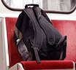 |  | 
 |  | 

Verb phrases: Activity 2
Listen and read. Match the verb phrase to the correct picture.

1. try to do something difficult
- 
- 
- 
2. find a parking space
- 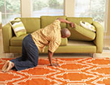
- 
- 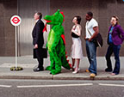
3. talk to a friend
- 
- 
- 
4. send a text message
- 
5. look for your keys
- 
6. swim in the ocean
7. tell somebody a secret
8. wait for a bus
9. forget somebody's name
10. use the internet
11. dance the tango

Verb phrases: Activity 3
﻿ Listen to the verb phrases in the box. Match the verb phrases to the correct pictures.
met a friend buy a newspaper sing a song call a taxi hear a noise
see a movie run a race paint a picture
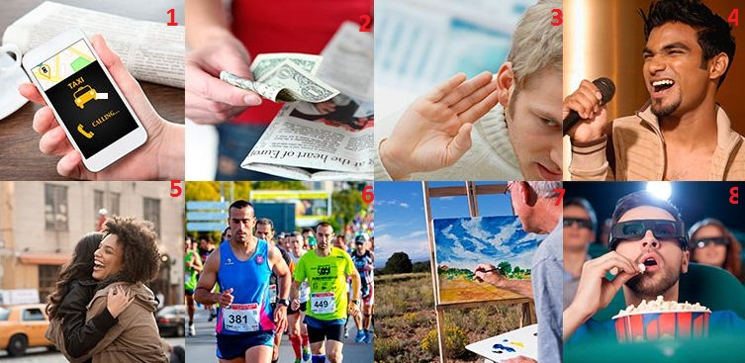

1. |  | 5.
2. |  | 6.
3. |  | 7.
4. |  | 8.

Sentence stress
Listen and choose the sentence you hear.

1.
  - I can sing.
  - I can't sing.
2.
  - She can dance very well.
  - She can't dance very well.
3.
  - He can cook.
  - He can't cook.
4.
  - I can come to the meeting.
  - I can't come to the meeting.
5.
  - You can park here.
  - You can't park here.
6.
  - I can drive.
  - I can't drive.

Let's go swimming: Activity 1
Listen to five conversations. Choose the correct answers.

1. Who's speaking?
  - A mother and daughter.
  - Two friends.

2. Where are they?
  - In the street.
  - At home.

3. Where are they?
  - At home.
  - At school.

4. Who's speaking?
  - A husband and wife.
  - A shop assistant and a customer.
5. Where are they?
  - Outside the movie theater.
  - Outside the office.

Let's go swimming: Activity 2
﻿Listen again and choose the correct answers.

  - They can go to the swimming pool on _____.
  - Saturday morning
  - Sunday afternoon
  - Saturday afternoon

  - The man can park outside _____.
  - the restaurant
  - the hospital
  - the movie theater

  - She can help her brother _____.
  - this evening
  - this afternoon
  - this morning

  - They don't have _____, so they can't send the postcard.
  - a stamp
  - the address
  - a pen

  - They can't go in because she _____.
  - can't open the door
  - can't find his keys
  - can hear his parents

