Simple past: irregular verbs: Activity 1
﻿Read Grammar Bank 7C. Then complete the sentences with the simple past form of the verbs. Listen and check.
Grammar Bank
7C simple past: irregular verbs
EXAMPLES
I went to Iceland in December. I didn't go to New York.
Did you go to a party? Who did you go with?
FORM
- Some verbs are irregular in the past [+] and change their form, e.g., go → went, have → had.
- We only use the irregular past form in [+] sentences.
I bought a bag last night.
- We use the base form after did / didn't.
Did you go out last night? NOT Did you went ...?
- Remember the word order in questions: auxiliary, subject, base form, e.g., Did you go out last night? or question word, auxiliary, subject, base form, e.g., Where did you go?
Look at the list of irregular verbs on page 165 of the Student Book.

1. Our train _______ the station at 7:30. (leave)
2. He _______ jeans last night. (wear)
3. I _______ my friends at a restaurant. (meet)
4. We _______ a Shakespeare play. (see)
5. They _______ a lot of photos. (take)
6. She _______ read when she was four. (can)
7. I _______ my wallet last night. (lose)
8. We _______ tired after the walk. (feel)

Simple past: irregular verbs: Activity 2
﻿Read Grammar Bank 7C. Then complete the sentences with the past simple form of the verbs. Listen and check.
Grammar Bank
7C simple past: irregular verbs
EXAMPLES
I went to Iceland in December. I didn't go to New York.
Did you go to a party? Who did you go with?
FORM
- Some verbs are irregular in the past [+] and change their form, e.g., go → went, have → had.
- We only use the irregular past form in [+] sentences.
I bought a bag last night.
- We use the base form after did / didn't.
Did you go out last night? NOT Did you went ...?
- Remember the word order in questions: auxiliary, subject, base form, e.g., Did you go out last night? or question word, auxiliary, subject, base form, e.g., Where did you go?
Look at the list of irregular verbs on page 165 of the Student Book.

1. ________________ it was Sunday today. (I / think)
2. How many souvenirs ________________ ? (you / buy)
3. I was late because ________________ find my keys. (I / not can)
4. What ________________ about the flowers? (his wife / say)
5. Where ________________ the party? (they / have)
6. ________________ about my new car. (he / not know)
7. ________________ coffee when I was a child. (I / not drink)
8. She felt sick, so ________________ home early. (she / come)

go
﻿Listen and read. Match the verb phrase to the correct picture.
1. go shopping
- 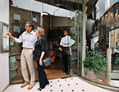
- 
- 
2. go by bus
- 
- 
- 
3. go to the beach
- 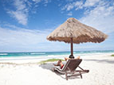
- 
4. go for a walk
- 
- 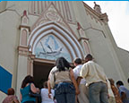
5. go on ﻿vacation
6. go to a restaurant
7. go back (to work)
- 
8. go home
9. go to bed (late)
10. go out (on a Friday night)
11. go to church

have
Listen to the verb phrases in the box. Match the verb phrases to the correct pictures.
have long hair have a good time have a sister have a car have breakfast
have a drink have a sandwich

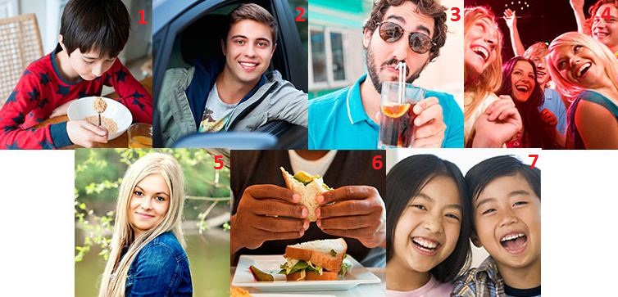
1.
2.
3.
4.
5.
6.
7.

get
Match the pictures to the correct verb phrases. Then listen and check.
1.  - get up  - get a taxi  - get dressed | 
2.  - get home  - get a newspaper  - get an email | 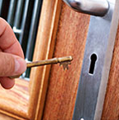
3.  - get dressed  - get a taxi  - get to the airport | 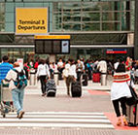
4.  - get home  - get an email  - get up | 
5.  - get dressed  - get a newspaper  - get to the airport | 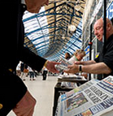
6.  - get up  - get a taxi  - get home | 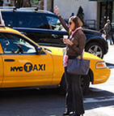
7.  - get to the airport  - get an email  - get a newspaper | 

Sentence stress
Listen and complete the sentences. Then listen and repeat.
1. When _________ _________ ?
2. Where _________ _________ ?
3. _________ were you _________ ?
4. Where did you _________ _________ ?
5. What _________ you _________ ?
6. _________ did you _________ ?
7. What _________ you _________ ?
8. _________ was the _________ like?
9. What time did you _________ _________ ?
10. Did you have a _________ _________ ?
A memorable night: Activity 1
Listen to an interview about a memorable night and answer the question.


  - What did Melissa do?
- she got home early with her friends
- she went to the beach with her friends
- she went to a concert with her friends

A memorable night: Activity 2
Listen again and answer the questions.
I = Interviewer, M = Melissa
I Can you tell us about a memorable night, Melissa?
M Well, let me see. There are a lot of them, actually. But yes, there was one particular night this year that was memorable.
I When was it?
M It was February 14th.
I Valentine’s Day?
M Yes. That’s why I remember the date. It was Valentine’s Day, but I didn’t have a boyfriend at the time. In fact, I was with two friends.
I Where were you?
M I was in Miami. There was a concert that night by my favorite singer, Drake, so I traveled to Miami to see it.
I When did you arrive in Miami?
M The night before the concert.
I So, what did you do before the concert?
M We had a coffee at an interesting coffee shop near the beach. Then we tried to find the concert. We didn’t know exactly where the theater was, so we drove around for a very long time. In the end, we got there five minutes before the concert started.
I Was the concert good?
M Yes, it was fantastic. Drake sang all our favorite songs, and we danced and sang for about two hours.
I Did you go home after the concert?
M No, we didn’t go home right away. We didn’t have dinner before it started, so we were hungry. We went to a fast-food restaurant and had a hamburger. It was delicious! After that, we drove home.
I What time did you get home?
M We didn’t get home that late. It was two o’clock in the morning, more or less. But we had a great time. That was the important thing.

  - When was it?
  - February 29th
  - February 14th
  - Who was Melissa with?
  - with her boyfriend
  - with two friends
  - Where were they?
  - Miami
  - the hotel
  - When did she arrive in the city?
  - The day of the concert.
  - The night before the concert.
  - Where did they have a coffee?
  - at the concert
  - at an interesting coffee shop near the beach
  - Did they have a good time? Why (not)?
  - No, the got lost.
  - Yes, the danced and sang.
  - What did they have for dinner?
  - seafood
  - a hamburger
  - What time did they get home?
  - ten o'clock at night
  - two o’clock in the morning

