Countable / uncountable nouns
Read Grammar Bank 9A. Then choose the correct answers. Listen and check.
Grammar Bank
9A countable / uncountable nouns
EXAMPLES
Countable
an apple three apples
Uncountable
rice meat
FORM
- English nouns can be countable and uncountable.
countable = things you can count, e.g., apples. Countable nouns can be singular (an apple) or plural (apples).
uncountable = things you can't count, e.g., rice, meat NOT two rices, three meats. Uncountable nouns are usually singular.
- Some nouns can be countable and uncountable, e.g., ice cream.
an ice cream = one ice cream in your hand
some ice cream = ice cream in a bowl

1. I like a butter / butter on my bread.
2. She usually has an egg / egg for breakfast.
3. Do you put a sugar / sugar in your coffee?
4. Would you like some candy / a candy ?
5. He often eats a sandwich / sandwich for lunch.
6. Do you want a toast / toast or cereal?
7. I had orange / an orange for dessert.
8. We always put cheese / a cheese on our pasta.

a / an, some / any
Read Grammar Bank 9A. Then complete the sentences with a, an, some or any. Listen and check.
Grammar Bank
9A a /an, some / any
EXAMPLES
countable uncountable
[+] We need an apple. some butter.
some apples.
[–] We don't need a tomato. any rice.
any tomatoes.
[?] Do we need an orange? any sugar?
any oranges?
FORM
- We use a / an with singular countable nouns. a / an = one.
- We use some in [+] with plural countable nouns and with uncountable nouns.
- We use any in [–] and [?] with plural countable nouns and with uncountable nouns.

1. Are there ____ onions?
2. We need ____ tomatoes.
3. There isn't ____ pasta.
4. I eat ____ apple every evening.
5. Would you like ____ banana?
6. There aren't ____ apples.
7. There are ____ carrots in the fridge.
8. Would you like ____ milk in your coffee?

Food and drink: Activity 1
Listen and read. Match the word to the correct picture.
1. sugar
- 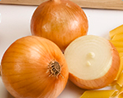
- 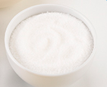
- 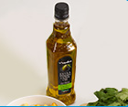
2. fish
- 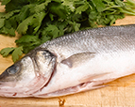
- 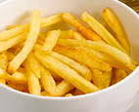
- 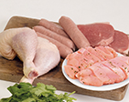
3. bananas
- 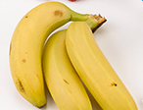
- 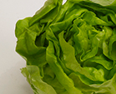
4. cheese
- 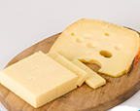
- 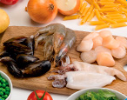
5. onions
6. meat
- 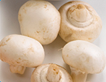
- 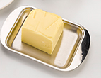
7. (olive) oil
8. French fries
9. lettuce
10. butter
11. seafood
12. mushrooms

Food and drink: Activity 2
Match the pictures to the correct words. Then listen and check.
1.  - cookies  - potato chips  - candy | 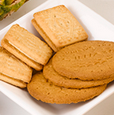
2.  - cereal  - toast  - bread | 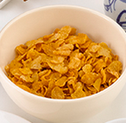
3.  - oranges  - strawberries  - apples | 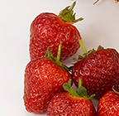
4.  - tea  - coffee  - (orange) juice | 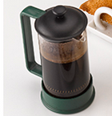
5.  - peppers  - peas  - carrots | 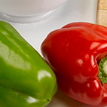
6.  - cake  - fruit salad  - ice cream | 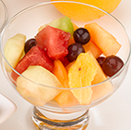
7.  - spices  - herbs  - nuts | 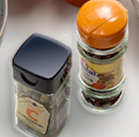
8.  - pasta  - salad  - rice | 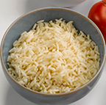

Food and drink: Activity 3
Listen to the words in the box. Match the words to the correct pictures.
eggs jam tomatoes a sandwich a pineapple milk chocolate potatoes

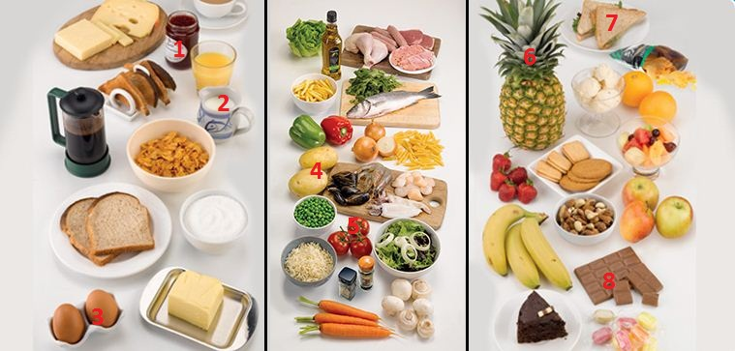
1. |  | 5.
2. |  | 6.
3. |  | 7.
4. |  | 8.

The letters ea
Listen and read. Match the word to the correct sound. Then listen and repeat.
- bread
  - /i/
  - /ɛ/
  - /eɪ/

- breakfast
  - /i/
  - /ɛ/
  - /eɪ/

- eat
  - /i/
  - /ɛ/
  - /eɪ/

- healthy
  - /i/
  - /ɛ/
  - /eɪ/

- ice cream
  - /i/
  - /ɛ/
  - /eɪ/

- meat
  - /i/
  - /ɛ/
  - /eɪ/

- peas
  - /i/
  - /ɛ/
  - /eɪ/

- steak
  - /i/
  - /ɛ/
  - /eɪ/

- tea
  - /i/
  - /ɛ/
  - /eɪ/

My Favorite Meal: Activity 1
Listen to four speakers talking about their favorite meal. Choose the correct words to complete the meals.
- Speaker 1: roast _____
  - potatoes
  - beef
  - chicken
- Speaker 2: _____ tikka masala
  - curry
  - chicken
  - vegetable
- Speaker 3: hot dog and _____
  - French fries
  - ketchup
  - hamburger
- Speaker 4: sweet and sour tofu and _____
  - fish
  - chicken
  - vegetables

Interview with a Detective: Activity 2
Listen again and match the speakers to the sentences.

A I often eat it outside.
B I always order rice with it.
C I have it at a local restaurant.
D I eat it when I visit my parents.
Speaker 1 ___
Speaker 2 ___
Speaker 3 ___
Speaker 4 ___

