Quantifiers: Activity 1
Read Grammar Bank 9B. Then complete the sentences with How much or How many. Listen and check.
Grammar Bank
9B quantifiers
EXAMPLES
uncountable short answers full answers
(singular)
How much sugar A lot. I eat a lot of sugar.
do you eat? A little. I eat a little sugar.
Not much. I don’t eat much sugar.
None. I don’t eat any sugar.
countable (plural)
How many cookies A lot. I eat a lot of cookies.
do you eat? A few. I eat a few cookies.
Not many. I don’t eat many cookies.
None. I don’t eat any cookies.
FORM
- We use How much…? with uncountable nouns and How many…? with plural countable nouns.
- We use:
a lot (of) with countable and uncountable nouns for a big quantity.
a little / not…much with uncountable nouns for a small quantity.
a few / not…many with countable plural nouns for a small quantity.
not…any (none in short answers) for zero quantity.
a lot of and much / many
- In [+] sentences we usually use a lot of.
- In [–] sentences and [?] we usually use much and many.
I don’t drink much water. Do you drink much coffee?
- It is also possible to use a lot of in [–] and [?].
I don’t eat a lot of vegetables. Do you drink a lot of coffee?

1. _________ sugar do you put in your tea?
2. _________ butter do you use?
3. _________ chocolates were in that box?
4. _________ rice do you want?
5. _________ bottles of water did you buy?
6. _________ cans of tuna do we have?
7. _________ coffee does he drink?
8. _________ cookies did you eat?

Quantifiers: Activity 2
Read Grammar Bank 9B. Then choose the correct word or phrase. Listen and check.
Grammar Bank
9B quantifiers
EXAMPLES
uncountable short answers full answers
(singular)
How much sugar A lot. I eat a lot of sugar.
do you eat? A little. I eat a little sugar.
Not much. I don’t eat much sugar.
None. I don’t eat any sugar.
countable (plural)
How many cookies A lot. I eat a lot of cookies.
do you eat? A few. I eat a few cookies.
Not many. I don’t eat many cookies.
None. I don’t eat any cookies.
FORM
- We use How much…? with uncountable nouns and How many…? with plural countable nouns.
- We use:
a lot (of) with countable and uncountable nouns for a big quantity.
a little / not…much with uncountable nouns for a small quantity.
a few / not…many with countable plural nouns for a small quantity.
not…any (none in short answers) for zero quantity.
a lot of and much / many
- In [+] sentences we usually use a lot of.
- In [–] sentences and [?] we usually use much and many.
I don’t drink much water. Do you drink much coffee?
- It is also possible to use a lot of in [–] and [?].
I don’t eat a lot of vegetables. Do you drink a lot of coffee?

1. I don't put many / much salt on my food.
2. A How much chocolate do you eat?
B A few / A little .
3. We don't eat a little / lots of candy.
4. A How much fruit do you buy?
B A lot of / A lot.
5. We eat a lot of / much fish.
6. A Do your children drink milk?
B No. Not many / Not much .
7. Donna ate her hamburger, but she didn't eat much / many French fries.
8. A How many vegetables do you eat?
B Any / None . I don't like them.
9. I had a few / a little cookies with my coffee.
10. A Do you eat much meat?
B No, I don't eat no / any meat. I'm a vegetarian.

Food containers: Activity 1
﻿Listen and read. Match the container to the correct picture.
1. a carton
- 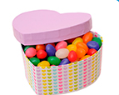
- 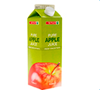
- 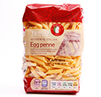
2. a jar
- 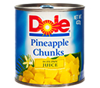
- 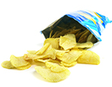
- 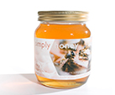
3. a package
- 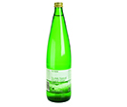
4. a can
5. a bottle
6. a box
7. a bag

Food containers: Activity 2
Complete the sentences. Listen and check.
can carton package jar bottle can
box

1. a __________ of jam
2. a __________ of sugar
3. a __________ of tuna
4. a __________ of water
5. a __________ of chocolates
6. a __________ of milk
7. a __________ of soda

Linking
﻿ Read and listen. Then say and record.
1.a package of cookies
2.a carton of milk
3.a bottle of water
4.a jar of jam
5.a can of pineapple
6.a carton of eggs
7.a can of so﻿da

/ʃ/ and /s/
Listen and read. Then match the word to the correct sound. Listen and repeat.
  - sure
  - /ʃ/
  - /s/

  - salad
  - /ʃ/
  - /s/

  - cereal
  - /ʃ/
  - /s/

  - fresh
  - /ʃ/
  - /s/

  - delicious
  - /ʃ/
  - /s/

  - center
  - /ʃ/
  - /s/

  - information
  - /ʃ/
  - /s/

  - science
  - /ʃ/
  - /s/

Healthy eating: Activity 1
﻿Listen to a radio interview about healthy eating. Choose the correct answers.
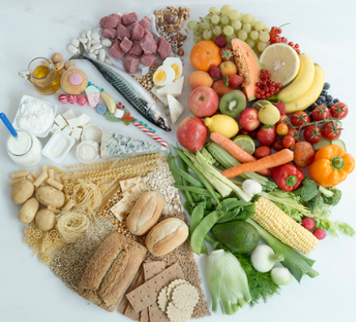
  - The guest on the show is ______.
  - an expert on food
  - a sportsperson
  - an actor
  - The guest talks about ______ different food groups.
  - six
  - four
  - five
  - She finishes by talking about ______ food.
  - vegetarian
  - healthy
  - unhealthy

Healthy eating: Activity 2
Listen again. Complete the sentences with ONE word.

1. A balanced diet is the right amount of _______ from each group.
2. Bread, pasta, _______ and potatoes are all carbohydrates.
3. We need something from the _______ and vegetables group at every meal.
4. We can get protein from meat and _______ .
5. We get calcium from dairy food like _______ and yogurt.
6. We only need fats and sugars once or twice a _______ .

