Verb be (+), subject pronouns: Activity 1
- are
- is
- am
- is
- are
- are
- is
- is

Verb be (+), subject pronouns: Activity 2
1. They're
2. He's
3. We're
4. She's
5. It's
6. They're
7. She's
8. We're

Days of the week
- Tuesday
- Friday
- Monday
- Thursday
- Sunday
- Wednesday
- Saturday

- 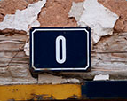
- 
- 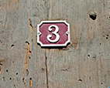
- 
- 
- 
- 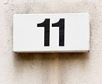
- 
- 
- 
- 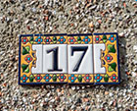
- 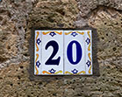

Numbers 0-20: Activity 2
- four
- nine
- eighteen
- two
- eight
- sixteen
- six
- fourteen
- nineteen

Vowel sounds
 |  |  | 
 |  |  | 
 |  |  | 

Hello: Activity 1
talking on the phone
talking in a language school
talking in a café
talking in a taxi

Hello: Activity 2

- 917-555-6542
- room five.
- five dollars and twenty cents.
- 23 Canal Street

