Simple present (+/-)
- speak
- don't play
- needs
- don't listen
- doesn't eat
- lives
- do
- doesn't work

Simple present - spelling
- finishes
- closes
- cleans
- does
- plays
- goes
- watches
- has
Verb phrases: Activity 1
1. | live in an apartment | 5. | go to the movies
2. | study history | 6. | take an umbrella
3. | speak German | 7. | drink water
4. | like animals | 8. | wear glasses

Verb phrases: Activity 2
 |  |  | 
 |  |  | 
 |  |  | 

Verb phrases: Activity 3
- 
- 
- 
- 
- 
- 
- 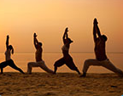
- 
- 
- 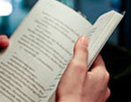
Third person -s
- /s/
- /z/
- /ɪz/
- /z/
- /ɪz/
- /s/
- /z/
- /s/
- /ɪz/
- /z/

Things I love about South Korea: Activity 1
- We can find that for you.
- Enjoy your dinner.
- Shopping on the street.
- Traveling is so easy!
Things I love about South Korea: Activity 2
- True
- False
- True
- True

