Vocabulary: clothes
Listen to the words in the box. Match the words to the correct pictures.
a T-shirt a shirt a jacket pants a sweater shoes a skirt jeans
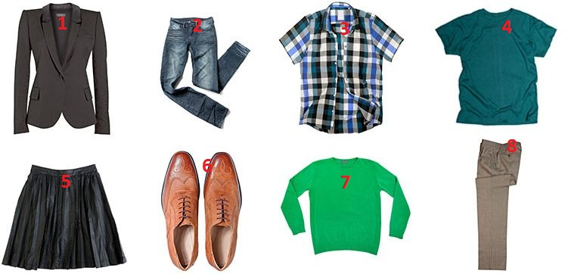
1. |  | 5.
2. |  | 6.
3. |  | 7.
4. |  | 8.

Interactive Video: you hear / you say
Watch the video of Rob buying clothes. Try to remember what he says. You can read the video script to help you. Then record Rob's part of the conversation.

Assistant: Can I help you?
Rob: Yes, what size is this shirt?
Assistant: Let’s see. It’s a small. What size do you need?
Rob: A medium.
Assistant: This is a medium.
Rob: Thanks. Where can I try it on?
Assistant: The changing rooms are over there.
Rob: Thank you.
Assistant: How is it?
Rob: It’s fine. How much is it?
Assistant: It’s £44.99.

Interactive Video: social English phrases
Watch the Social English phrases. Then record yourself saying them.
Jenny: It’s so cool!
Jenny: Right now?
Eddie: Wait a minute.
Jenny: I have to go.
Eddie: Have fun!
Rob: What’s wrong?
Jenny: No way!

