**Present perfect: Activity 1**

﻿Read Grammar Bank 12A. Complete the sentences with the correct form of the present perfect. Listen and check.

|  |
| --- |
| Grammar Bank  **12A** present perfect  EXAMPLES  **1  A Have you seen** the new Matt Damon film?  **B** Yes, **I have**.  **She hasn't read** any books in English.  **2**  **Have you ever read** a Russian novel?  **I've never worked** in an office,  **3**  **Have you finished** the exercise?  **Your parents have arrived**. They're in the living room.  FORM  **1**  We use the present perfect when we talk or ask about events in the past, but when we don't say or ask when.  **2**  We often use the present perfect with *ever* (= at any time in your life) and *never* (= at no time in your life).  **3**  We also use the present perfect to talk about recent events, e.g., *I've finished my homework*.   * To make the present perfect we use *have* / *has* and the past participle of the verb. * *'s* = *has* in present perfect. * Past participles of regular verbs are the same as the simple past. * Past participles of irregular verbs are sometimes the same as the simple past, e.g., *read* /red/ but sometimes different, e.g., *seen*.   **Look at the list of irregular past participles on page 165 of the Student Book.** |

|  |  |
| --- | --- |
| 1.  I 's seen / 've seen / hasn't seen this movie.  2.  She hasn't read / haven't read / 've read the book.  3.  You hasn't washed / 's washed / haven't washed the dishes.  4.  We hasn't done / 's done / 've done the housework.  5.  Have they gone / They've gone / Have gone they to the beach?  6.  He haven't been / 's been / 've been sick.  7.  They hasn't eaten / haven't eaten / 's eaten Egyptian food before.  8.  She's broken / Has she broken / Has broken she her leg? |  |

**Present perfect: Activity 2**

Read Grammar Bank 12A. Then complete the sentences with the present perfect form of the verbs. Use contractions. Listen and check.

|  |
| --- |
| Grammar Bank  **12A** present perfect  EXAMPLES  **1  A Have you seen** the new Matt Damon film?  **B** Yes, **I have**.  **She hasn't read** any books in English.  **2**  **Have you ever read** a Russian novel?  **I've never worked** in an office,  **3**  **Have you finished** the exercise?  **Your parents have arrived**. They're in the living room.  FORM  **1**  We use the present perfect when we talk or ask about events in the past, but when we don't say or ask when.  **2**  We often use the present perfect with*ever* (= at any time in your life) and *never* (= at no time in your life).  **3**  We also use the present perfect to talk about recent events, e.g., *I've finished my homework*.   * To make the present perfect we use*have*/*has* and the past participle of the verb. * *'s* = *has* in present perfect. * Past participles of regular verbs are the same as the simple past. * Past participles of irregular verbs are sometimes the same as the simple past, e.g., *read* /red/ but sometimes different, e.g., *seen*.   **Look at the list of irregular past participles on page 165 of the Student Book.** |

|  |  |
| --- | --- |
| 1.  Yes, __________ a famous actor. (I / meet)  2.  __________ his new shirt. (he / not wear)  3.  __________ to your boss? (you / speak)  4.  __________ their homework. (they / not do)  5.  __________ in New York? (your sister / work)  6.  __________ her book at home. ( she / leave)  7.  __________ any photos. (we / not take)  8.  __________ all the chocolate? (they / eat) |  |

**Irregular past participles**

Complete the sentences with the past participle of the verbs in the list. Then listen and check.

|  |  |
| --- | --- |
| buy   fall   give   hear   leave   read   see    tell |  |

**1.**  I've never __________ *Titanic.*  
**2.**  Has Holly __________ you her news?  
**3.**  Eddie has __________ a new car.  
**4.**  Have you ever __________ in love?  
**5.**  My parents have __________ us their old sofa.  
**6.**  I'm surprised that you've never __________ of Thelonius Monk.  
**7.**  The train has __________ the station.  
**8.**  Don't give Beth that book – she's __________ it before.

**Sentence stress**

Read and listen. Then say and record.

|  |  |
| --- | --- |
| 1.Have you **seen** *To* ***Kill a Mockingbird****?* |  |
| 2.**No**, I **haven't**. |  |
| 3.Have you **read** the **book**? |  |
| 4.**Yes**, I **have**. |  |
| 5.**I've read** it **three times**. |  |

**From book to film: Activity 1**

Listen to a radio interview about movie adaptations of books. Choose the correct answers.

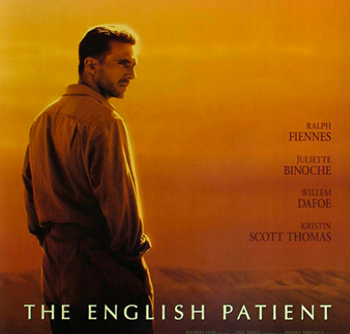

|  |  |
| --- | --- |
| 1. The interview is about two ______ movie adaptations.    * bad    * new    * good 2. The first movie is ______ adaptation of *Great Expectations*.    * a terrible    * an early    * a recent 3. The second movie is ______ adaptation of *The English Patient*.    * a more recent    * an earlier    * a really bad |  |

**From book to film: Activity 2**

Listen to the interview again. Read the sentences and write T (true) or F (false).

|  |  |
| --- | --- |
| 1.  The adaptation of *Great Expectations* is from 1956.   ___  2.  This adaptation is a black-and-white movie.   ___  3.  The main character in *Great Expectations* is a girl.   ___  4.  The movie is more frightening than the book.   ___  5.  The author of *The English Patient* isn't British.   ___  6.  The main character of *The English Patient* had a car crash.   ___  7.  The critic says the best thing about the movie is the love story.   ___  8.  Both the book and the movie won important prizes.   ___ |  |