**Singular and plural nouns: Activity 1**

Read Grammar Bank 2A. Then make the sentences plural. Use contractions. Listen and check.

|  |
| --- |
| **Grammar Bank**  **2A** singular and plural nouns  ***a*/*an*, plurals**  EXAMPLES  **singular nouns            plural nouns**  It's **a** book.                   They're **books**.  It's **a** watch.                  They're **watches**.  It's **a** dictionary.            They're **dictionaries**.  It's **an** umbrella.            They're **umbrellas**.  It's **an** ID card.              They're **ID cards**.  FORM  • We use *a* / *an* with singular nouns. • We use *an* with a noun beginning with a vowel (*a, e, i, o, u*). • We use *a* with nouns beginning with *u* or *eu* when the sound = /yu/, e.g. *a university*, *a euro*. • We don't use *a* / *an* with plural nouns. *They're books*. **NOT** *They're a books.*  **regular plurals**  **Singular**        **Plural**            **Spelling**  a book            book**s**            add -*s*  a key               key**s**  a wat**ch**          watch**es**        add -*es* after *ch*, *sh*, *s*, *x*  a bo**x**              box**es**  a countr**y**       countr**ies**      consonant + *y* > *ies*  a dictionar**y**   dictionar**ies**  • We add -*s* (or -*es* or -*ies*) to make plural nouns.   *It’s a pen. They’re pens.* • With two-word nouns, we add -*s* (or -*es* or -*ies*) to the second noun.   *credit card, credit cards* **NOT** *credits cards* |

|  |  |
| --- | --- |
| 1.  It's a photo.   __________________ .  2.  It's a watch.  __________________ .  3.  It's a city.   __________________ .  4.  It's an address.   __________________ .  5.  She's a teacher.   __________________ .  6.  It's a university. __________________ .  7.  It's a change purse.   __________________ .  8.  He's a student.   __________________ . |  |

**Singular and plural nouns: Activity 2**

Read Grammar Bank 2A. Then choose the correct noun forms. Listen and check.

|  |
| --- |
| **Grammar Bank**  **2A** irregular plurals  **singular                        plural**  a man /mæn/                men /mɛn/  a woman /ˈwʊmən/        women /ˈwɪmən/  a child /tʃaɪld/                children /ˈtʃɪldrən/  a person /ˈpərsn/           people /ˈpipl/ |

|  |  |
| --- | --- |
| 1.  The child / children are at school.  2.  One man / men is in a taxi.  3.  The person / people are at the airport.  4.  Two women / woman are at the restaurant.  5.  A person / people is in my hotel room.  6.  Three man / men are in the museum.  7.  A children / child is under the desk.  8.  The woman / women is from Turkey. |  |

**Things: Activity 1**

Listen and read. Match the word to the correct picture.

|  |  |
| --- | --- |
| 1. a lamp |  |
| 2. a coin |  |
| 3. an umbrella |  |
| 4. an ID card |  |
| 5. a pencil |  |
| 6. scissors |  |
| 7. a cal﻿endar |  |
| 8. sunglasses |  |
| 9. a laptop |  |
| 10. a wallet |  |
| 11. a piece of paper |  |
| 12. a newspaper |  |

**Things: Activity 2**

Listen to the words in the box. Match the words to the picture.

|  |
| --- |
| a tablet a notebook a pen a change purse a key a charger a credit card a ticket |

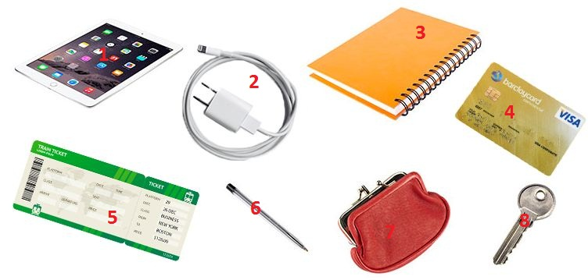

|  |  |  |  |
| --- | --- | --- | --- |
| 1. |  | 5. |  |
| 2. |  | 6. |  |
| 3. |  | 7. |  |
| 4. |  | 8. |  |

**Things: Activity 3**

﻿Look at the picture and complete the sentences with *in, on*, or *under*. Then listen and check.



|  |  |
| --- | --- |
| 1. The headphones are ... the bag.    * in    * on    * under 2. The file is ... the desk.    * in    * on    * under 3. The phone is ... the chair.    * in    * on    * under 4. The tissues are ... the bag.    * in    * on    * under 5. The watch is ... the book.    * in    * on    * under 6. The photo is ... the desk.    * in    * on    * under 7. The magazine is ... the bag.    * in    * on    * under |  |

**Final *-s* and *-es***

Read and listen. Then say and record.

|  |  |  |  |
| --- | --- | --- | --- |
| 1.bag**s** |  | 6.laptop**s** |  |
| 2.watch**es** |  | 7.box**es** |  |
| 3.charger**s** |  | 8.ticket**s** |  |
| 4.tablet**s** |  | 9.sunglass**es** |  |
| 5.page**s** |  | 10.umbrella**s** |  |

**What's in your bag? Activity 1**

Listen to four speakers talking about the things in their bags. Check the speakers with books in their bags.

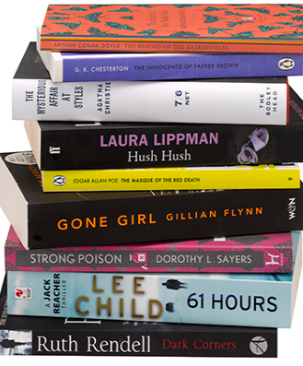

|  |  |
| --- | --- |
| * Speaker 1 * Speaker 2 * Speaker 3 * Speaker 4 |  |

**What's in your bag? Activity 2**

Listen again. Match the sentences to the speakers. Write *A*-*D*.

|  |  |
| --- | --- |
| Speaker 1  ___ Speaker2 ___ Speaker 3 ___ Speaker 4 ___  **A** has a book in his / her bag that helps him / her speak to people **B** has something to listen to music **C** changes bags every day **D** has a computer in his / her bag |  |