**Simple present (+/-)**

﻿Read Grammar Bank 3A. Then make [+] or [–] simple present sentences with the verbs in parentheses. Use contractions. Listen and check.

|  |
| --- |
| **Grammar Bank**  **3A**﻿simple present [+] and [–]  ﻿EXAMPLES  I **speak** English.  Americans **like** fast food.  My mother **cooks** fantastic food.  I **don't drink** tea.  We **don't live** in a big city.  He **doesn't play** the guitar.  FORM  [+]  I / you / we / you / they **work**  he / she / it **works**  [–]  I / you / we / you / they **don't work**  he / she / it **doesn't work**   * We use the simple present for things that are generally true or are habits. * **Contractions**: *don't* = *do not*, *doesn't* = *does not*. * To make negatives we use *don't* / *doesn't* + verb (base form). *He doesn't* ***work***. NOT *He doesn't works.* |

|  |  |
| --- | --- |
| 1.  (+) You __________ Arabic very well. (speak)  2.  (-) I __________ games on my phone. (play)  3.  (+) Julia __________ a new laptop. (need)  4.  (-) We __________ to music in the car. (listen)  5.  (-) My friend __________ fast food. (eat)  6.  (+) Oliver __________ in an apartment. (live)  7.  (+) They __________ housework on the weekend. (do)  8.  (-) She __________ on Saturdays. (work) |  |

**Simple present - spelling**

Read Grammar Bank 3A. Then complete the sentences with the correct form of the verbs in parentheses. Listen and check.

|  |
| --- |
| **Grammar Bank**  **3A** simple present spelling rules for *he* / *she* / *it*  I work / play / live.    He work**s** / play**s** / live**s**.    add *-s*  I watch / finish.         She watch**es** / finish**es**.     add *-es* after c*h, sh, s, x*  I study.                       She stud**ies**.                        consonant + *y* → *ies*  **Be careful with some *he* / *she* / *it* forms.**  I have      he has /hæz/  **NOT** he haves  I go          he goes /ɡoʊz/  I do          he does /dʌz/ |

|  |  |
| --- | --- |
| 1.  The class _________ at 7:30 p.m. (finish)  2.  The store _________ very late. (close)  3.  Marius _________ his room on Sunday mornings. (clean)  4.  Leo _________ housework on the weekend. (do)  5.  My teacher _________ tennis on Saturdays. (play)  6.  Amy _________ to the movies on Wednesday evenings. (go)  7.  Max _________ soccer on TV. (watch)  8.  My friend _________ a big yard. (have) |  |

**Verb phrases: Activity 1**

Listen to the verb phrases in the box. Match the verb phrases to the correct pictures.

|  |
| --- |
| live in an apartment take an umbrella like animals go to the movies  drink water wear glasses study history speak German |

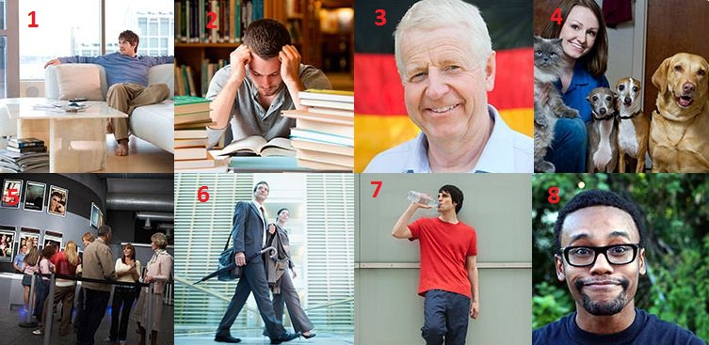

|  |  |  |  |
| --- | --- | --- | --- |
| 1. |  | 5. |  |
| 2. |  | 6. |  |
| 3. |  | 7. |  |
| 4. |  | 8. |  |

**Verb phrases: Activity 2**

Listen to the words in the box. Match the words to the picture.

|  |  |  |
| --- | --- | --- |
|  |  |  |
|  |  |  |

|  |  |  |  |
| --- | --- | --- | --- |
|  |  |  |  |
|  |  |  |  |
|  |  |  |  |

**Verb phrases: Activity 3**

﻿Listen and read. Match the verb phrase to the correct picture.

|  |  |
| --- | --- |
| 1. listen to music |  |
| 2. play tennis |  |
| 3. do homework |  |
| 4. play the guitar |  |
| 5. say sorry |  |
| 6. cook dinner |  |
| 7. do yoga |  |
| 8. drive a car |  |
| 9. have a garden |  |
| 10. read a book |  |

**Third person *-s***

Listen and read. Match the word to the correct sound. Then listen and repeat.

|  |  |  |  |
| --- | --- | --- | --- |
| 1.cook**s**   * /s/ * /z/ * /ɪz/ |  | 6. speak**s**   * /s/ * /z/ * /ɪz/ |  |
| 2.do**es**   * /s/ * /z/ * /ɪz/ |  | 7. rain**s**   * /s/ * /z/ * /ɪz/ |  |
| 3. clos**es**   * /s/ * /z/ * /ɪz/ |  | 8. drink**s**   * /s/ * /z/ * /ɪz/ |  |
| 4. go**es**   * /s/ * /z/ * /ɪz/ |  | 9. watch**es**   * /s/ * /z/ * /ɪz/ |  |
| 5. finish**es**   * /s/ * /z/ * /ɪz/ |  | 10. ha**s**   * /s/ * /z/ * /ɪz/ |  |

**Things I love about South Korea: Activity 1**

Read and listen. Choose the best heading for each paragraph 1-4.

|  |
| --- |
| **Things I love about South Korea**  *Carly Hamilton is American, but she lives in Seoul, South Korea. Here are some things she loves about living there.*  **1 _________________________**  In South Korea, the customer is really important. When you walk into a store, the salespeople greet you with a smile and say, “Hello.” As you shop, they ask you if you need help. If you can’t find something you want, the salespeople try to find it for you. They want you to be happy.  **2 _________________________**  I love restaurants that serve South Korean meat. It’s so delicious. The servers grill the meat, and then they cut it for you! They also serve banchan—little side dishes of vegetables. The servers are very busy in South Korean restaurants. They don’t talk as much as servers in the US, but they make sure that you have a great meal!  **3 _________________________**  There are so many places to shop in South Korea! People sell things like clothes and jewelry on the street. There are shopping booths in the subway stations, too! When I take the subway to work, I often buy a pretty bracelet or necklace because they’re so cheap. It’s really nice!  **4 _________________________**  The transportation system is great here! It’s easy to get around because there are signs, and a lot of them are in English! You can use your cell phone on the subway here, too. You can’t do that in the US! |

|  |  |
| --- | --- |
| 1. Paragraph 1    * Shopping on the street.    * We can find that for you.    * Traveling is so easy!    * Enjoy your dinner. 2. Paragraph 2    * Traveling is so easy!    * Enjoy your dinner.    * Shopping on the street.    * We can find that for you. 3. Paragraph 3    * Traveling is so easy!    * Enjoy your dinner.    * Shopping on the street.    * We can find that for you. 4. Paragraph 4    * We can find that for you.    * Enjoy your dinner.    * Traveling is so easy!    * Shopping on the street. |  |

**Things I love about South Korea: Activity 2**

Read the text again and choose *true* or *false*.

|  |
| --- |
| **Things I love about South Korea**  *Carly Hamilton is American, but she lives in Seoul, South Korea. Here are some things she loves about living there.*  **1 We can find that for you**  In South Korea, the customer is really important. When you walk into a store, the salespeople greet you with a smile and say, “Hello.” As you shop, they ask you if you need help. If you can’t find something you want, the salespeople try to find it for you. They want you to be happy.  **2 Enjoy your dinner**  I love restaurants that serve South Korean meat. It’s so delicious. The servers grill the meat, and then they cut it for you! They also serve banchan—little side dishes of vegetables. The servers are very busy in South Korean restaurants. They don’t talk as much as servers in the US, but they make sure that you have a great meal!  **3 Shopping on the street**  There are so many places to shop in South Korea! People sell things like clothes and jewelry on the street. There are shopping booths in the subway stations, too! When I take the subway to work, I often buy a pretty bracelet or necklace because they’re so cheap. It’s really nice!  **4 Traveling is so easy!**  The transportation system is great here! It’s easy to get around because there are signs, and a lot of them are in English! You can use your cell phone on the subway here, too. You can’t do that in the US! |

1. In South Korea, salespeople want the customer to be happy.
   * True
   * False
2. Restaurants in South Korea are not busy.
   * True
   * False
3. You can buy a shirt and earrings on the street in South Korea.
   * True
   * False
4. Transportation in Seoul is very good.
   * True
   * False