**Possessive *'s, Whose...?* Activity 1**

﻿Read Grammar Bank 4A. Then complete the sentences with the correct possessive phrases.Listen and check.

|  |
| --- |
| **Grammar Bank**  **4A** possessive *'s*, *Whose ...?*  ﻿EXAMPLES  **1** He's Brad Pitt**'s** brother. It's James**'s** laptop.  **2** It's my parent**s'** car.  **3** "**Whose** is this bag?" "It's Maria**'s**."  **4** The end of the movie is fantastic. I live near the city park.  FORM  **1** We use a person + *'s* to talk about family and possessions.  *He's Brad Pitt****'s*** *brother*. **NOT** *He's the brother of Brad Pitt.*  **2** With regular plural nouns we put the ' after the *s*.  *It's my parent****s'*** *car*. **NOT** *It's my parent's car*.   * With irregular plural nouns, e.g. *children*, *men*, we use *'s*, e.g., *the children's room*, *men's clothes*.   **3** We use *Whose ...?* to ask about possession.  We can ask *Whose is this bag?***OR** *Whose bag is this?*  We can answer *It's Maria's bag*. **OR** *It's Maria's*.  **4** We don't usually use a thing + *'s*, e.g., *the end of the class* **NOT** *the class's end*, *the city park* **NOT** *the city's park*. |

|  |  |
| --- | --- |
| 1.  It's my mother's birthday / mothers' birthday .  2.  That's her parent's house / parents' house .  3.  These are childrens' books / children's books .  4.  Whose / Who's phone is this?  5.  Those are the student's desks / the students' desks .  6.  That's Annes' bag / Anne's bag .  7.  Who's / Whose Kevin's girlfriend?  8.  Those are women's sunglasses / womens' sunglasses . |  |

**Possessive *'s, Whose...?* Activity 2**

Read Grammar Bank 4A. Complete the sentences. Use *'s* or *s*' with the person / people in parentheses, and the bold word. Listen and check.

|  |
| --- |
| **Grammar Bank**  **4A** possessive*'s*, *Whose ...?*  ﻿EXAMPLES  **1** He's Brad Pitt**'s** brother. It's James**'s** laptop.  **2** It's my parent**s'** car.  **3** "**Whose** is this bag?" "It's Maria**'s"**.  **4** The end of the movie is fantastic. I live near the city park.  FORM  **1** We use a person + *'s* to talk about family and possessions.  *He's Brad Pitt****'s****brother*. **NOT** *He's the brother of Brad Pitt.*  **2** With regular plural nouns we put the ' after the *s*.  *It's my parent****s'****car*. **NOT** *It's my parent's car*.   * With irregular plural nouns, e.g.,*children*, *men*, we use *'s*, e.g., *the children's room*, *men's clothes*.   **3** We use *Whose ...?* to ask about possession.  We can ask *Whose is this bag?***OR** *Whose bag is this?*  We can answer *It's Maria's bag*. **OR** *It's Maria's*.  **4** We don't usually use a thing + *'s*, e.g.,*the end of the class* **NOT** *the class's end*, *the city park* **NOT** *the city's park*. |

|  |  |
| --- | --- |
| 1.  "Whose **wallet** is that?" "It's _______________ ." (my brother)  2.  "Whose **keys** are those?" "They're _______________ ." (Tina)  3.  "Which **room** is this?" "It's the _______________ ." (teachers)  4.  "Whose **headphones** are those?" "They're _______________ ." (my girlfriend)  5.  "What kind of **book** is this?" "It's a _______________ ." (children)  6.  "Whose **bags** are those?" "They're _______________ ." (my friends)  7.  "Which **jackets** are those?" "They're the _______________ ." (children)  8.  "Whose **car** is that?" "It's _______________ ." (my grandparents) |  |

**Family: Activity 1**

Look at the family tree and choose the correct answers. Listen and check.

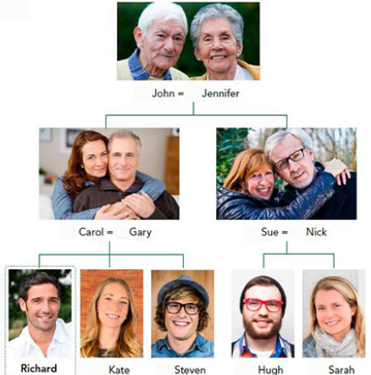

|  |  |
| --- | --- |
| 1. Kate is Richard's ______ .    * aunt    * sister    * mother 2. Nick is Richard's ______ .    * uncle    * father    * brother 3. Jennifer is Richard's ______ .    * aunt    * grandmother    * mother 4. Hugh is Richard's ______ .    * brother    * uncle    * cousin 5. Carol is Richard's ______ .    * mother    * sister    * aunt 6. John is Richard's ______ .    * uncle    * grandfather    * father 7. Steven is Richard's ______ .    * brother    * uncle    * father 8. Sue is Richard's ______ .    * aunt    * mother    * sister 9. Gary is Richard's ______ .    * uncle    * father    * brother |  |

**Family: Activity 2**

Look at the family trees for Richard and his sister Kate. Choose the correct answers. Listen and check.

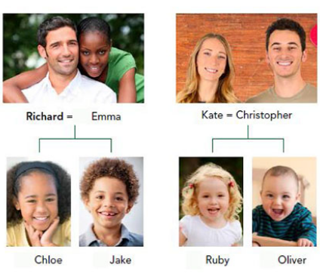

|  |  |
| --- | --- |
| 1. Emma is Richard's ______ .    * daughter    * wife    * niece 2. Oliver is Richard's ______ .    * niece    * nephew    * son 3. Chloe is Richard's ______ .    * wife    * niece    * daughter 4. Christopher is Richard's ______ .    * stepbrother    * husband    * brother-in-law 5. Ruby is Richard's ______ .    * daughter    * cousin    * niece 6. Jake is Richard's ______ .    * nephew    * son    * husband |  |

**Family: Activity 3**

﻿ Complete the sentences with the correct family words. Listen and check.

|  |  |
| --- | --- |
| mother-in-law parents-in-law children partner  grandparents parents stepfather stepmother  sister-in-law couple |  |

1.  My father and my mother are my __________________ .

2.  My wife's mother and father are my __________________ .

3.  My grandfather and my grandmother are my __________________ .

4.  My son and my daughter are my __________________ .

5.  A husband and wife are a __________________ .

6.  My wife's mother is my __________________ .

7.  My husband's sister is my __________________ .

8.  My mother's new husband is my __________________ .

9.  My father's new wife is my __________________ .

10.  The person I'm in a relationship with is my __________________ .

**/ʌ/, the letter *o***

Listen and read. Then match the word to the correct sound. Listen and repeat.

|  |  |
| --- | --- |
| 1. c**o**me   * + /ɑ/   + /oʊ/   + /ʌ/   + /u/ |  |
| 2. d**o**   * + /ɑ/   + /oʊ/   + /ʌ/   + /u/ |  |
| 3. d**o**ctor   * + /ɑ/   + /oʊ/   + /ʌ/   + /u/ |  |
| 4. d**o**n't   * + /ɑ/   + /oʊ/   + /ʌ/   + /u/ |  |
| 5. g**o**   * + /ɑ/   + /oʊ/   + /ʌ/   + /u/ |  |
| 6. j**o**b   * + /ɑ/   + /oʊ/   + /ʌ/   + /u/ |  |
| 7. m**o**ney   * + /ɑ/   + /oʊ/   + /ʌ/   + /u/ |  |
| 8. wh**o**   * + /ɑ/   + /oʊ/   + /ʌ/   + /u/ |  |
| 9. m**o**del   * + /ɑ/   + /oʊ/   + /ʌ/   + /u/ |  |
| 10. h**o**me   * + /ɑ/   + /oʊ/   + /ʌ/   + /u/ |  |
| 11. **o**ne   * + /ɑ/   + /oʊ/   + /ʌ/   + /u/ |  |
| 12. b**oo**t   * + /ɑ/   + /oʊ/   + /ʌ/   + /u/ |  |

**Who's that? Activity 1**

Listen to Jessie showing photos to her friend.

|  |  |
| --- | --- |
| 1. How many photos does she show her friend?    * 6    * 3    * 2    * 4 |  |

**Who's that? Activity 2**

Listen again and choose True or False.

|  |  |
| --- | --- |
| 1. Jessie's sister has a son.    * True    * False 2. Jessie's sister is short.    * True    * False 3. Jessie's sister plays basketball.    * True    * False 4. The beach in the photo is in Canada.    * True    * False 5. Jessie went to a music festival with her sister.    * True    * False 6. Rosie has blond hair.    * True    * False 7. Rosie sees her boyfriend all the time.    * True    * False 8. Pete is Jessie's boss.    * True    * False |  |