**Prepositions - time**

﻿Read Grammar Bank 4B. Then complete the sentences with the correct prepositions of time. Listen and check.

|  |
| --- |
| Grammar Bank  **4B** prepositions of time (*at, in, on*)  EXAMPLES  **in                          on                                    at**  the morning        Monday (morning)       three o'clock  the afternoon      January 1                       noon / midnight  the evening         the weekend                  lunchtime  the summer                                                 night  December  2018  FORM   * We use *in* for parts of the day, seasons, months, and years. * We use on for days, dates, and the weekend. * We use *at* for times of the day and night. |

|  |  |
| --- | --- |
| 1.  My father works on / in / at the weekend.  2.  Bye! See you on / in / at Monday.  3.  It's cold on / in / at night.  4.  My birthday is on / in / at September.  5.  He starts his new job on / in / at March 1st.  6.  We have English classes on / in / at Tuesday mornings.  7.  They watch TV on / in / at the evening.  8.  The museum closes on / in / at 5:30. |  |

**Prepositions - place**

﻿ ﻿Read Grammar Bank 4B. Then complete the sentences with *at*, *in* or *to*. Listen and check.

|  |
| --- |
| Grammar Bank  **4B** prepositions of place and movement  EXAMPLES  **1** He has lunch **at** work.     He works **in** an office.  **2** He goes **to** work at 8:00.  FORM  **1** We use *at* and *in* for place.   * We use *at* + *work, home, school.* * We use in + other places, e.g., a house, an office, a room, etc. * We can use *in or at* with some public places, e.g., a restaurant, the movies, etc.   *On Saturdays he usually has lunch****in*** / ***at****a restaurant*.  **2** We use *to* for movement or direction.  *She goes* ***to*** *the gym.* **NOT** *She goes at the gym.*  We don't use *to* before *home*.  *go home* **NOT** *go to home* |

|  |  |
| --- | --- |
| 1.  They live ____ an old house.  2.  It's a beautiful day. Let's go ____ the beach.  3.  Sorry, John isn't here. He's ____ work.  4.  Beth isn't ____ home. She's on vacation.  5.  The children go ____ school by bus.  6.  She works ____ an office.  7.  We go ____ the movies on the weekend.  8.  Do you drive ____ work or do you take the bus? |  |

**Daily routine: Activity 1**

Match the pictures to the correct verb phrases. Then listen and check.

|  |  |  |
| --- | --- | --- |
| 1.   * + take a shower   + get dressed   + put on make-up |  |  |
| 2.   * + wake up at 7:00   + go to work by bus   + have a coffee |  |  |
| 3.   * + put on make-up   + get to work   + start work at 8:30 |  |  |
| 4.   * + go to work by bus   + take a shower   + get dressed |  |  |
| 5.   * + get to work   + have a coffee   + wake up at 7:00 |  |  |
| 6.   * + start work at 8:30   + take a shower   + put on make-up |  |  |
| 7.   * + have a coffee   + get dressed   + go to work by bus |  |  |
| 8.   * + start work at 8:30   + wake up at 7:00   + get to work |  |  |

**Daily routine: Activity 2**

﻿ Listen to the verb phrases in the box. Match the phrases to the correct pictures.

|  |
| --- |
| have lunch at work have pizza for dinner check emails do housework  go shopping finish work at 6.30 go to bed get home late |

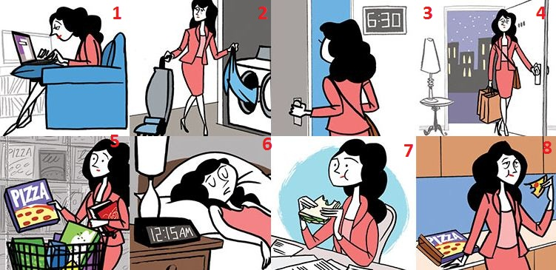

|  |  |  |  |
| --- | --- | --- | --- |
| 1. |  | 5. |  |
| 2. |  | 6. |  |
| 3. |  | 7. |  |
| 4. |  | 8. |  |

**Daily routine: Activity 3**

Listen and read. Match the verb phrase to the correct picture.

|  |  |
| --- | --- |
| 1. go to Spanish classes |  |
| 2. get up at 8:00 |  |
| 3. have breakfast |  |
| 4. go home early |  |
| 5. walk to work |  |
| 6. relax |  |
| 7. take the dog for a walk |  |
| 8. sleep for eight hours |  |
| 9. make dinner |  |
| 10. take a bath |  |
| 11. shave |  |
| 12. see friends |  |

**Linking**

Read and listen.Then say and record. Try to link the connected words.

|  |  |
| --- | --- |
| 1.I **get**_**up**_at **seven**. |  |
| 2.I **take**_a **shower**. |  |
| 3.I **go** to **work**. |  |
| 4.I **have**_a **sandwich** for **lunch**. |  |
| 5.I **get home**_at **six**. |  |
| 6.I **go** to **bed_**at **ten**. |  |
| 7.**What_**a **life**! |  |

**Valeria's day: Activity 1**

Listen to Valeria talking about her week. Choose the correct answer.

|  |  |
| --- | --- |
| 1. Valeria is ______.  * a teacher * an administrator * a model   2. Valeria makes breakfast for her family ______.   * on vacation * on weekdays * on weekends   3. On the weekend, Valeria ______.   * goes to work * learns English * makes breakfast for her family |  |

**Valeria's day: Activity 2**

Listen again to Valeria talking about her week. Complete the gaps with a word, a number, or a time, e.g., 2:00.

|  |  |
| --- | --- |
| **Morning** She gets up at _____ . She starts work at _____ .  **Afternoon** She has coffee at _____ . She finishes work at _____ and gets home around _____ .  **Weekends** Valeria and her husband don't _____ on the weekends. She usually gets up around _____ . Her husband _____ breakfast for the family. She goes English class on _____ at 4:00. She goes to bed at _____ at night but doesn't go to sleep until about 11:00. |  |

**Writing 3 - An article**

Write an article called *My Typical Monday*.

|  |  |
| --- | --- |
| Make notes to answer the questions below. Add more information to make the article interesting.  - What's your favorite or least favorite thing about Mondays?  - What do you usually do in the morning?  - Where do you usually have lunch? Who with? What do you do after lunch?  - What do you usually do in the evening?  **Write four paragraphs.** | Writing here … |