***can / can't* (+/-)**

Read Grammar Bank 5A. Then complete the sentences with *can* or *can't* and a verb from the list. Listen and check.

|  |
| --- |
| **Grammar Bank**  **5A** *can / can't*  EXAMPLES  **1**  **I can** sing, but **I can't** dance.  **2**  **I can** come on Tuesday, but **I can't** come on Wednesday.  **3**  **You can** park here. **You can't** park there.  **4**  **Can you** help me? **Can I** open the window?  FORM   * *can* + base form has different meanings:   **1**  *I can (sing)* = I know how to.  *I can't (dance)* = I don't know how to.  **2***I can (come)* = It's possible for me.  *I can't (come)* = It isn't possible for me.  **3**  *You can (park here)* = It's OK. / It's permitted.  *You can't (park there)* = It isn't OK. / It isn't permitted.  **4**  *Can you (help me)?* = Please do it.  *Can I (open the window)?* = Is it OK if I do it?   * *can* and *can't* are the same for all persons (*I, you, he*, etc.).   **NOT** *He cans*.   * **Contraction:** *can't* = *cannot*. * We don't use*to* after *can*.   ***I can swim***. **NOT** *I can to swim*. |

|  |  |
| --- | --- |
| come   go   meet    park   play   speak   swim   take |  |

**1.**  She __________ Chinese, but not Japanese.  
**2.**  The road is closed. We __________ that way.  
**3.**  My boyfriend likes music, but he __________ the guitar.  
**4.**  The hotel has a parking lot. We __________ there.  
**5.** We __________ to your party. We're on vacation that week.  
**6.**  I'm free tomorrow. I __________ you after work.  
**7.**  It says "No cameras". We __________ photos here.  
**8.**  The beach has a green flag today. We __________ in the ocean today.

***can / can't* (?)**

Read Grammar Bank 5A. Then rewrite the questions with *can* or *can't*. Listen and check.

|  |
| --- |
| **Grammar Bank**  **5A** *can / can't*  EXAMPLES  **1**  **I can** sing, but **I can't** dance.  **2**  **I can** come on Tuesday, but **I can't** come on Wednesday.  **3**  **You can** park here. **You can't** park there.  **4**  **Can you** help me? **Can I** open the window?  FORM   * *can* + base form has different meanings:   **1**  *I can (sing)* = I know how to.  *I can't (dance)* = I don't know how to.  **2***I can (come)* = It's possible for me.  *I can't (come)* = It isn't possible for me.  **3**  *You can (park here)* = It's OK. / It's permitted.  *You can't (park there)* = It isn't OK. / It isn't permitted.  **4**  *Can you (help me)?* = Please do it.  *Can I (open the window)?* = Is it OK if I do it?   * *can* and *can't* are the same for all persons (*I, you, he*, etc.).   **NOT** *He cans*.   * **Contraction:** *can't* = *cannot*. * We don't use*to* after *can*.   ***I can swim***. **NOT** *I can to swim*. |

|  |  |
| --- | --- |
| Is it OK if I close the window.   __________ the window?  2.  Does she know how to play tennis?   __________ tennis?  3.  Is it OK if I use your phone?   __________ your phone?  4.  Is it possible to call me later?   __________ me later?  5.  Is it OK if I open the door?  __________ the door?  6.  Are we permitted to take photos here?   __________ photos here?  7.  Does he know how to drive a bus?   __________ a bus?  8.  Is it possible for you to come tomorrow?   __________ tomorrow? |  |

**Verb phrases: Activity 1**

Listen and read. Match the pictures to the correct verb phrases.

|  |  |  |
| --- | --- | --- |
|  |  |  |
|  |  |  |

|  |  |  |  |
| --- | --- | --- | --- |
|  |  |  |  |
|  |  |  |  |
|  |  |  |  |

**Verb phrases: Activity 2**

Listen and read. Match the verb phrase to the correct picture.

|  |  |
| --- | --- |
| 1. try to do something difficult |  |
| 2. find a parking space |  |
| 3. talk to a friend |  |
| 4. send a text message |  |
| 5. look for your keys |  |
| 6. swim in the ocean |  |
| 7. tell somebody a secret |  |
| 8. wait for a bus |  |
| 9. forget somebody's name |  |
| 10. use the internet |  |
| 11. dance the tango |  |

**Verb phrases: Activity 3**

﻿ Listen to the verb phrases in the box. Match the verb phrases to the correct pictures.

|  |
| --- |
| met a friend buy a newspaper sing a song call a taxi hear a noise  see a movie run a race paint a picture |

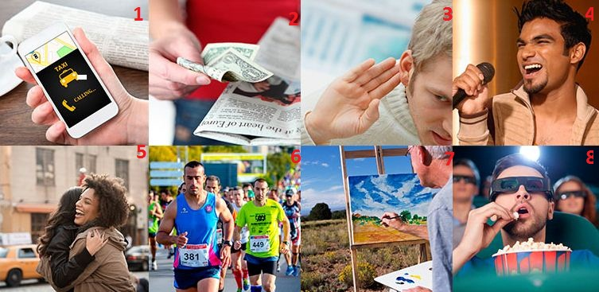

|  |  |  |  |
| --- | --- | --- | --- |
| 1. |  | 5. |  |
| 2. |  | 6. |  |
| 3. |  | 7. |  |
| 4. |  | 8. |  |

**Sentence stress**

Listen and choose the sentence you hear.

|  |  |
| --- | --- |
| 1.   * + I can sing.   + I can't sing. |  |
| 2.   * + She can dance very well.   + She can't dance very well. |  |
| 3.   * + He can cook.   + He can't cook. |  |
| 4.   * + I can come to the meeting.   + I can't come to the meeting. |  |
| 5.   * + You can park here.   + You can't park here. |  |
| 6.   * + I can drive.   + I can't drive. |  |

**Let's go swimming: Activity 1**

Listen to five conversations. Choose the correct answers.

|  |  |
| --- | --- |
| 1. Who's speaking?   * + A mother and daughter.   + Two friends. |  |
| 2. Where are they?   * + In the street.   + At home. |  |
| 3. Where are they?   * + At home.   + At school. |  |
| 4. Who's speaking?   * + A husband and wife.   + A shop assistant and a customer. |  |
| 5. Where are they?   * + Outside the movie theater.   + Outside the office. |  |

**Let's go swimming: Activity 2**

﻿Listen again and choose the correct answers.

|  |  |
| --- | --- |
| * 1. They can go to the swimming pool on _____.   + Saturday morning   + Sunday afternoon   + Saturday afternoon |  |
| * 1. The man can park outside _____.   + the restaurant   + the hospital   + the movie theater |  |
| * 1. She can help her brother _____.   + this evening   + this afternoon   + this morning |  |
| * 1. They don't have _____, so they can't send the postcard.   + a stamp   + the address   + a pen |  |
| * 1. They can't go in because she _____.   + can't open the door   + can't find his keys   + can hear his parents |  |