**Present continuous (+/-)**

﻿ Read Grammar Bank 5B. Complete the sentences with the present continuous form of the verbs in parentheses. Use contractions. Then listen and check.

|  |
| --- |
| Grammar Bank  **5B** present continuous  EXAMPLES  **They're having** a party next door.  Oh no! **The baby's crying**.  **It's raining**.  **A** What **are you doing**?  **B** **I'm waiting** for my brother.  FORM  [+]  I**'m** **having** a party.  You / We / They**'re** **having** a party.  He / She / It**'s** **having** a party.  [–]  I**'m not having** a party.  You / We / They **aren't having** a party.  He / She / It **isn't having** a party.   * We use the present continuous for things that are happening now / at the moment. * *At the moment* can mean *around now*.   *I****'m reading*** *a good book at the moment*. (= not exactly now).   * We also use the present continuous with longer periods of time, e.g., *today, this week, this month*. The present continuous emphasizes that the action is temporary, not a habit.   *I****'m working****at home****this week****because my daughter isn't very well*.  Spelling rules for -*ing* forms  **infinitive            verb + -ing                spelling**  cook                     cook**ing**                      + -*ing*  dance                   danc**ing**                    **no** *e* + -*ing*  swim                    swimm**ing**                 one vowel + one consonant                                                                                                      = double consonant + *-ing* |

|  |  |
| --- | --- |
| 1.  Matt's in his room. He ________ to music. (listen)  2.  They ________ their homework. They're talking. (not do)  3.  I can't talk now. I ________ . (drive)  4.  Joe and Anna aren't at home. They ________ tennis. (play)  5.  Emily ________ . She's on the phone. (not study)  6.  You ________ . What's wrong? (cry)  7.  I ________ TV. I'm reading a book. (not watch)  8.  They're late. That's why they ________ .(run) |  |

**Present continuous (?)**

﻿ ﻿Order the words to make present continuous questions.

|  |
| --- |
| you I am helping |

1. _________ _________ _________ _________ ?

|  |
| --- |
| for your looking you are keys |

2. _________ _________ _________ _________ _________ _________ ?

|  |
| --- |
| calling is Tom who |

3. _________ _________ _________ _________ ?

|  |
| --- |
| the are children getting dressed |

4. _________ _________ _________ _________ _________ ?

|  |
| --- |
| waiting we who for are |

5. _________ _________ _________ _________ _________ ?

|  |
| --- |
| painting what Chloe is |

6. _________ _________ _________ _________ ?

**Noise: verbs and verb phrases**

Complete the sentences with the verbs in the box. Then listen and check.

|  |  |
| --- | --- |
| practice make play have cry argue  have bark |  |

1.  My neighbors _________ noisy parties on the weekend.

2.  Couples often _________ about money.

3.  Children _________ a lot of noise when they're playing.

4.  Babies _________ when they're hungry.

5.  Dogs often _________ at people they don't know.

6.  Some people _________ loud music when they're angry.

7.  My nephew and niece _________ the piano every evening.

8.  Some families _________ the TV on at dinner time.

**/ŋ/**

﻿ Listen to the verb phrases in the box. Match the phrases to the correct pictures.

|  |  |
| --- | --- |
| * 1. pi**n**k   + /ŋ/   + /n/ |  |
| * 1. wi**n**dy   + /n/   + /ŋ/ |  |
| * 1. pe**n**cil   + /n/   + /ŋ/ |  |
| * 1. wro**ng**   + /n/   + /ŋ/ |  |
| * 1. goi**ng**   + /n/   + /ŋ/ |  |
| * 1. twe**n**ty   + /n/   + /ŋ/ |  |
| * 1. tha**n**ks   + /n/   + /ŋ/ |  |
| * 1. pai**n**t   + /n/   + /ŋ/ |  |
| * 1. doi**ng**   + /ŋ/   + /n/ |  |
| * 1. se**n**d   + /n/   + /ŋ/ |  |

**Noisy neighbors: Activity 1**

Listen to an interview with Yuko Wada. Choose the correct answers.

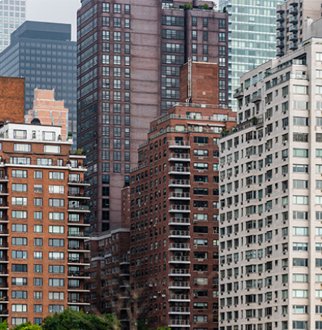

|  |  |
| --- | --- |
| 1. Yuko lives in ___.    * a house    * an apartment 2. Her home is in ___.    * Japan    * Toronto 3. At night, it's very ___ where she lives.    * noisy    * quiet |  |

**Noisy neighbors: Activity 2**

Listen to the interview again and choose the correct word to complete the sentence.

|  |  |
| --- | --- |
| 1. The rule's in Yuko's apartment building are very __________.    * relaxed    * strict 2. Between 12:30 and two o’clock and after ten o’clock at night, Yuko can't __________.    * sleep    * make noise 3. Yuko can listen to music __________.    * at night    * with headphones 4. Yuko can't take a shower because her bathroom is next to__________.    * her bedroom    * her neighbor's bedroom 5. Yuko's apartment is__________.    * large    * small 6. On Saturday after 10:00 in the evening, the rules__________.    * are not as strict    * are the same 7. If it is too noisy, the neighbors __________call the building manager.    * can    * can't 8. Yuko's neighbor's__________ very noisy.    * are    * aren't 9. Yuko__________ there should be strict rules on the weekend.    * thinks    * doesn't think |  |