be or do?: Activity 1
﻿ Read Grammar Bank 6C. Then put the phrases in the correct box. Listen and check.
Grammar Bank
6C be or do?
be
EXAMPLES
1 Hi, I'm Jim.
She isn't very friendly.
Are you Thai?
2 I can't talk. I'm driving.
They aren't working today.
Is it raining?
FORM
1 We use be as a main verb.
2 We also use be to form the present continuous. Be here is an auxiliary verb.
- Remember to invert be and the subject to make questions.
He's Spanish. Is he Spanish?
do / does
EXAMPLES
1 I'm doing my homework.
Do you do your homework regularly?
2 Do you speak English?
Where do they live?
They don't have children.
Does your sister have a car?
Where does your father work?
Alan doesn't like jazz.
FORM
1 We use do as a main verb.
2 We also use do / does to make questions and don't / doesn't to make negatives in the simple present. Do here is an auxiliary verb.
- Remember the word order for simple present questions: auxiliary, subject, base form OR question word, auxiliary, subject, base form (see Grammar Bank 3C).

bored walk to work talking to me calling a taxi
have lunch at home like animals get up early
remember his name cold wear glasses
using the internet frightened

Are you...? | Do you...?

be or do?: Activity 2
Read Grammar Bank 6C. Then complete the dialogues with the correct form of be or do. Use contractions where possible. Listen and check.
Grammar Bank
6C be or do?
be
EXAMPLES
1 Hi, I'm Jim.
She isn't very friendly.
Are you Thai?
2 I can't talk. I'm driving.
They aren't working today.
Is it raining?
FORM
1 We use be as a main verb.
2 We also use be to form the present continuous. Be here is an auxiliary verb.
- Remember to invert be and the subject to make questions.
He's Spanish. Is he Spanish?
do / does
EXAMPLES
1 I'm doing my homework.
Do you do your homework regularly?
2 Do you speak English?
Where do they live?
They don't have children.
Does your sister have a car?
Where does your father work?
Alan doesn't like jazz.
FORM
1 We use do as a main verb.
2 We also use do / does to make questions and don't / doesn't to make negatives in the simple present. Do here is an auxiliary verb.
- Remember the word order for simple present questions: auxiliary, subject, base form OR question word, auxiliary, subject, base form (see Grammar Bank 3C).

1. A ________ your parter cook?
B Yes. He ________ making dinner now.
2. A ________ you busy?
B Yes, I ________ doing my homework.
3. A How old ________ your father?
B He's 70, but he ________ want to retire.
4. A ________ you watching TV?
B No, we ________ playing a video game.
5. A ________ you speak German?
B Yes, but I ________ speak it very well.
6. A Why ________ you crying?
B Because I ________ feeling sad.

Music: Activity 1
Listen and read. Match the musical instrument to the correct picture.
1. drums
- 
- 
- 
2. piano
- 
- 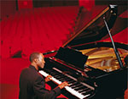
- 
3. violin
- 
- 
4. accordion
- 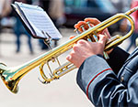
5. guitar
6. bass
7. bass
8. keyboard
9. trumpet

Music: Activity 2
Who plays these instruments? Complete the sentences with the musician words. Listen and check.
Musicians
To form the words for musicians, use:
instrument + -ist, e.g., pianist
instrument + -er, e.g., trumpeter
instrument + player, e.g., keyboard player

1. A __________ plays the piano.
2. A __________ plays the trumpet.
3. A __________ plays the keyboards.
4. A __________ plays the violin.
5. A __________ plays the bass.
6. A __________ plays the guitar.
7. A __________ plays the drums.
8. A __________ plays the saxophone.
9. An __________ plays the accordion.

/y/
Listen and write the words you hear. Then listen and repeat.
Quick tips
Hidden /y/ sound
Some words with the /u/ sound (spelled with u or ew) also have a /y/ sound before the /u/,
e.g., music /ˈmyuzɪk/ NOT /ˈmuzɪk/.

________
________
________
________
________
________

Giving opinions
Read and listen. Then say and record.
Quick tips
Giving opinions
When we give opinions, we put extra stress on adjectives and adverbs, e.g., I really like her. She's fantastic.

- I like her. She's great. |  | 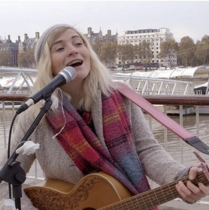
- I really like him. He's fantastic.
- I don't like it. It's awful.
- I don't like them. They're terrible.

Music is changing their lives: Activity 1
﻿Read and listen. Choose the correct answers.
Music is changing their lives
Inside the concert hall a top orchestra is playing brilliantly. Their young conductor, Gustavo Dudamel, is one of the best in the world. But we are not in New York, London, or Vienna. We are in Caracas, the capital of Venezuela. The orchestra is the Simón Bolívar Youth orchestra, and its conductor and young musicians come from the poorest families in the country. They are a product of El Sistema ("the system" in Spanish), a project started in 1975 to save poor children from crime and drug addiction through classical music.
Today more than 270,000 young Venezuelans from the barrios (poor areas in Caracas) are learning to play instruments. They practice Beethoven and Brahms instead of learning to steal and shoot. Gisella, age 11, says "I am learning the viola because I want to escape from the barrio. In Venezuela now it’s cooler to like Strauss than salsa." Edgar, 22, who plays in the orchestra, says "sometimes when we finish late I stay in town – it’s dangerous to go home at that time. But now most of my friends are here. We are a family as well as an orchestra."
Dudamel is now also the Musical Director of the Los Angeles Philharmonic, one of America’s top orchestras. But he returns frequently to Caracas to conduct. "I miss my orchestra, but I will never leave them. They’re family," he says.

1. The Simón Bolívar Youth Orchestra is from _______ .
  - the UK
  - Venezuela
  - the US
2. The musicians in the orchestra don't have a lot of _______.
  - friends
  - instruments
  - money
3. The conductor works in _______ country / countries.
  - one
  - two
  - three

Music is changing their lives: Activity 2
Read the article again. Complete the sentences with ONE or TWO words.
Read
Music is changing their lives
Inside the concert hall a top orchestra is playing brilliantly. Their young conductor, Gustavo Dudamel, is one of the best in the world. But we are not in New York, London, or Vienna. We are in Caracas, the capital of Venezuela. The orchestra is the Simón Bolívar Youth orchestra, and its conductor and young musicians come from the poorest families in the country. They are a product of El Sistema ("the system" in Spanish), a project started in 1975 to save poor children from crime and drug addiction through classical music.
Today more than 270,000 young Venezuelans from the barrios (poor areas in Caracas) are learning to play instruments. They practice Beethoven and Brahms instead of learning to steal and shoot. Gisella, age 11, says "I am learning the viola because I want to escape from the barrio. In Venezuela now it’s cooler to like Strauss than salsa." Edgar, 22, who plays in the orchestra, says "sometimes when we finish late I stay in town – it’s dangerous to go home at that time. But now most of my friends are here. We are a family as well as an orchestra."
Dudamel is now also the Musical Director of the Los Angeles Philharmonic, one of the America’s top orchestras. But he returns frequently to Caracas to conduct. "I miss my orchestra, but I will never leave them. They’re family," he says.

1. Gustavo Dudamel is a very good ________ .
2. The Simón Bolívar Youth Orchestra is part of the El Sistema ________.
3. El Sistema uses ________ to help children from poor families.
4. Some musicians don't go home at night because it's ________ .
5. They don't mind staying in town because the orchestra is their ________ .
6. Dudamel conducts one of America's best orchestras in ________ .

Do you like reading in English?
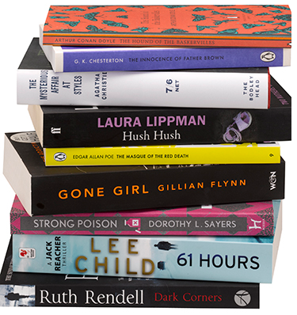 | Do you like reading in English? Why, or why not?  What do you like reading?  Go to Discussions and share your ideas with your classmates.

Writing 5 - An informal email
Write an informal email to invite a friend to a concert or gig.
Quick tips
Informal emails
Beginning: Hi + name
Middle: Use contractions, e.g., I’m from Madrid.
End: Best wishes or Love (for a good friend)

Think of a concert or gig you want to see. Which friend will you invite? Write an informal email to invite him or her. Include information on the following:
- What band is it?
- What type of music is it?
- Where is it?
- When is it?
Write three paragraphs.

write here …

