**Simple past: irregular verbs: Activity 1**

﻿Read Grammar Bank 7C. Then complete the sentences with the simple past form of the verbs. Listen and check.

|  |
| --- |
| **Grammar Bank**  **7C** simple past: irregular verbs  EXAMPLES  I **went** to Iceland in December. I **didn't go** to New York.  **Did** you **go** to a party? Who **did** you **go** with?  FORM   * Some verbs are irregular in the past [+] and change their form, e.g., *go → went*, *have → had*. * We only use the irregular past form in [+] sentences.   *I* ***bought*** *a bag last night.*   * We use the base form after *did / didn't*.   ***Did*** *you* ***go*** *out last night?* **NOT** *Did you went ...?*   * Remember the word order in questions: auxiliary, subject, base form, e.g., *Did you go out last night?* or question word, auxiliary, subject, base form, e.g., *Where did you go?*   **Look at the list of irregular verbs on page 165 of the Student Book.** |

|  |  |
| --- | --- |
| 1.  Our train _______ the station at 7:30. (leave)  2.  He _______ jeans last night. (wear)  3.  I _______ my friends at a restaurant. (meet)  4.  We _______ a Shakespeare play. (see)  5.  They _______ a lot of photos. (take)  6.  She _______ read when she was four. (can)  7.  I _______ my wallet last night. (lose)  8.  We _______ tired after the walk. (feel) |  |

**Simple past: irregular verbs: Activity 2**

﻿Read Grammar Bank 7C. Then complete the sentences with the past simple form of the verbs. Listen and check.

|  |
| --- |
| **Grammar Bank**  **7C** simple past: irregular verbs  EXAMPLES  I **went** to Iceland in December. I **didn't go** to New York.  **Did**you**go** to a party? Who**did**you**go** with?  FORM   * Some verbs are irregular in the past [+] and change their form, e.g., *go → went*, *have → had*. * We only use the irregular past form in [+] sentences.   *I****bought****a bag last night.*   * We use the base form after *did / didn't*.   ***Did****you****go****out last night?* **NOT** *Did you went ...?*   * Remember the word order in questions: auxiliary, subject, base form, e.g., *Did you go out last night?* or question word, auxiliary, subject, base form, e.g., *Where did you go?*   **Look at the list of irregular verbs on page 165 of the Student Book.** |

|  |  |
| --- | --- |
| 1.  ________________ it was Sunday today. (I / think)  2.  How many souvenirs ________________ ? (you / buy)  3.  I was late because ________________ find my keys. (I / not can)  4.  What ________________ about the flowers? (his wife / say)  5.  Where ________________ the party? (they / have)  6.  ________________ about my new car. (he / not know)  7.  ________________ coffee when I was a child. (I / not drink)  8.  She felt sick, so ________________ home early. (she / come) |  |

***go***

﻿Listen and read. Match the verb phrase to the correct picture.

|  |  |
| --- | --- |
| 1. go shopping |  |
| 2. go by bus |  |
| 3. go to the beach |  |
| 4. go for a walk |  |
| 5. go on ﻿vacation |  |
| 6. go to a restaurant |  |
| 7. go back (to work) |  |
| 8. go home |  |
| 9. go to bed (late) |  |
| 10. go out (on a Friday night) |  |
| 11.  go to church |  |

**have**

Listen to the verb phrases in the box. Match the verb phrases to the correct pictures.

|  |
| --- |
| have long hair have a good time have a sister have a car have breakfast  have a drink have a sandwich |

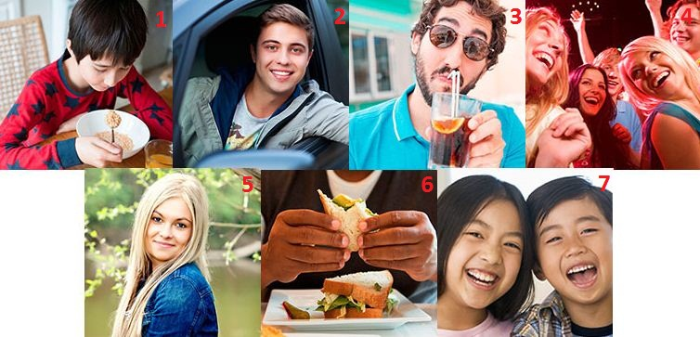

|  |  |
| --- | --- |
| 1. |  |
| 2. |  |
| 3. |  |
| 4. |  |
| 5. |  |
| 6. |  |
| 7. |  |

**get**

Match the pictures to the correct verb phrases. Then listen and check.

|  |  |  |
| --- | --- | --- |
| 1.   * + get up   + get a taxi   + get dressed |  |  |
| 2.   * + get home   + get a newspaper   + get an email |  |  |
| 3.   * + get dressed   + get a taxi   + get to the airport |  |  |
| 4.   * + get home   + get an email   + get up |  |  |
| 5.   * + get dressed   + get a newspaper   + get to the airport |  |  |
| 6.   * + get up   + get a taxi   + get home |  |  |
| 7.   * + get to the airport   + get an email   + get a newspaper |  |  |

**Sentence stress**

Listen and complete the sentences. Then listen and repeat.

|  |  |
| --- | --- |
| 1. When _________ _________ ? |  |
| 2.  Where _________ _________ ? |  |
| 3.  _________ were you _________ ? |  |
| 4.  Where did you _________ _________ ? |  |
| 5.  What _________ you _________ ? |  |
| 6.  _________ did you _________ ? |  |
| 7.  What _________ you _________ ? |  |
| 8.  _________ was the _________ like? |  |
| 9.  What time did you _________ _________ ? |  |
| 10.  Did you have a _________ _________ ? |  |

**A memorable night: Activity 1**

Listen to an interview about a memorable night and answer the question.



|  |  |
| --- | --- |
| * 1. What did Melissa do? * she got home early with her friends * she went to the beach with her friends * she went to a concert with her friends |  |

**A memorable night: Activity 2**

Listen again and answer the questions.

|  |  |
| --- | --- |
| **I** = Interviewer,**M** = Melissa  **I** Can you tell us about a memorable night, Melissa?  **M** Well, let me see. There are a lot of them, actually. But yes, there was one particular night this year that was memorable.  **I** When was it?  **M** It was February 14th.  **I** Valentine’s Day?  **M** Yes. That’s why I remember the date. It was Valentine’s Day, but I didn’t have a boyfriend at the time. In fact, I was with two friends.  **I** Where were you?  **M** I was in Miami. There was a concert that night by my favorite singer, Drake, so I traveled to Miami to see it.  **I** When did you arrive in Miami?  **M** The night before the concert.  **I** So, what did you do before the concert?  **M** We had a coffee at an interesting coffee shop near the beach. Then we tried to find the concert. We didn’t know exactly where the theater was, so we drove around for a very long time. In the end, we got there five minutes before the concert started.  **I** Was the concert good?  **M** Yes, it was fantastic. Drake sang all our favorite songs, and we danced and sang for about two hours.  **I** Did you go home after the concert?  **M** No, we didn’t go home right away. We didn’t have dinner before it started, so we were hungry. We went to a fast-food restaurant and had a hamburger. It was delicious! After that, we drove home.  **I** What time did you get home?  **M** We didn’t get home that late. It was two o’clock in the morning, more or less. But we had a great time. That was the important thing. |  |

* 1. When was it?
  + February 29th
  + February 14th
  1. Who was Melissa with?
  + with her boyfriend
  + with two friends
  1. Where were they?
  + Miami
  + the hotel
  1. When did she arrive in the city?
  + The day of the concert.
  + The night before the concert.
  1. Where did they have a coffee?
  + at the concert
  + at an interesting coffee shop near the beach
  1. Did they have a good time? Why (not)?
  + No, the got lost.
  + Yes, the danced and sang.
  1. What did they have for dinner?
  + seafood
  + a hamburger
  1. What time did they get home?
  + ten o'clock at night
  + two o’clock in the morning