there is / there are
Read Grammar Bank 8B. Then complete the sentences with [+], [–] or [?] of There's / There are. Use contractions. Listen and check.
Grammar Bank
8B there is / there are
EXAMPLES
singular plural
[+] There's a garage. There are some pictures on the wall.
[–] There isn't a swimming pool. There aren't any plants in the room.
[?] Is there a bathroom downstairs? Are there any neighbors with children?
[✓] Yes, there is. Yes, there are.
[✗] No, there isn’t. No, there aren't.
FORM
there is / there are
- We use there is / there are to say that something exists or doesn't exist, e.g., A There's a bathroom upstairs. There isn't a bathroom downstairs.
- We use there is + a singular noun and there are + plural nouns.
- There is is often contracted to There's. There are is not usually contracted.
- When we talk about a list of things, we use there is if the first thing in the list is singular and there are if the first thing in the list is plural.
In my bedroom there's a bed, two chairs, and a desk.
In the living room there are two armchairs and a sofa.

Quick tips
There is / There are or It is / They are?
Be careful. There is and It is are different.
There’s a key on the table. It’s the key to the kitchen.
There are three bedrooms in the apartment. They’re all very small.

1. _______ an armchair in my room. I often sit and read there.
2. _______ any tissues in your pocket?
3. _______ an elevator – we use the stairs.
4. _______three bedrooms in my apartment.
5. _______a rug in the living room?
6. _______any books on the shelf. It's empty.
7. _______ a pen in my bag. Here you go.
8. _______ a shower in the bathroom?

some / any + plural nouns
Read Grammar Bank 8B. Then choose a / an, some, or any to complete the conversation. Listen and check.
Grammar Bank
8B some / any + plural nouns
a / an, some and any
- We often use there is / isn't with a / an, and there are / there aren't with some and any.
- We use some and any with plural nouns. Some = not an exact number, e.g., There are some eggs in the fridge.
- We use some in [+] sentences, and any in [–] and [?].

A Tell me about your apartment, Danny.
B Oh, OK. Um, There's a / an / some / any living room...
A Are there a / an / some / any armchairs in the living room?
B No, but there's a / an / some / any orange sofa. I'm not sure if I like it, really.
A Hmm. What about the bedroom?
B The bedroom is very small. There's a / an / some / any bed, and there are a / an / some / any shelves for my books. But there isn't a / an / some / any closet.
A Oh. And the kitchen?
B It isn't very big. There aren't a / an / some / any cupboards, but there are a / an / some / any nice plants.
A Danny, why are you living there?
B Well, it's very cheap ...

The house – rooms
﻿Listen to the words in the box. Match the words to the picture.
an office | a kitchen | a bedroom | a bathroom | a dining room | a living room | a hall

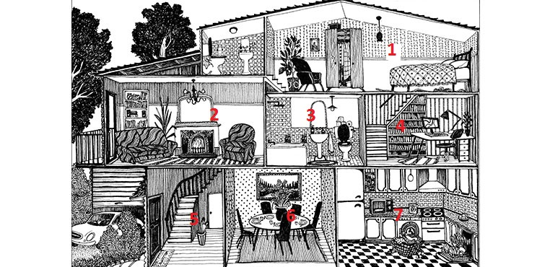

The house - parts of a house
Listen and read. Match the pictures to the correct words. Look at Activity 3 again to help you.
a balcony | a ceiling | a floor | stairs | a wall

 | 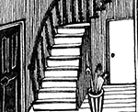 | 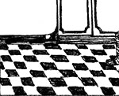 | 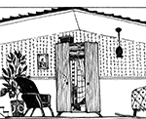 | 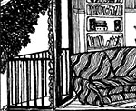

The house - things in a room
﻿Listen and read. Match the word to the correct picture.
- a dishwasher |  | - 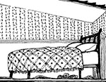  - 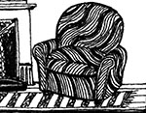  - 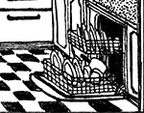
- a microwave |  | - 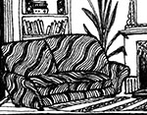  - 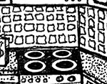  - 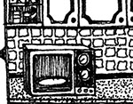
- a wardrobe |  | - 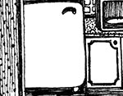  -   - 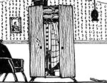
- an armchair |  | -   - 
- a stove |  | - 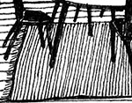
- a washing machine
- a shelf
- a bed
- a couch
- a fridge
- a cupboard
- a rug

/ɛr/ and /ɪr/
Listen and read. Then match the word to the correct sound. Listen and repeat.
Quick tips
/ɛr/ and /ɪr/
/ɛr/ chair
/ɪr/ ear

- stairs
  - /ɛr/
  - /ɪr/
- where
  - /ɛr/
  - /ɪr/
- here
  - /ɛr/
  - /ɪr/
- there
  - /ɛr/
  - /ɪr/
- we're
  - /ɛr/
  - /ɪr/
- near
  - /ɛr/
  - /ɪr/
- wear
  - /ɛr/
  - /ɪr/
- hear
  - /ɛr/
  - /ɪr/

This is the kitchen: Activity 1
Listen to a conversation between a woman and a young couple. The woman is showing them her house. Check the rooms she shows them.
- dining room
- kitchen
- toilet
- bedroom
- hall
- study
- bathroom
- garage
- living room

This is the kitchen: Activity 2
Listen again. Choose the correct answers. You can read the audio script to help you .

M = Mrs. Goodings, J = Joanna, B = Bradley
M Hello. Good morning. I’m Mrs. Goodings.
J Hi. I’m Joanna, and this is Bradley.
B Hi.
M Hello. Please come in. So…let’s start, OK? This is the kitchen, as you can see.
B It’s very big.
M Yes. There isn’t a dining room, so we eat in here.
J Oh look! The walls are big windows! You can see the yard– it’s beautiful!
B Can I ask you a question, Mrs. Goodings? Why did we come in the back door?
M We always use the back door. There isn’t a rug in the kitchen so there aren’t any problems with dirty shoes.
B Oh. Right.
J Where’s the washing machine?
M It’s in the corner over there.
J Oh, yes. I see it. Why is there a hole in the ceiling?
M Well, upstairs is the bathroom. The hole is for when you have a shower. You take off your clothes and put them down the hole. They land on the floor next to the washing machine.
J Oh. That’s interesting!
M Yes…It was my idea…Now…this way please…I want to show you the living room. There. What do you think?
J Oh! There are big windows here, too. I love it!
B Mrs. Goodings, is there a television?
M No, there isn’t. My husband and I don’t watch TV. We prefer listening to music. Now…let’s go upstairs.
J There are four bedrooms upstairs, is that right?
M Yes. Four bedrooms and a bathroom.
B Is this the bathroom?
M Yes, it is. Be careful with the…
B Aargh!!!
J Bradley? Bradley? Where is he?
M Don’t worry. He’s in the kitchen.
J What?
M Do you remember the hole in the ceiling?
J Oh no! Bradley? Bradley? Are you all right?

1. Mrs Goodings always eats in the kitchen.
  - True
  - False
2. Joanna doesn't like the kitchen.
  - True
  - False
3. There isn't a washing machine in the kitchen.
  - True
  - False
4. There's a hole in the ceiling of the kitchen.
  - True
  - False
5. Joanna likes the windows in the living room.
  - True
  - False
6. There's a TV in the living room.
  - True
  - False
7. There are three bedrooms upstairs.
  - True
  - False
8. Bradley forgets about the hole in the ceiling.
  - True
  - False

Writing 6 - Describing your home
Write a description of a house or apartment.

Quick tips
so
The kitchen is small, but there’s a table and chairs, so you can eat there.
We can use so to express a result or consequence, e.g.,
I was very tired, so I went to bed early.
My office is near my house, so I walk to work.

Think of a family member or friend's house or apartment and write a description for a website. Make notes to answer the following questions:
- Where is it? What places or services are nearby?
- What can you see from the house or apartment?
- How far is it from downtown?
- What rooms are there?
Write your description.

Write here …

