there was / were: Activity 1
Read Grammar Bank 8C. Then complete the conversation with the correct form of there was / there were. Use contractions. Listen and check.
Grammar Bank
8C there was / there were
EXAMPLES
singular plural
[+] There was a big mirror. There were four lamps.
[–] There wasn't a TV. There weren't any ghosts.
[?] Was there a bathroom? Were there any windows?
[✓] Yes, there was. Yes, there were.
[✗] No, there wasn't. No, there weren't.
FORM
- there was / there were is the past of there is / there are. We use there was / there were to say that something existed or didn't exist, e.g., There were two computers in the office, but there wasn't a printer.

A How many rooms ________ in your hotel?
B ________20 rooms; 12 upstairs and 8 downstairs.
A ________a shower in your bathroom?
B No, ________; only a bathtub.
A ________any towels?
B No, ________ , so we asked the receptionist for towels.
A ________ a big window in your room?
B Yes, and ________ a wonderful view of the ocean.

there was / were: Activity 2
Read Grammar Bank 8C. Then write the underlined phrases correctly. Add a word or change a word to correct the mistakes. Use contractions. Listen and check.
Grammar Bank
8C there was / there were
EXAMPLES
singular plural
[+] There was a big mirror. There were four lamps.
[–] There wasn't a TV. There weren't any ghosts.
[?] Was there a bathroom? Were there any windows?
[✓] Yes, there was. Yes, there were.
[✗] No, there wasn't. No, there weren't.
FORM
- there was / there were is the past of there is / there are. We use there was / there were to say that something existed or didn't exist, e.g., There were two computers in the office, but there wasn't a printer.

1. There was some guests in the hotel. ________________
2. We couldn't watch the news because there wasn't any TV. ________________
3. Were there some cupboards in your room? ________________
4. I couldn't work because there weren't a desk. ________________
5. Was there restaurant in the hotel? ________________
6. There weren't cups, so I couldn't make coffee. ________________
7. The children were scared because there was big dog. ________________
8. We couldn't park because wasn't a parking lot. ________________

Prepositions – place
﻿Listen and read. Match the preposition to the correct ghost.
Quick tips
above and below
above /əˈbʌv/ is similar to over.
below /bɪˈloʊ/ is similar to under.

1. in (the wardrobe) |  | - 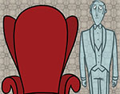  - 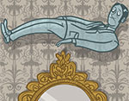  - 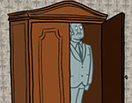
2. under (the bed) |  | - 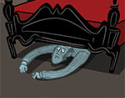  - 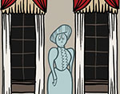  - 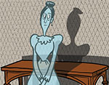
3. across from (the woman) |  | - 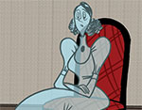  - 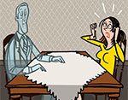
4. over (the mirror) |  | - 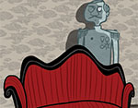
5. between (the windows)
6. on (the chair)
7. behind (the sofa)
8. next to (the armchair)
9. in front of (the table)

Prepositions – movement
Listen and read. Match the ghosts to the correct prepositions.

down (the stairs)
into (the wardrobe)
up (the stairs)
from (the bedroom) to (the bathroom)
out of (the wardrobe)
through (the window)

- 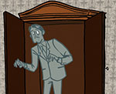 | - 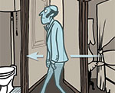 | - 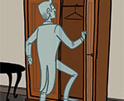
- 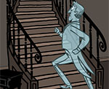 | - 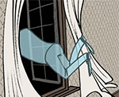 | - 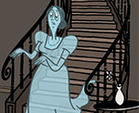

Silent letters
Read and listen. Then say and record.
Quick tips
Silent letters
Some English words have a silent letter, e.g., in ghost /ɡoʊst/ you don’t pronounce the h.

1.cupboard |  | 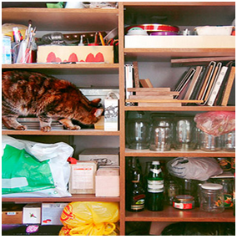
2.guest
3.hour
4.know
5.talk
6.write
7.could
8.friend
9.half
10.island
11.listen
12.what

A haunted house: Activity 1
Read and listen. Choose the correct answers.
Maesmawr Hall: A Haunted House in Wales
Maesmawr Hall is a manor house in Powys, Wales. It was built in 1535 and today is a 20-bedroom hotel and venue for weddings. It is famous because people say it is haunted.
Many guests say that they have seen ghosts. A businessman who stayed at the hotel said that when he looked out of the window he saw hundreds of Roman soldiers marching. In fact, in Roman times there was a road which passed through the grounds of Maesmawr Hall. Other guests said they saw the ghosts of the Davies sisters who owned the hotel in the 1900s, and the ghost of an old housekeeper walking through a wall in the hall. But perhaps most frightening is the story that the ghost of an evil man called Robin Drwg haunts the woods around the hotel. Some people say that they have seen this ghost suddenly change into the shape of a bull.
Maesmawr was on a TV show about houses with ghosts called Most Haunted. The TV show presenters and investigators from the Mid Wales Paranormal (MWP) reported lots of strange activity in the hall – seeing balls of light, feeling movements, and hearing unusual sounds. During the investigation, the floor in one of the upstairs rooms moved. The hotel’s current owner, Nigel Humphryson, says he often hears voices and banging noises that he cannot explain.
So if you’re interested in ghosts, why not stay here? But don’t go outside at night unless you’re feeling really brave!

1. Maesmawr Hall is ______.
- a small, old hotel
- a big, modern hotel
- a small, modern hotel.
2. People say the ghosts are ______.
- downstairs in the house
- inside and outside the house
- upstairs in the house
3. TV reporters _____ in the house.
- had strange experiences
- were very frightened
- saw a lot of ghosts

A haunted house: Activity 2
Read the text again. Choose the correct answers.
Read  Maesmawr Hall: A Haunted House in Wales  Maesmawr Hall is a manor house in Powys, Wales. It was built in 1535 and today is a 20-bedroom hotel and venue for weddings. It is famous because people say it is haunted.  Many guests say that they have seen ghosts. A businessman who stayed at the hotel said that when he looked out of the window he saw hundreds of Roman soldiers marching. In fact, in Roman times there was a road which passed through the grounds of Maesmawr Hall. Other guests said they saw the ghosts of the Davies sisters who owned the hotel in the 1900s, and the ghost of an old housekeeper walking through a wall in the hall. But perhaps most frightening is the story that the ghost of an evil man called Robin Drwg haunts the woods around the hotel. Some people say that they have seen this ghost suddenly change into the shape of a bull.  Maesmawr was on a TV show about houses with ghosts called Most Haunted. The TV show presenters and investigators from the Mid Wales Paranormal (MWP) reported lots of strange activity in the hall – seeing balls of light, feeling movements, and hearing unusual sounds. During the investigation, the floor in one of the upstairs rooms moved. The hotel’s current owner, Nigel Humphryson, says he often hears voices and banging noises that he cannot explain.  So if you’re interested in ghosts, why not stay here? But don’t go outside at night unless you’re feeling really brave! | 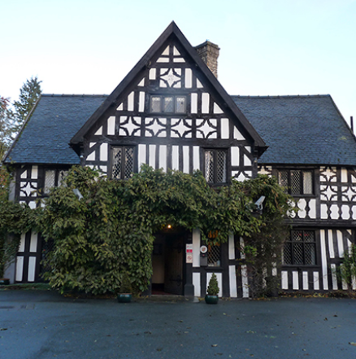

1. Maesmawr Hall is more than 500 years old.
  - True
  - False
2. People sometimes go to Maesmawr Hall to get married.
  - True
  - False
3. One guest says he saw a large group of men walking past the hotel.
  - True
  - False
4. Other guests say they saw some women standing on a wall in the garden.
  - True
  - False
5. Robin Drwg's ghost sometimes appears as a bull.
  - True
  - False
6. The owner thinks it's possible that Maesmawr Hall is haunted.
  - True
  - False

What do you like about your house?
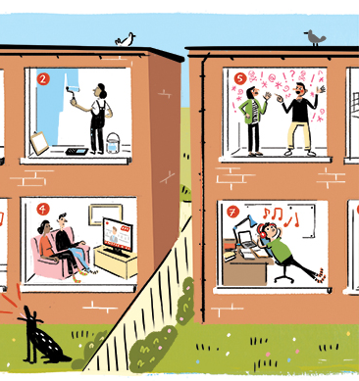 | What do you like about your house or apartment?  Describe it.  Go to Discussions and share your ideas with your classmates.

