**Countable / uncountable nouns**

Read Grammar Bank 9A. Then choose the correct answers. Listen and check.

|  |
| --- |
| **Grammar Bank**  **9A** countable / uncountable nouns  EXAMPLES  **Countable**  *an apple   three apples*  **Uncountable**  *rice   meat*  FORM   * English nouns can be**countable** and **uncountable**.   countable = things you can count, e.g.,*apples*. Countable nouns can be singular (***an****apple*) or plural (*apple****s***).  uncountable = things you can't count, e.g., *rice*, *meat***NOT***two rices, three meats.*Uncountable nouns are usually singular.   * Some nouns can be countable and uncountable, e.g., *ice cream*.   *an ice cream* = one ice cream in your hand  *some ice cream* = ice cream in a bowl |

|  |  |
| --- | --- |
| 1.  I like a butter / butter on my bread.  2.  She usually has an egg / egg for breakfast.  3.  Do you put a sugar / sugar in your coffee?  4.  Would you like some candy / a candy ?  5.  He often eats a sandwich / sandwich for lunch.  6.  Do you want a toast / toast or cereal?  7.  I had orange / an orange for dessert.  8.  We always put cheese / a cheese on our pasta. |  |

**a / an, some / any**

Read Grammar Bank 9A. Then complete the sentences with *a, an, some* or *any*. Listen and check.

|  |
| --- |
| **Grammar Bank**  **9A** *a* /*an, some* / *any*  EXAMPLES  **countable             uncountable**  [+] We need              **an** apple.               **some** butter.  **some** apples.  [–] We don't need    **a** tomato.               **any** rice.  **any** tomatoes.  [?] Do we need         **an** orange?            **any** sugar?  **any** oranges?  FORM   * We use *a* / *an* with singular countable nouns. *a* / *an* = one. * We use *some* in [+] with plural countable nouns and with uncountable nouns. * We use *any* in [–] and [?] with plural countable nouns and with uncountable nouns. |

|  |  |
| --- | --- |
| 1.  Are there ____ onions?  2.  We need ____ tomatoes.  3.  There isn't ____ pasta.  4.  I eat ____ apple every evening.  5.  Would you like ____ banana?  6.  There aren't ____ apples.  7.  There are ____ carrots in the fridge.  8.  Would you like ____ milk in your coffee? |  |

**Food and drink: Activity 1**

Listen and read. Match the word to the correct picture.

|  |  |
| --- | --- |
| 1. sugar |  |
| 2. fish |  |
| 3. bananas |  |
| 4. cheese |  |
| 5. onions |  |
| 6. meat |  |
| 7. (olive) oil |  |
| 8. French fries |  |
| 9. lettuce |  |
| 10. butter |  |
| 11. seafood |  |
| 12. mushrooms |  |

**Food and drink: Activity 2**

Match the pictures to the correct words. Then listen and check.

|  |  |  |
| --- | --- | --- |
| 1.   * + cookies   + potato chips   + candy |  |  |
| 2.   * + cereal   + toast   + bread |  |  |
| 3.   * + oranges   + strawberries   + apples |  |  |
| 4.   * + tea   + coffee   + (orange) juice |  |  |
| 5.   * + peppers   + peas   + carrots |  |  |
| 6.   * + cake   + fruit salad   + ice cream |  |  |
| 7.   * + spices   + herbs   + nuts |  |  |
| 8.   * + pasta   + salad   + rice |  |  |

**Food and drink: Activity 3**

Listen to the words in the box. Match the words to the correct pictures.

|  |
| --- |
| eggs jam tomatoes a sandwich a pineapple milk chocolate potatoes |

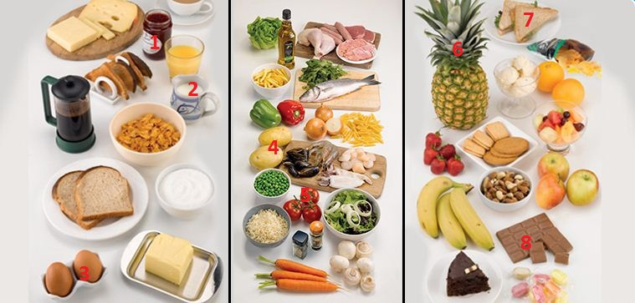

|  |  |  |  |
| --- | --- | --- | --- |
| 1. |  | 5. |  |
| 2. |  | 6. |  |
| 3. |  | 7. |  |
| 4. |  | 8. |  |

**The letters *ea***

Listen and read. Match the word to the correct sound. Then listen and repeat.

|  |  |
| --- | --- |
| 1. br**ea**d    * /i/    * /ɛ/    * /eɪ/ |  |
| 1. br**ea**kfast    * /i/    * /ɛ/    * /eɪ/ |  |
| 1. **ea**t    * /i/    * /ɛ/    * /eɪ/ |  |
| 1. h**ea**lthy    * /i/    * /ɛ/    * /eɪ/ |  |
| 1. ice cr**ea**m    * /i/    * /ɛ/    * /eɪ/ |  |
| 1. m**ea**t    * /i/    * /ɛ/    * /eɪ/ |  |
| 1. p**ea**s    * /i/    * /ɛ/    * /eɪ/ |  |
| 1. st**ea**k    * /i/    * /ɛ/    * /eɪ/ |  |
| 1. t**ea**    * /i/    * /ɛ/    * /eɪ/ |  |

**My Favorite Meal: Activity 1**

Listen to four speakers talking about their favorite meal. Choose the correct words to complete the meals.

|  |  |
| --- | --- |
| 1. Speaker 1: roast _____    * potatoes    * beef    * chicken 2. Speaker 2: _____ tikka masala    * curry    * chicken    * vegetable 3. Speaker 3: hot dog and _____    * French fries    * ketchup    * hamburger 4. Speaker 4: sweet and sour tofu and _____    * fish    * chicken    * vegetables |  |

**Interview with a Detective: Activity 2**

Listen again and match the speakers to the sentences.

|  |  |
| --- | --- |
| **A** I often eat it outside. **B** I always order rice with it. **C** I have it at a local restaurant. **D** I eat it when I visit my parents.  Speaker 1 ___ Speaker 2 ___ Speaker 3 ___ Speaker 4 ___ |  |