***be going to* (predictions): Activity 1**

1. F
2. C
3. A
4. G
5. D
6. H
7. B
8. E

***be going to* (predictions): Activity 2**

1. 's going to see
2. 're going to be
3. 'm not going to like
4. isn't going to remember
5. 's going to take
6. isn't going to rain
7. aren't going to win
8. 're going to have

**Verb phrases**

1. 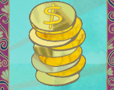
2. 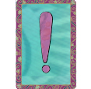
3. 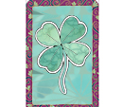
4. 
5. 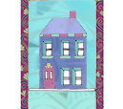
6. 
7. 
8. 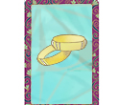
9. 
10. 

**Word stress**

1. first syllable
2. second syllable
3. first syllable
4. first syllable
5. first syllable
6. second syllable
7. first syllable
8. second syllable
9. first syllable
10. first syllable
11. second syllable
12. first syllable

**The name behind the method: Activity 1**

1. How do you like your tea?
2. What's inside the ball?
3. Let's play cards
4. Give me your hand

**The name behind the method: Activity 2**

1. True
2. False
3. True
4. False
5. False
6. True