**Verb *be* (+), subject pronouns: Activity 1**

1. are
2. is
3. am
4. is
5. are
6. are
7. is
8. is

**Verb *be* (+), subject pronouns: Activity 2**

1.  They're

2.  He's

3.  We're

4.  She's

5.  It's

6.  They're

7.  She's

8.  We're

**Days of the week**

1. Tuesday
2. Friday
3. Monday
4. Thursday
5. Sunday
6. Wednesday
7. Saturday
8. 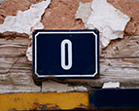
9. 
10. 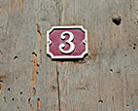
11. 
12. 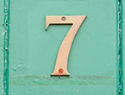
13. 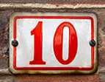
14. 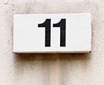
15. 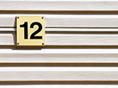
16. 
17. 
18. 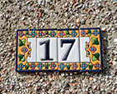
19. 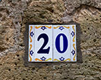

**Numbers 0-20: Activity 2**

1. four
2. nine
3. eighteen
4. two
5. eight
6. sixteen
7. six
8. fourteen
9. nineteen

**Vowel sounds**

|  |  |  |  |
| --- | --- | --- | --- |
|  |  |  |  |
|  |  |  |  |
|  |  |  |  |

**Hello: Activity 1**

|  |  |
| --- | --- |
|  | talking on the phone |
|  | talking in a language school |
|  | talking in a café |
|  | talking in a taxi |

**Hello: Activity 2**

1. 917-555-6542
2. room five.
3. five dollars and twenty cents.
4. 23 Canal Street