**Possessive adjectives: Activity 1**

1. your
2. our
3. He’s
4. My
5. she
6. your
7. We’re
8. Its

**Possessive adjectives: Activity 2**

1.  Her

2.  Our

3.  its

4.  My

5.  Their

6.  your

7.  His

8.  your

**Classroom language: Activity 1**

1. 
2. 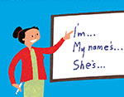
3. 
4. 
5. 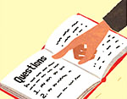
6. 
7. 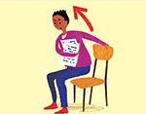
8. 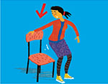
9. 
10. 
11. 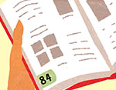
12. 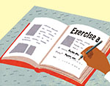

**Classroom language: Activity 2**

1. Can I have a copy, please?
2. How do you spell it?
3. I don't know.
4. How do you say *gato* in English?
5. Can you help me, please?
6. What page is it?
7. Sorry, can you repeat that, please?
8. Sorry I'm late.

**The alphabet**

1. L
2. J
3. K
4. C
5. B
6. M
7. W
8. Y

**/oʊ/, /u/, /ɑr/**

1. /u/
2. /ɑr/
3. /oʊ/
4. /u/
5. /oʊ/
6. /ɑr/
7. /oʊ/
8. /u/
9. /ɑr/

**Can I help you? Activity 1**

1. a hotel
2. the US
3. 503

**Can I help you? Activity 2**

**First name**   Erik   
**Last name**   Taylor   
**Country**   USA   
**City**   Miami  
**Address**  15 Atkinson Road  
**Zip code**  33156   
**Email address**  eriktaylor @mail.com  
**Phone number**   305-555- 5692 .  
**Cell phone number**   305-555-5701

**Writing 1 - Completing a form**

**VISIT AND SHORT STAY (VISAF2)**  
 *Visa application form for a visitor or student*  
  
About you  
 **First name**          John   
**Last name (Family name)** Evans  
**Mr / Mrs / Ms**    Mr   
**Date of birth**       12 03 1987  
**Nationality** American  
**Place of birth:  
   country** US   
**town / city** New York  
**Address**  
  
    48 Main Street  
  
   Los Angeles  
  
   California  
 **Email address**john.evans@mail.com