**Singular and plural nouns: Activity 1**

1. They're photos
2. They're watches
3. They're cities
4. They're addresses
5. They're teachers
6. They're universities
7. They're change purses
8. They're students

**Singular and plural nouns: Activity 2**

1.  The children are at school.

2.  One man is in a taxi.

3.  The people are at the airport.

4.  Two women are at the restaurant.

5.  A person is in my hotel room.

6.  Three men are in the museum.

7.  A child is under the desk.

8.  The woman is from Turkey.

**Things: Activity 1**

1. 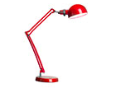
2. 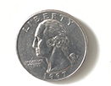
3. 
4. 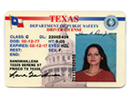
5. 
6. 
7. 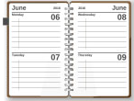
8. 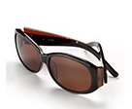
9. 
10. 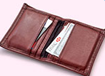
11. 
12. 

**Things: Activity 2**

|  |  |  |  |
| --- | --- | --- | --- |
| 1. | a tablet | 5. | a ticket |
| 2. | a charger | 6. | a pen |
| 3. | a notebook | 7. | a change purse |
| 4. | a credit card | 8. | a key |

**Things: Activity 3**

1. in
2. under
3. on
4. in
5. on
6. on
7. under

**What's in your bag? Activity 1**

* Speaker 2
* Speaker 3

**What's in your bag? Activity 2**

1. D
2. B
3. A
4. C