**Simple present (+/-)**

1. speak
2. don't play
3. needs
4. don't listen
5. doesn't eat
6. lives
7. do
8. doesn't work

**Simple present - spelling**

1. finishes
2. closes
3. cleans
4. does
5. plays
6. goes
7. watches
8. has

**Verb phrases: Activity 1**

|  |  |  |  |
| --- | --- | --- | --- |
| 1. | live in an apartment | 5. | go to the movies |
| 2. | study history | 6. | take an umbrella |
| 3. | speak German | 7. | drink water |
| 4. | like animals | 8. | wear glasses |

**Verb phrases: Activity 2**

|  |  |  |  |
| --- | --- | --- | --- |
|  |  |  |  |
|  |  |  |  |
|  |  |  |  |

**Verb phrases: Activity 3**

1. 
2. 
3. 
4. 
5. 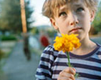
6. 
7. 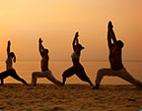
8. 
9. 
10. 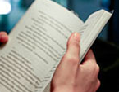

**Third person *-s***

1. /s/
2. /z/
3. /ɪz/
4. /z/
5. /ɪz/
6. /s/
7. /z/
8. /s/
9. /ɪz/
10. /z/

**Things I love about South Korea: Activity 1**

1. We can find that for you.
2. Enjoy your dinner.
3. Shopping on the street.
4. Traveling is so easy!

**Things I love about South Korea: Activity 2**

1. True
2. False
3. True
4. True